Autumn/Winter 2019 MENU – WEEK 2
OPTION | MONDAY |  | TUESDAY |  |  | WEDNESDAY |  |  | THURSDAY |  |  | FRIDAY
1 | Seasoned chicken breast with ½ jacket potato and spaghetti hoops | 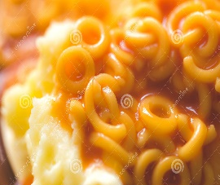 | Roast chicken with stuffing, creamed & roast potatoes, broccoli, carrots and gravy | 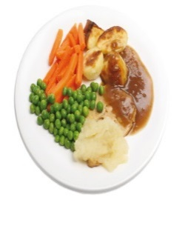 |  | Baked gammon, creamed potatoes, baked beans, peas or cauliflower | 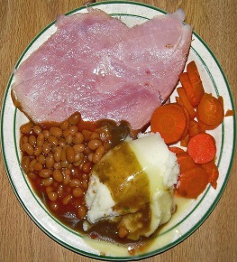 |  | Pork sausage with sauté potatoes, carrots and broccoli | 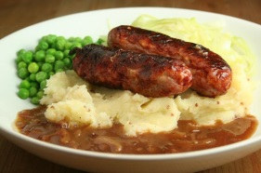 |  | Coated chicken served with chips, peas or baked beans
2
V | Tortilla boat filled with quorn chilli served with 50/50 rice and sweetcorn | 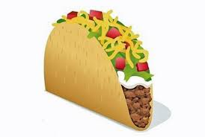 | Tomato and mascarpone pasta bake | 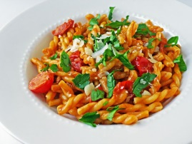 |  | Vegetarian balti with 50/50 rice |  |  | Vegetarian spaghetti bolognaise served with broccoli | 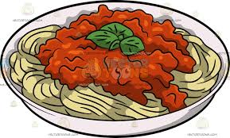 |  | Tempura fish served with chips, peas or baked beans
JP | Jacket Potato with cheese |  | Jacket Potato with tuna and mayonnaise |  |  | Jacket Potato with cheese and coleslaw |  |  | Jacket Potato with tuna mayonnaise and sweetcorn |  |  | Jacket Potato with beans
PL | Available daily as an alternative: - Sandwiches served with vegetables, a dessert and drink
DESSERTS
 | Apple and blackberry crumble, custard or ice cream |  | Fresh fruit salad |  | Chocolate sponge and custard |  |  | Flapjack |  |  | Banoffee waffle or cookie
Available daily as an alternative:- Fruit yoghurt, a selection seasonal fresh fruit, soreen and cheese & biscuits available everyday
Unlimited fresh salad and unlimited wholemeal bread
LUNCH WILL BE SERVED WITH FRESH MILK OR WATER
Menu Cycle Week 2: 11th Nov, 2nd Dec, 23rd Dec, 13th Jan, 3rd Feb, 24th Feb, 16th Mar

