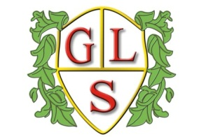
Class Sunflower Topics Summer 2023

Science
Testing Materials
All about Animals

(Topic Day Theme – What do we know about dinosaurs?)

History
Monarchs – Queen Victoria & Queen Elizabeth II

Geography
Landmarks in the UK

Computing
Multimedia: Films, Animation
Programming & Algorithms

Spanish
Spanish Greetings
Spanish Food

RE
Hindu Dharma Places of Worship
Christianity: Jesus and his Disciples

Art
Vases and Pots

Design Technology
Mechanisms: Moving Storybooks

PSHE
Staying healthy: Diet, Teeth and Exercise
Change and how to cope

PE
Wolves Foundation

