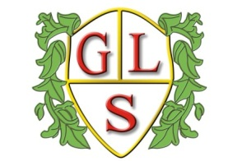
Class P5 Topics Summer 2019

Our topic theme this term is ‘Out in the community’

English
Magazines and Newspapers
Newspapers

Maths
Data Handling- pictograms and bar charts
Telling the time- units of time
Shape and Space- Pattern and Symmetry
Number- Recap of number

Science
Watching plants grow
Why does it light up?
What do we know about dinosaurs?

Geography
Our School

ICT
Using technology in the community

RE
Places of Worship- Where can we find guidance on how to live our lives?
Places of Worship- Mosques and Churches

Art
Local Artists and Art Galleries

Design Technology
Cooking at home

PSHE
SRE
Money Matters

