Spring Summer 2019 MENU – WEEK 2
OPTION | MONDAY |  | TUESDAY |  |  | WEDNESDAY |  |  | THURSDAY |  |  | FRIDAY
1 | Selection of wholemeal Pizza with various toppings  served with herby diced potatoes, peas or sweetcorn |  | Roast chicken with stuffing with roast & creamed potatoes. Fresh broccoli or carrots gravy |  |  | Pasta carbonara served with garlic bread, carrots and peas |  |  | Chicken Balti and rice |  |  | Red tractor chicken poppers served with chunky chipped potatoes, peas or baked beans
2 |  |  |  |  |  | Chicken enchiladas with savoury rice, salad and coleslaw |  |  |  |  |  | Oven baked battered salmon served with chunky chipped potatoes, peas or baked beans
V | Vegetarian tortilla boat filled with mild vegetarian chilli served with rice and sweetcorn | 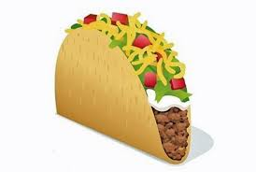 | Tomato and mascarpone wholemeal pasta bake  served with garlic bread and broccoli | 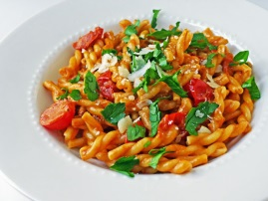 |  | Pasta carbonara served with garlic bread, carrots and peas |  |  | Vegetarian sausage roll with sauté potatoes and baked beans |  |  | Cheese flan served with chunky chips, peas or baked beans
JP | Jacket Potato with cheese |  | Jacket Potato with tuna and mayonnaise |  |  | Jacket Potato with cheese and coleslaw |  |  | Jacket Potato with tuna mayonnaise and sweetcorn |  |  | Jacket Potato with beans
PL | Available daily as an alternative: - Sandwiches served with vegetables, a dessert and drink
DESSERTS
 | Vanilla Ice Cream or fruit topped waffle |  | Sticky toffee cake |  | Fruit salad or  yoghurt |  |  | Fruit Mousse |  |  | Cookie
Available daily as an alternative:- Fruit yoghurt, a selection seasonal fresh fruit, soreen and cheese & biscuits available everyday
Unlimited fresh salad and unlimited wholemeal bread
LUNCH WILL BE SERVED WITH FRESH MILK OR WATER
Menu Cycle Week 2: 13th May, 3rd June, 24th June, 15th July, 9th Sept, 30th Sept, 21st Oct

