Home Learning Activities
Maths  Get someone at home to test you on your 2-5 times tables | Maths  Design a gaming room- how much would it cost? Where would you get all the things for it from? | Maths  Visit Maths Workout, Maths Whizz or Maths Warm Up and do 1 hour of activities.  (same as last week) | Maths  56 is the answer- what could be the question? Think of as many different questions as possible. E.g I have £1 and spend 44p, what is my change? | Maths  Find as many different ways as you can to make 22.
English  Keep a daily diary of your time at home. What did you do today?  (continue from last week- this is an ongoing task) | English  Write a story about a dream school day: what would it be like? | English  Read some of your book  (continue from last week- ongoing task) | English  Write a description of this haunted house… | English  Write a short explanation text that explains something you’re really good at- e.g. playing Minecraft
PSHE  Tidy your room or any other room for your parents. | PSHE  Ask someone in your family to tell you something about themselves you may not know- do they have a hidden talent!? | PSHE  Write a letter/ make a card for a relative you can’t see at the moment | PSHE  Telephone/facetime a friend and have a chat. | PSHE  Play a game with someone in your house.  (ongoing task)
PE  Jog up and down stairs- can you do it more than last week? | PE  Go for a walk/run/walk the dog. | PE  Do a circuit – 20 star jumps, 10 press ups, 20 tuck jumps, 30 second wall sit. Repeat 3 times.  Or, if you follow a physio programme, do some of the moves from it. | PE  See if you can keep up with this yoga for kids video?  https://www.youtube.com/watch?v=X655B4ISakg | PE  Lift some weights. Use real ones if you have them or if not, use tins! Do exercises you have learned!  Continue from last week- can you do more repetitions than last week?
ART  Got any old bottles or cardboard boxes you are going to recycle?  Why not try and make something from them. Check out this junk model image made from an old bottle:  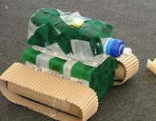 | FOOD TECH  Choose one of the following to either prepare for your family OR learn to make:  Cheese on toast  Beans on toast  Scrambled eggs | DT  Using some paper/cardboard- design a place mat or mug coaster  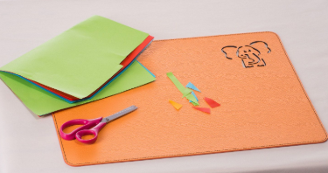 | SCIENCE  Choose a subject to research on the BBC bitesize website  Same activity as last week- but choose a different subject | COMPUTING  Using e-safety rules, stay in touch and chat to your friends for an hour or two each day.  Continue from last week- it is important to maintain good relationships with friends.
Class: P1 Week: 3 Week Beg: 6th April

