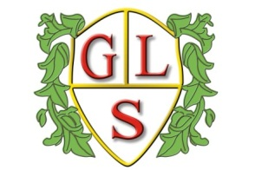
Class P1 Topics Summer 2019

Maths
Range of topics on 4 operations of number along with geometry and measure topics (throughout the term)

English
Stories-Adventure/ Scary
Poetry – Oral performance, riddles & Children’s Authors.

Science
Investigating circuits (Summer 1)
Plants (Summer 2)

History
Study of the Indus Valley civilisation (Summer 1)

Geography
Where does our food come from? (Summer2)

ICT
Databases, 3D modelling, concept maps (throughout the term)

Design Technology
Summer Salads (Summer 1)
Independent Travel Training (Summer 2)

Spanish
Colours, songs, conversations, food

RE
Festivals (Summer 1)
Inspirational Leaders (Summer 2)

Art
Day of the Dead Mexican art (Summer 1)
Bright pots (Summer 2)

PSHE
Living in the Wider World (Summer 1)
Enterprise (Summer 2)

PE
Tag Rugby
(throughout term)

