

**Topics**

**Number: -** Number and place value. Counting and comparing numbers. Addition & Subtraction, (+), subtraction (-) and equals (=) signs. One step problems.

**Measures –** Money – know the value and denominations.

Long/short

**Data handling:** Pictograms and tally charts

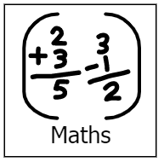

**Topics**

Poems

Stories by the same author (Julia Donaldson)

Letters and sounds, phonics work, Guided Reading,

Handwriting.

Speech and language work.

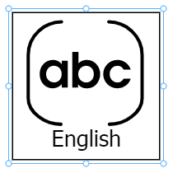

**Topics**

Data

e-books





**Topics**

Materials

Forces

Science day – The land before time

**Topic**

3D giants

**Topic**

Scotland and Wales



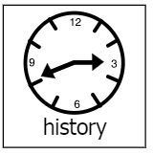

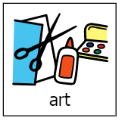

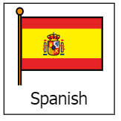

**Topics** –

All about Spain

Colours

**Topic**

Clothes through time

**Topics**

Hindu Dharma

Easter

**Easter=**

**Topics**

Games

Core skills

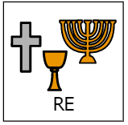

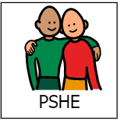

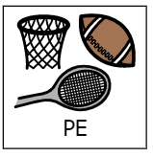

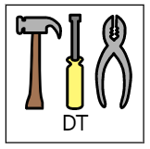

**Topic**

Healthy choices

Stranger danger

**Topic** –

Puppets