P2 Spring Term 2021

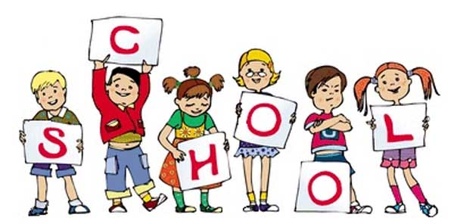

P2 staff Ms K.White

Mrs K.Dickson

Mrs L. Stewart

Ms J.Farrington

**Topics**

**Autumn 1**

Statistics

Measurement

Number: addition and subtraction

**Autumn 2**

Number: Fractions finding halves and quarters

Geometry: shape work

**Topics**

Class Novel – Charlie and the chocolate factory.

Spelling and Phonics, Guided Reading, Guided Writing, Handwriting.

Speech and language work.

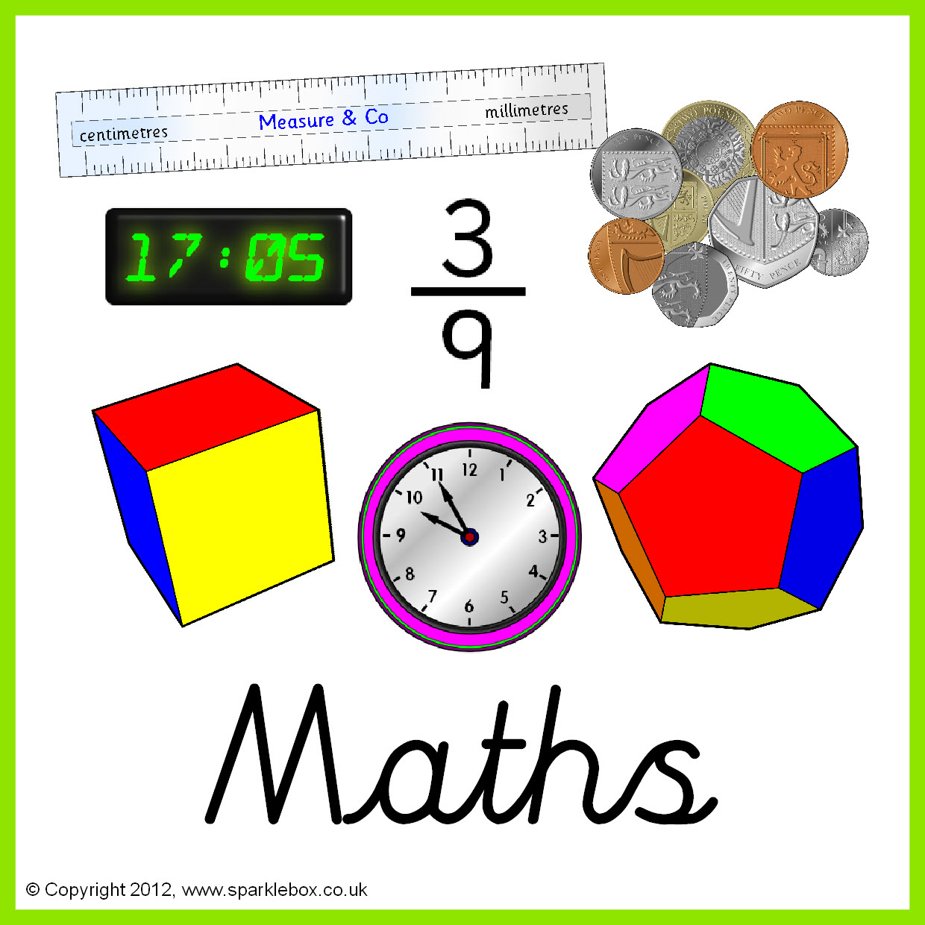

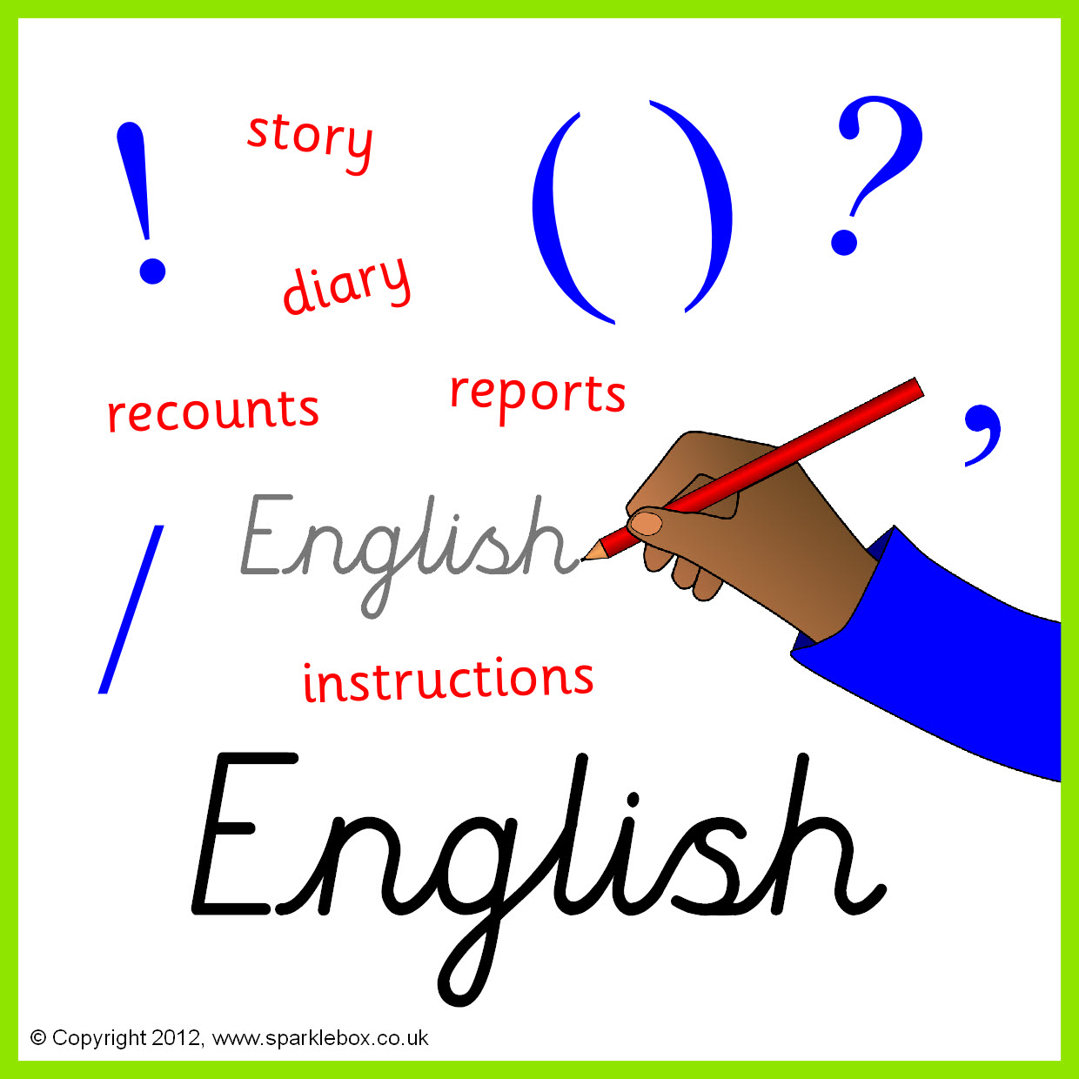

**Topics**

The sun across the sky - Earth and Space

How can we see in the dark? - Light and electricity

**Topics -** Taught by D. Taylor

E Safety

Multimedia: Photos; Sound & Music; eBooks

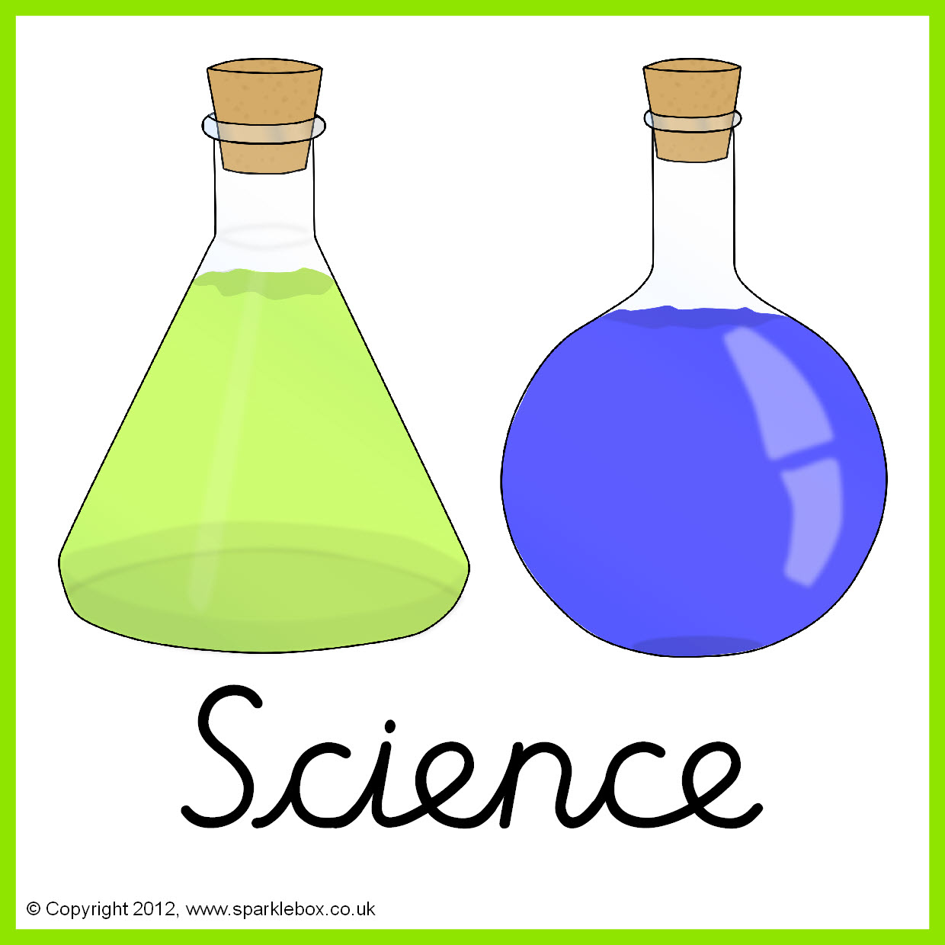



**Topics** – Taught by L.Fernyhough

Everyday objects.

African art pottery – Relief clay work.

**Topics** - Taught by L. Fernyhough

Greenwich meantime. \Timezones.

Extreme Natural Disasters.





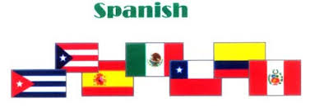

**Topics** Months of the year- Mi cumpleanos (My birthday) Numbers to 20.

Spanish greetings: conversations- how are you? Feelings.

**Topic** -Taught by L. Fernyhough

Crime and punishment – then and now.



**Topics**

Sacred texts - Quran /The Bible.

Places of worship – Mosque/Church - events leading up to Easter.

**Topics**

Archery and gymnastics.





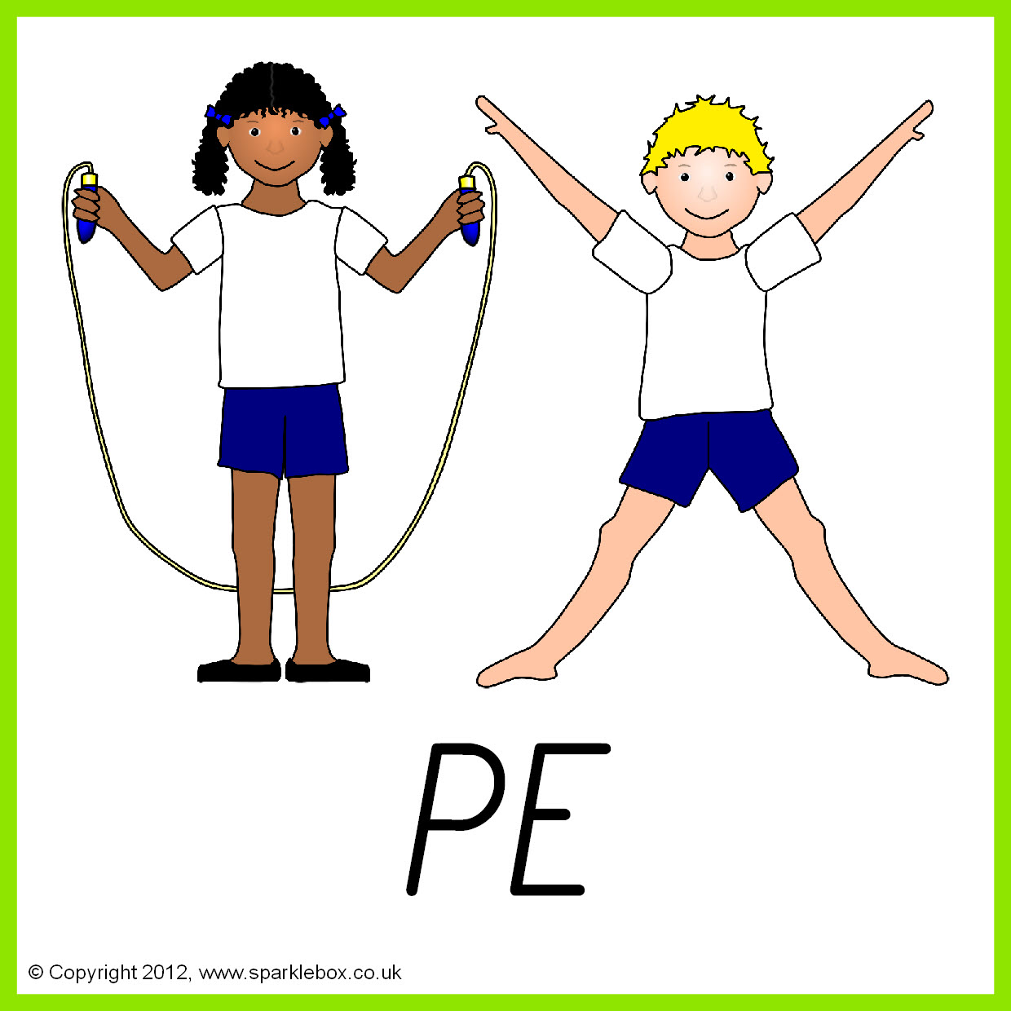

**Topics** Electrical - How things work in the home.

Ways with eggs.

**Topics**

Changing adolescent body.

Relationships with others.

.

