**Speech & Language Therapy**

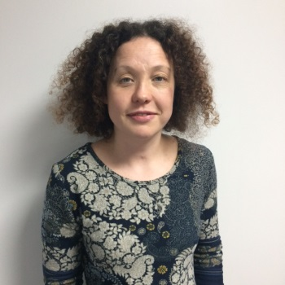

Angie Holliday

Speech & Language

Therapist

Angie works in Green Lane two days a week. She also works in Fox Wood School and for our Mainstream Service. Angie sees children to assess and review their progress and meets regularly with Teaching Staff.

Ruth Knight

Specialist Speech

& Language Therapist

Ruth works in school two days a week. She sees children to assess and review their progress, meets regularly with Teaching Staff and delivers training in school. Ruth also works for our Mainstream Service.

Hello from your Speech & Language Therapy Team at Green Lane School.

We are in school throughout the week working closely with Teaching Staff to support

children with a range of communication needs. We provide advice, strategies,

training and treatment in school.

We work closely with Parents, Carers, Teaching Staff and other professionals as much as possible in helping children to meet their communication potential. We fully involve Parents, Carers and Teaching Staff in target setting and will talk about your concerns.

Our aim is to help children achieve their communication potential.

Claire Shepherd

Highly Specialist Speech

& Language Therapist

Claire works in school two days a week (alternate weeks). She sees children to assess and review their progress, meets regularly with Teaching Staff, delivers training in school and supports children with their eating and drinking skills.

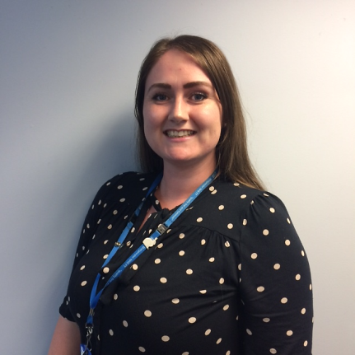

Debbie Foster

Speech & Language Therapy Assistant

Debbie is the newest member of the team in Green Lane School. She sees children for one-to-one therapy sessions. Debbie also works for our Community Clinic Team at Health Services at Wolves.

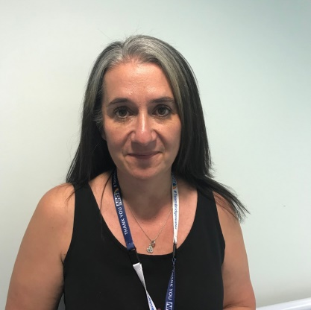

You are welcome to contact us at any time if you have questions or would like to discuss your child’s communication needs on **01925 251 389.** You can also find out more about our service on our website: www.bridgewater.nhs.uk/warrington/paediatricspeechandlanguagetherapy/