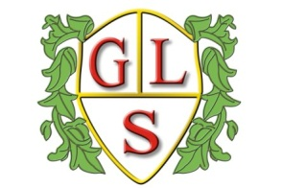
Class 6 Topics Spring 2019

Science
Rocks

History
Would you have wanted to live in the 1950s?

Geography
Continents and Seas

ICT
Writing for different audiences
Logo

Spanish
Weather
Months

RE
Easter
Islam

Art
Working the Surface
Design Technology
Structures-playgrounds
PSHE
Relationships

PE
Physical Education with the Wolves Foundation

