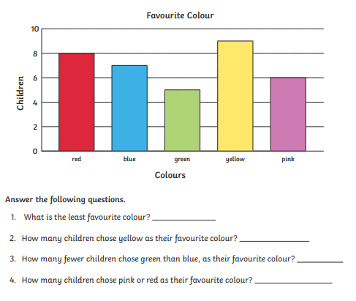
Can you write your own question about the bar chart?
___________________________________________________________________________________________________________________________________

