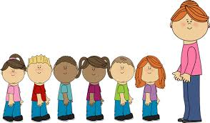

Class 1 Autumn 2021

Autumn

Polar Regions

Phonics

The Leaf Man, Scarecrow’s wedding and Room on the Broom.

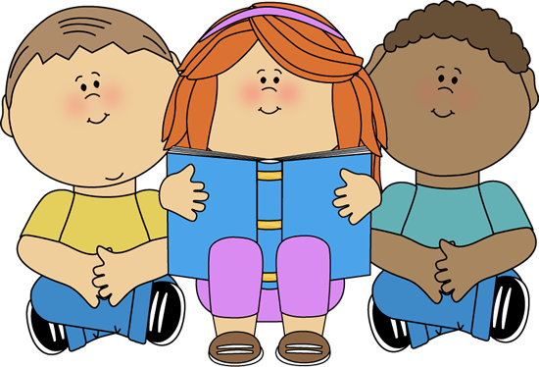

Fine and Gross motor development skills.

Moving with control.

Enjoying physical exercise.

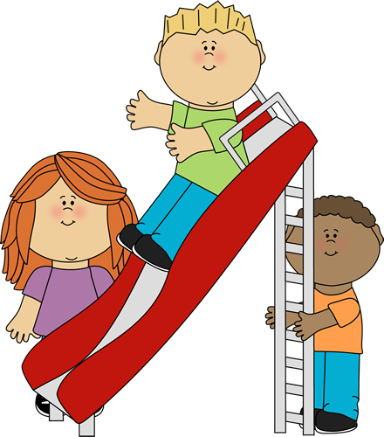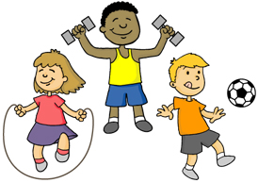

Making myself understood using my preferred means of communication.

Asking for things I want

Interacting with others.

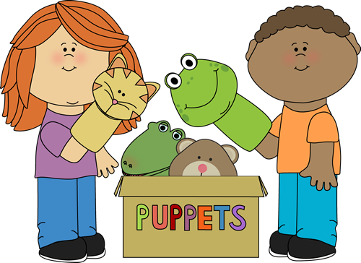

Who am I?

Who are my friends?

How do I feel?

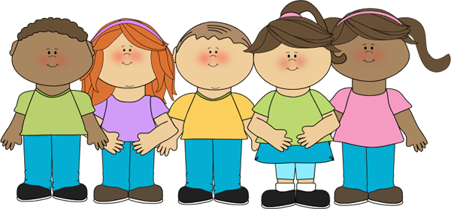

Physical Development

Class 1 Staff

Mrs C Skermer

Mrs G Phillips

Miss H Chadwick

Our curriculum is based on the EYFS strategy. We encourage the children to explore and learn through play.

Learning and recognising numbers.

Counting and adding

Naming and recogising shapes.

Naming and recognising colours.

Communication and language.

Singing songs

Exploring how instruments work

Mark making with different materials.

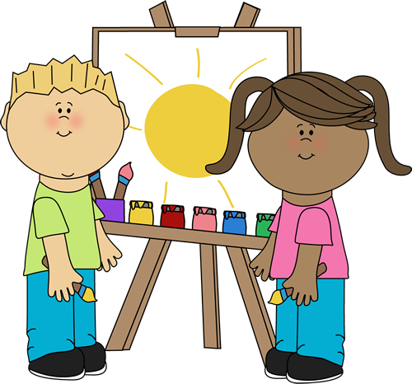

How does outside change with the seasons?

What animals live in cold places?

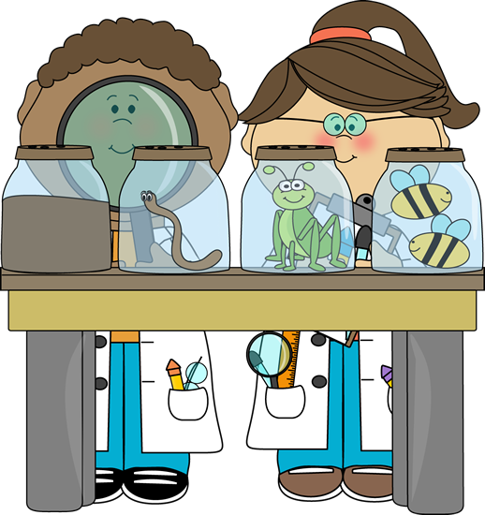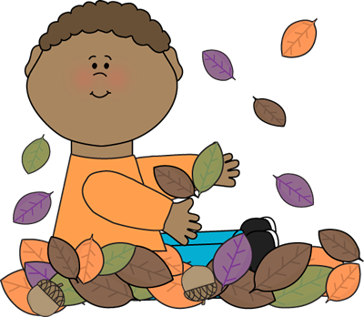

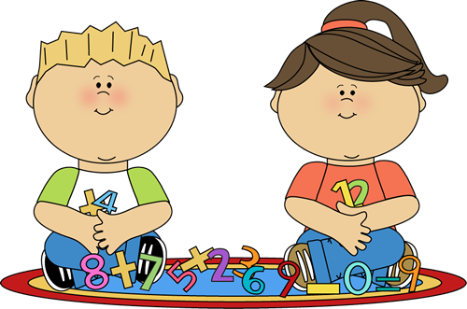

Personal, Social and emotional development.

Expressive Arts

Knowledge and understanding of the world.

Mathematics

Literacy

A Unique + Positive + Enabling = Learning and

child relationships environments development