Royal visitor flies into Birchwood to judge cooking contest – Woolston Sixth Form College takes first place

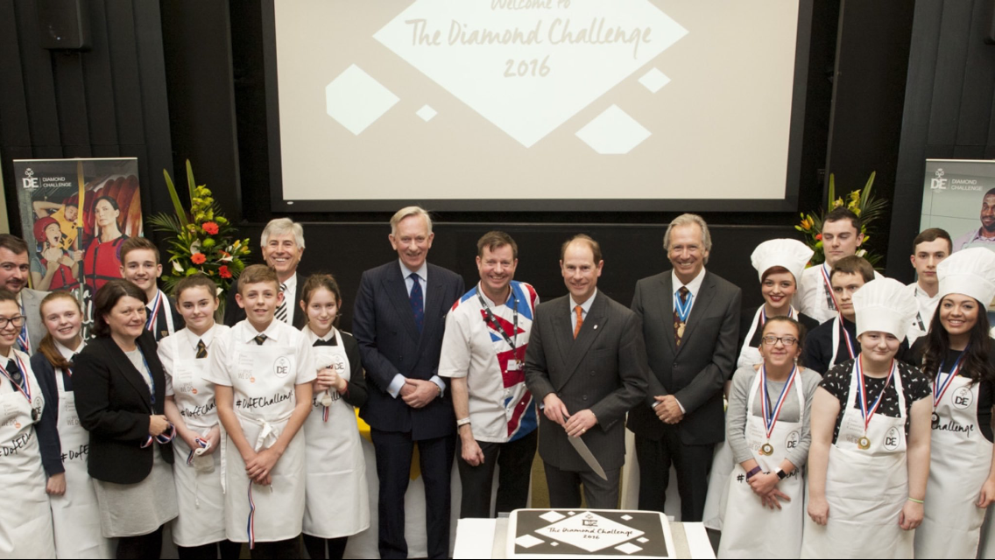
Woolston 6th Form College students got to meet His Royal Highness Prince Edward when he judged their cooking skills at a celebration for the Duke of Edinburgh Award’s 60th anniversary. The event, at the headquarters of Dine Contract Catering in Birchwood, is just one of the challenges organised to mark 60 years of the Duke of Edinburgh’s Award.
Samantha Harrison and Christopher Long were part of the welcome party that greeted the Prince, while our Head girl, Nissa Flexmann Smith, presented Prince Edward with a commemorative apron to mark the event.
Lois Inskip and Jack Chadwick from college joined students from Birchwood Community High School, Penketh High School and apprentices from Dine Contract Catering in Birchwood and members of the Duke of Edinburgh Award team to battle it out by cooking the best chicken noodle salad in 10 minutes.
The Earl of Wessex was joined by celebrity chef Andrew Nutter and Cheshire High Sheriff, Bill Holroyd, as they judged the dishes cooked by five teams in a ‘Ready, Steady, Cook’ competition.
Woolston 6th Form College took first place and Neil Bothwell said: “This event highlights all the fantastic work we have been doing over the past two years as part of the Duke of Edinburgh Award.”

