Topics

Coding

Online safety

Spreadsheets

Questioning

What do we remember on rememberance Sunday?

Languages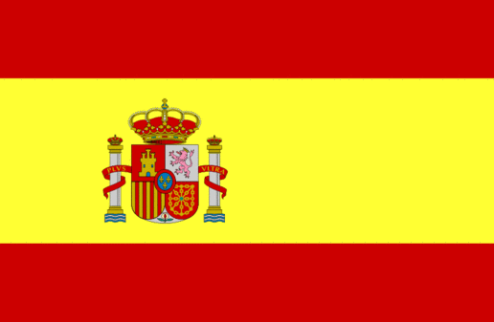

Topics

My spanish passport

Numbers to 5

Spanish Christmas

Computing

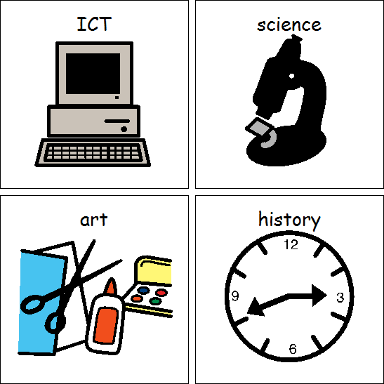

Maths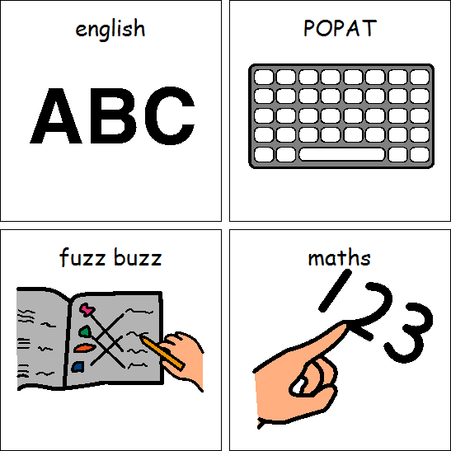

Topics

Number

Measurement

Shape & Space

What makes me special?

Emergency Services

What do people in our school/community tell us about god?

Celebrations

English



Topics

Significant Author

Non-chronological report

POPAT

Letters and sounds

Playground swings

Image

DT

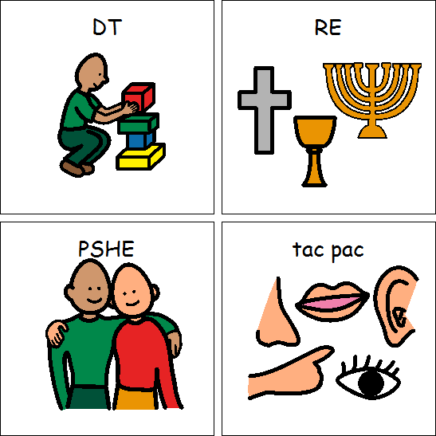

ART



PSHE

RE

Dance

Gymnastics

PE

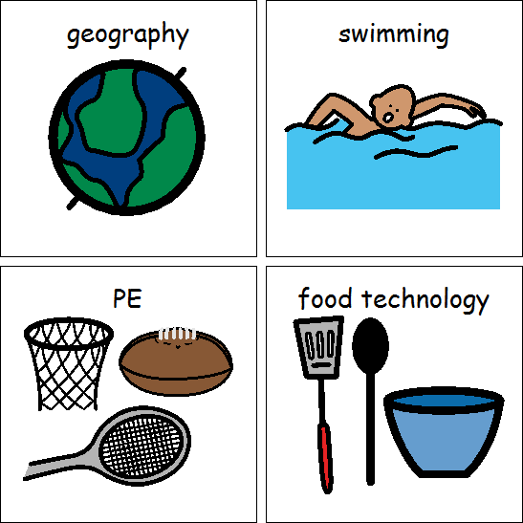

Animals

The human body

Science



England and Ireland

Geography

History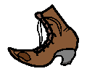

Class 4 Autumn 2018