 | 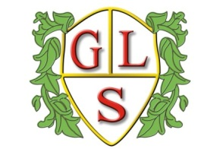 | Paul King  Headteacher  Joanne Mullineux  Deputy Headteacher
ORDER FORM FOR SCHOOL UNIFORM
Please send cash or cheque with your completed order. Thank you.

SIZES

Child Size |  | Adult Size
Age: 3/4 |  | Small 36/38
Age: 5/6 |  | Medium 40
Age: 7/8 |  | Large 42/44
Age: 9/11 |  | Ex Large 46
Age: 12/13 |  | Ex Ex Large 48/50
Age: 14/15 |  | Ex Ex Ex Large 52

ITEMS AND PRICES (£)

 | Child size | Adult size
SWEATSHIRTS (red) with school logo | £11.00 | £14.00
POLO SHIRTS (white) with school logo | £9.00 | £12.00
FLEECE JACKET (red) with school logo | £14.00 | £17.00
CARDIGAN (red) with school logo  JACKETS (red) with school logo | £12.00  £28.00 | £15.00  £30.00
BASEBALL CAP (red) with school logo | £4.50 | £5.50
WOOLEN HAT (red) with school logo | £5.00

CHILD’S NAME _______________________ CLASS __________
ITEM | SIZE | QUANTITY | PRICE | TOTAL
 |  |  | GRAND  TOTAL | :

Please send cash or cheque with the order,
cheques payable to “Green Lane School”. Thank You!

