Grand Final Fever at Green Lane!
Grand Final fever swept Green Lane as staff and children celebrated a ‘wear your colours’ day in recognition of tomorrows Super League Grand Final between Warrington and Wigan.
Staff and children were resplendent in their respective shirts and there was a big surprise in assembly when Wolfie and Mighty Max appeared to join in the festivities!
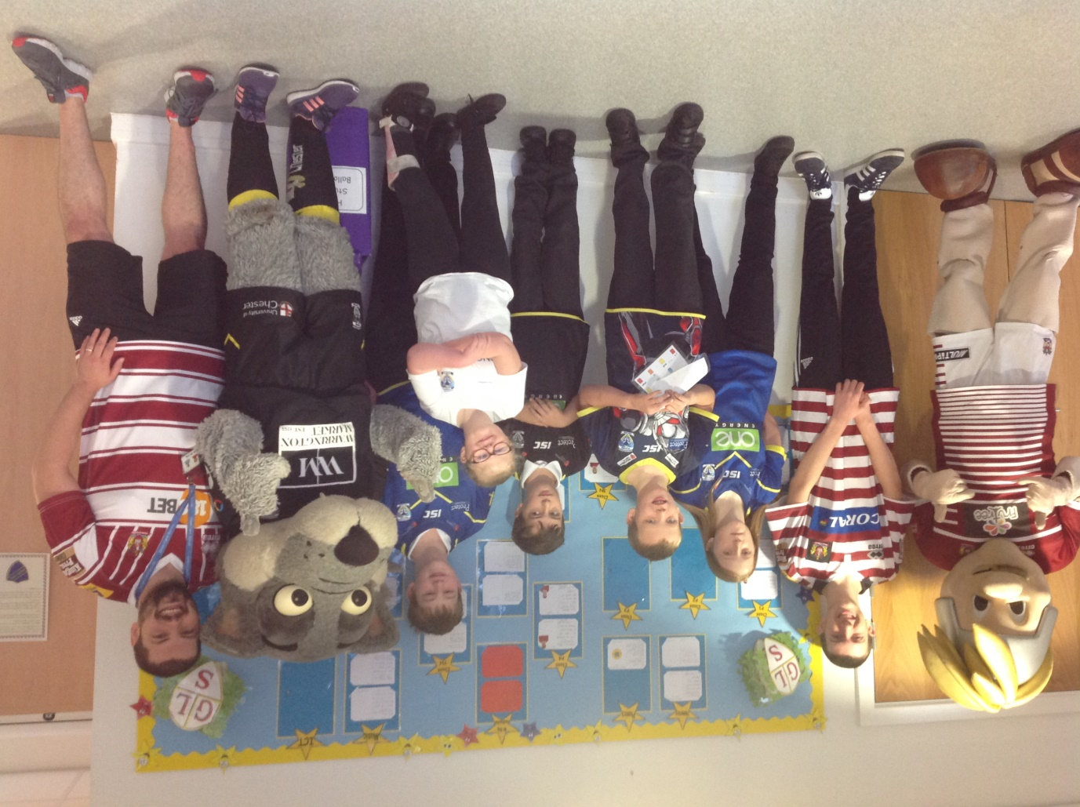
Kick off for the big match is tomorrow at 6pm!

