Home Learning Activities Class P1
Maths (3 days)  https://classroom.thenational.academy/subjects-by-year/year-3/subjects/maths  Follow this link and try some of the lessons on fractions.  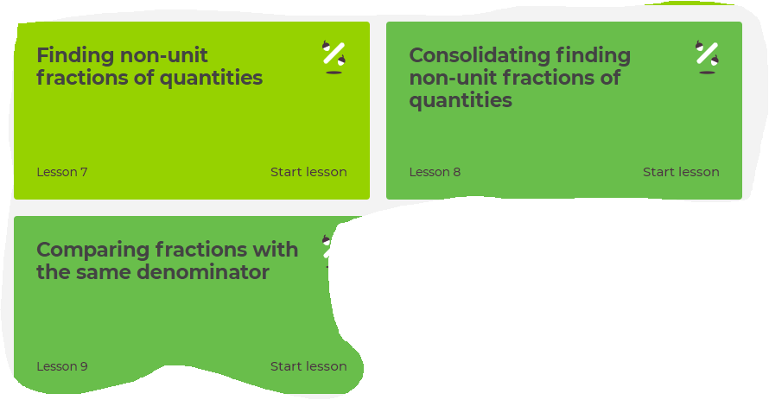 |  |  | Maths  Visit Maths Workout, Maths Whizz or Maths Warm Up and do 1 hour of activities.  (same as last week) | Maths  Find as many different ways as you can to make 250.
English (3 days of work)  https://classroom.thenational.academy/subjects-by-year/year-2/subjects/english  This week I would like to follow on from the Oak Academy lessons we did last week about the firework maker’s daughter.  I would like to try these lessons. It is all about writing recount texts. These lessons are sort of a build-up to writing the recount. Once again, this is aimed at Year 2 but I think the pitch is about right. Plus you get an actual teacher teaching you!  The screen should look like this:  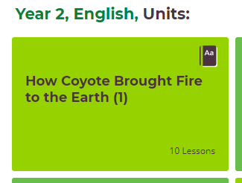 |  |  | English  Keep a daily diary of your time at home. What did you do today?  (continue from last week- this is an ongoing task) | English  Read some of your book  (continue from last week- ongoing task)
PSHE  Go on to BBC Newsround. There are a lot of different stories. Watch some of the videos or read some articles and spend some time researching this topic. |  |  | PSHE  Telephone/facetime a friend and have a chat.  (keep as a weekly task) | PSHE  Play a game with someone in your house.  (ongoing task)
PE  https://www.youtube.com/watch?v=wBdMZMEKq-s  Try some ‘cosmic yoga!’ | PE  Try the daily Joe Wicks PE lesson on You Tube | PE  How many of something can you do?  For example, how many keepy ups can you do with a football, how many bounces on a trampoline can you do in a row before getting tired? How many times can you thrown or bounce a ball without dropping it?  *KEEP THIS ACTIVITY FROM LAST WEEK- CAN YOU IMPROVE ON YOUR TOTAL?* | PE  Do a circuit – 20 star jumps, 10 press ups, 20 tuck jumps, 30 second wall sit. Repeat 3 times.  Keep this routine from last time BUT- can you add an extra 10 reps to each exercise?  Or, if you follow a physio programme, do some of the moves from it. | PE  Lift some weights. Use real ones if you have them or if not, use tins! Do exercises you have learned!  Continue from last week- can you do more repetitions than last week?
ART  https://www.twinkl.co.uk/resource/t-c-1551-mindfulness-colouring-sheets-bumper-pack  This takes you to a huge pack of mindful colouring sheets. | Geography  Research a European country of your choice | History  As we are learning about the Romans, have a llok at some of the Horrible History videos on YouTube | SCIENCE  Giant Squid!  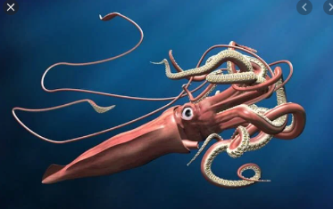  Can you find out as many facts as you can about these amazing creatures! | COMPUTING  Using e-safety rules, stay in touch and chat to your friends for an hour or two each day.  Continue from last week- it is important to maintain good relationships with friends.

****Grown-ups- please remember, do not put yourselves under lots of pressure to try and complete everything on this sheet. Do what you feel you can. If there is one particular area of interest, then do more on that and less on the other bits. I know how busy you all are in these strange times! Stay safe!****

