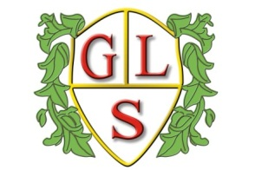
Class P1 Topics Spring Term 2022

Maths
Graph work, statistics and measures

English
Work on our class novel and selection of stories

Science
Life cycles and Energy

History
The Victorians

Geography
Greenwich Meridian and time zones

ICT
E safety and multi media

Design Technology
Textiles: how things fasten (spring 1) and ‘Ways with Potatoes (spring 2)

Spanish
Numbers to 40 and Spanish alphabet

Art
‘Journeys’ and ‘Animal art’

PSHE
‘Being successful in relationships’ and ‘Coping with Peer Pressure’

PE
Judo and Rounders

