P2 Spring Term 2018/19

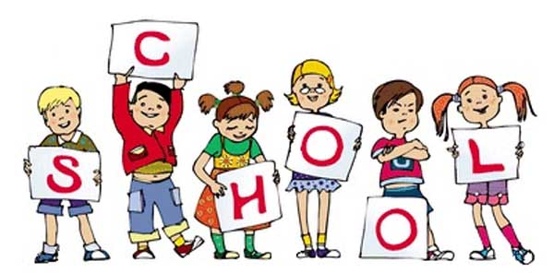

P2 staff Ms K.White

Mrs K.Dickson

Mrs L. Stewart (Wed)

Miss S.Beechall (a.m)

**Topics**

Money.

Recognising coins, Amounts & change,

Shopping/Bills.

Fractions.

Shape – Properties.

Angles, Pattern & Symmetry

Reflections

& Rotations

**Topics**

Class Novel – Billionaire Boy by David Walliams.

Spelling, Guided Reading,

Guided Writing, Handwriting.

Speech and language work.

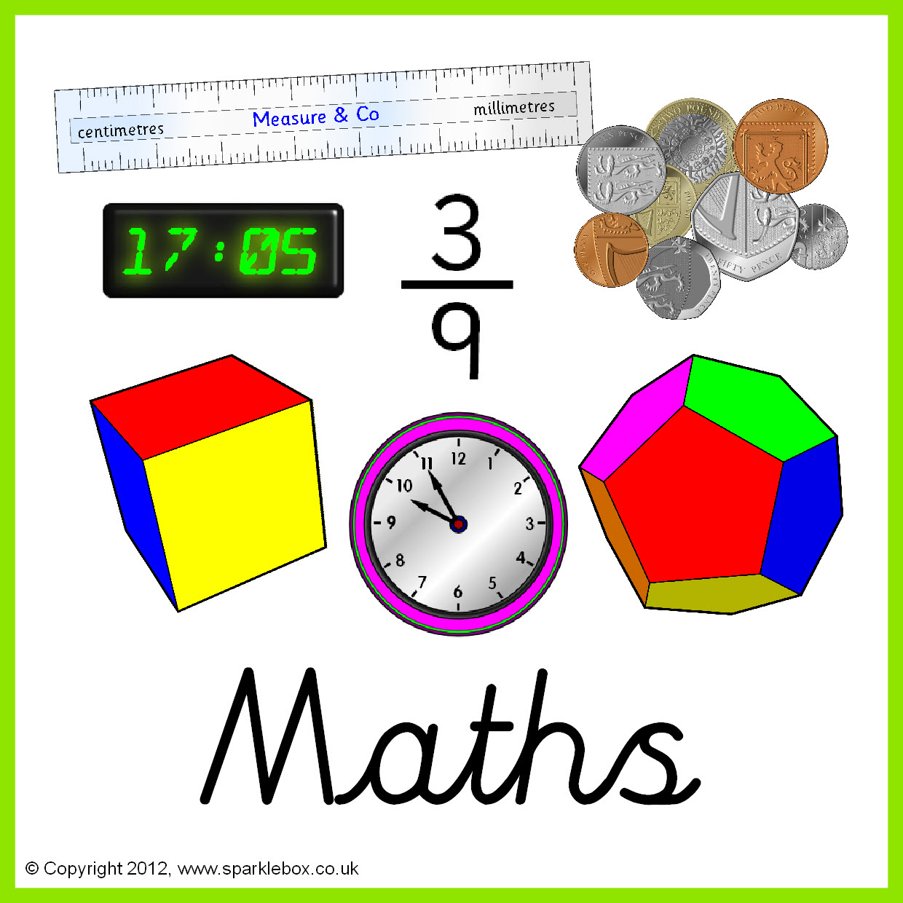

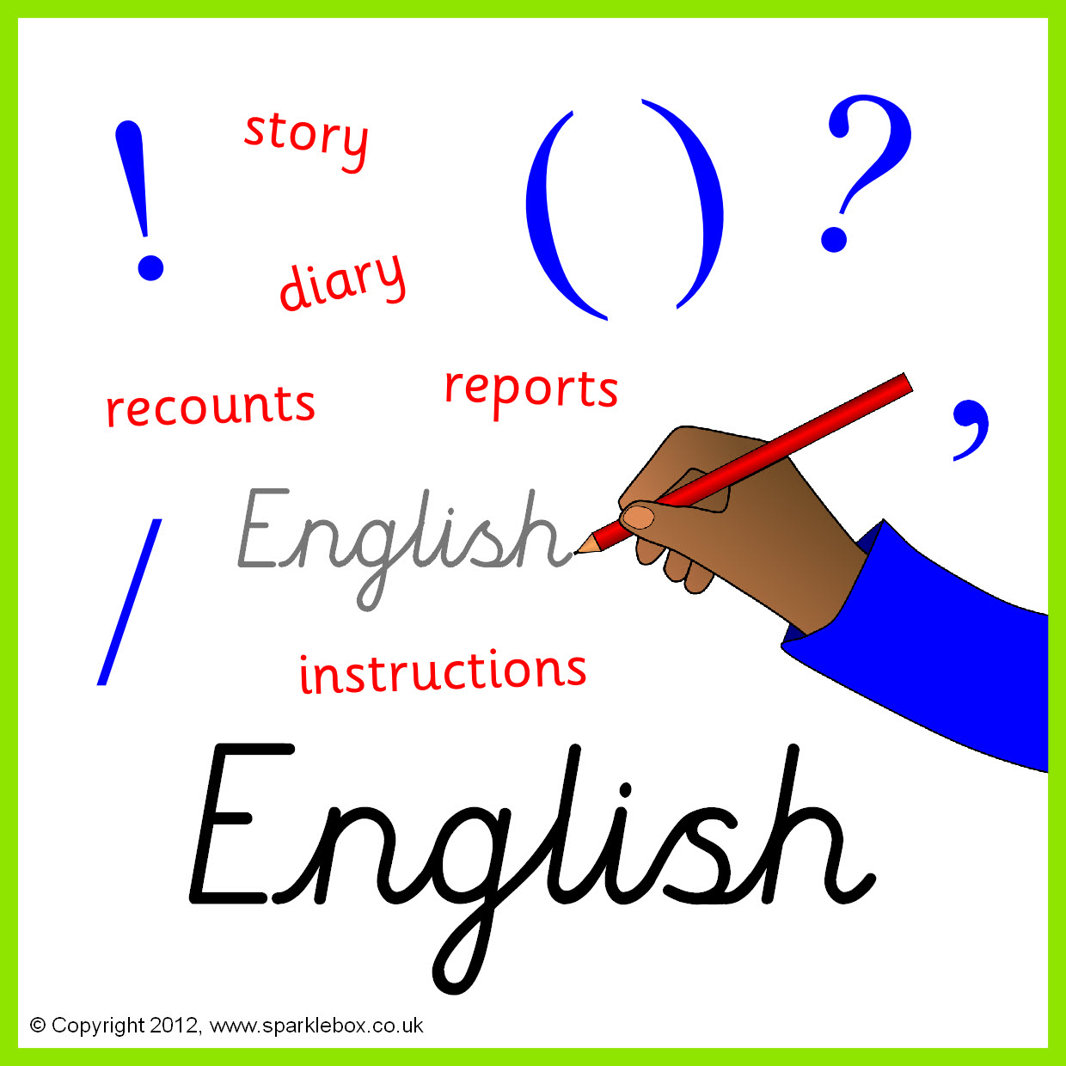

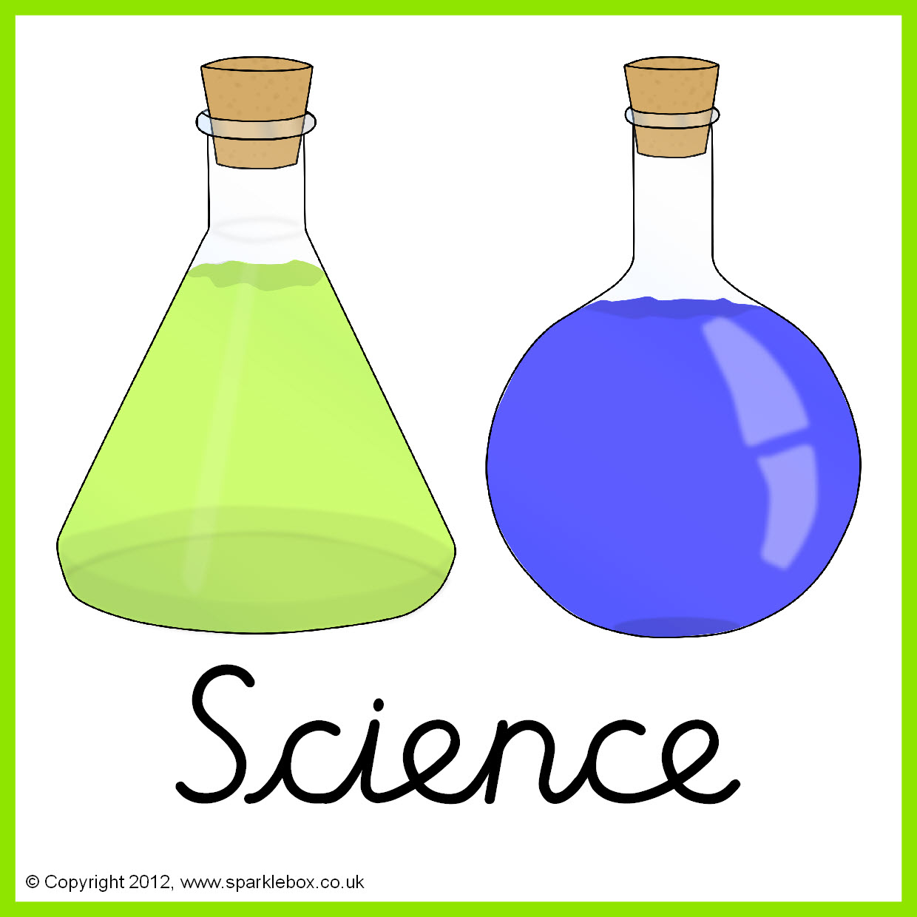

**Topics**

Changing Sounds and sound waves.

Types of rocks and rocks for different jobs.

**Topics -** Taught by D. Taylor

Spreadsheets and basic skills.

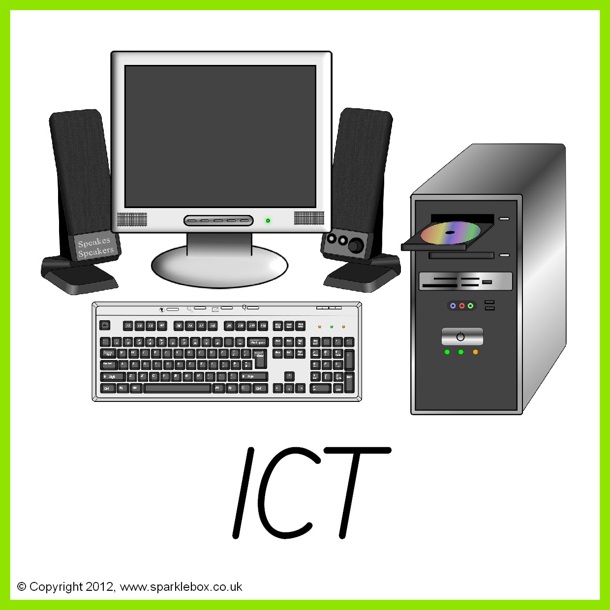

**Topic** Taught by L. Fernyhough

Island Life.

Continents and famous landmarks around the world.

**Topic** -Taught by L. Fernyhough

Journeys – Aboriginal art.

Crazy Creatures inspired by Tim Burton.

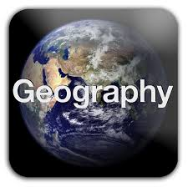

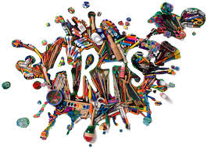

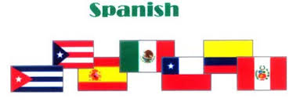

**Topic**-Taught by L. Fernyhough

Numbers to 20 – How old are you?

Spanish instruments and music.

**Topic** -Taught by L. Fernyhough

Places – Britain’s settlement by Anglo-Saxons and Scots.

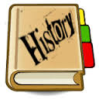

**Topics**

Sacred texts – Torah, Buddhist scriptures.

Can words have power?

**Topics** Taught by M.King

Gymnastics.

Games.



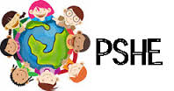

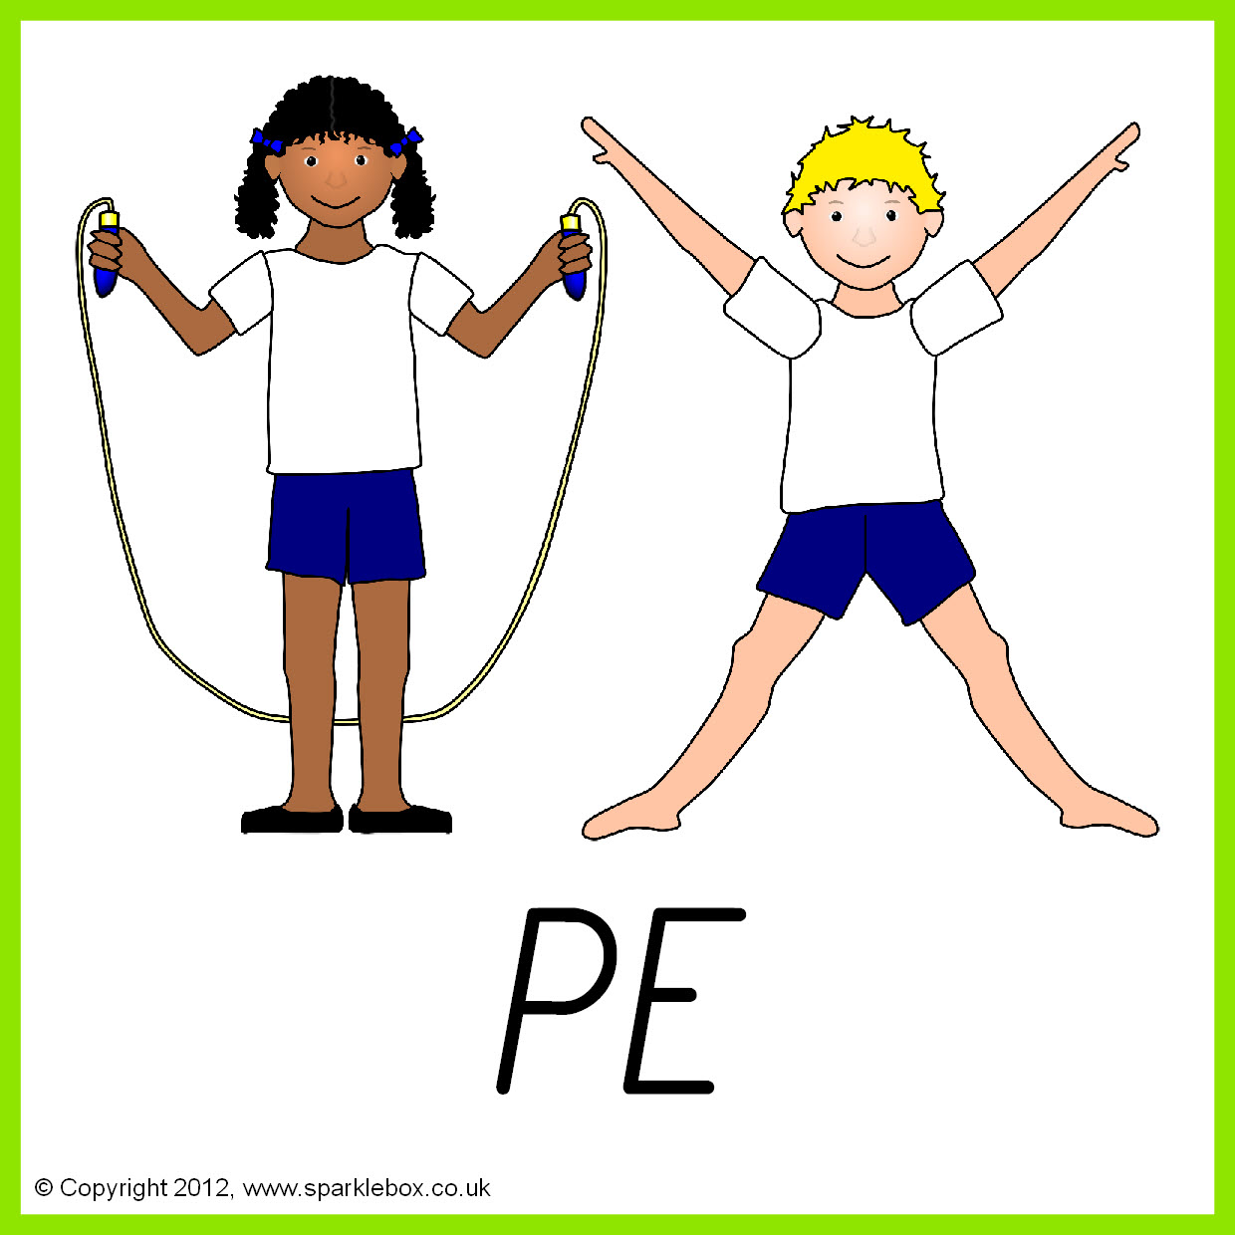

**Topic**

Citizenship, Nationality.

Democracy and the political system.

.

**Topic** Taught by A.Davey

Making jewellery.

Meals in minutes.

