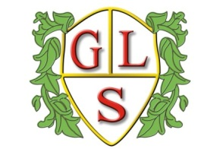
Class 2MC Topics Autumn 2021

Science
How are Everyday Objects Made?
Living Things and their Habitats

History
The Sinking of the Titanic

Geography
Cardiff

ICT
E Safety
What is a Computer?
Multimedia: Photographs/Text

Spanish
Numbers to 20: number games
Days of the week/Spanish Christmas

RE
The Church
Celebrations- Christmas

Art
Matisse

Design Technology
Where food comes from- Grains bread/cakes

PSHE
Bullying and staying happy
My body- Personal boundaries and saying no

PE
Warrington Wolves Foundation

