P2 Spring Term 2022

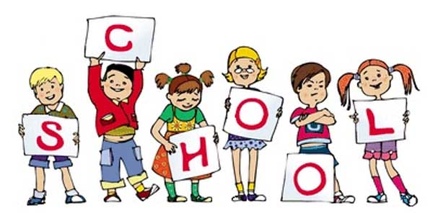

P2 staff

Ms K.White

Mrs K.Dickson

Ms J.Forrest

**Topics**

**Spring 1 -** Multiplication and Division strategies, written methods and problem solving. Measures including time.

**Spring 2 –** Measures including money and change. Fractions. Recognising, ordering and fractions of amounts.

**Topics**

**Spring 1 –** Class Novel

**Spring 2 –** Class Novel

Billionaire Boy – David Walliams.

**Ongoing** - Spelling and Phonics, Guided Reading, Guided Writing, Handwriting.

Speech and language work.

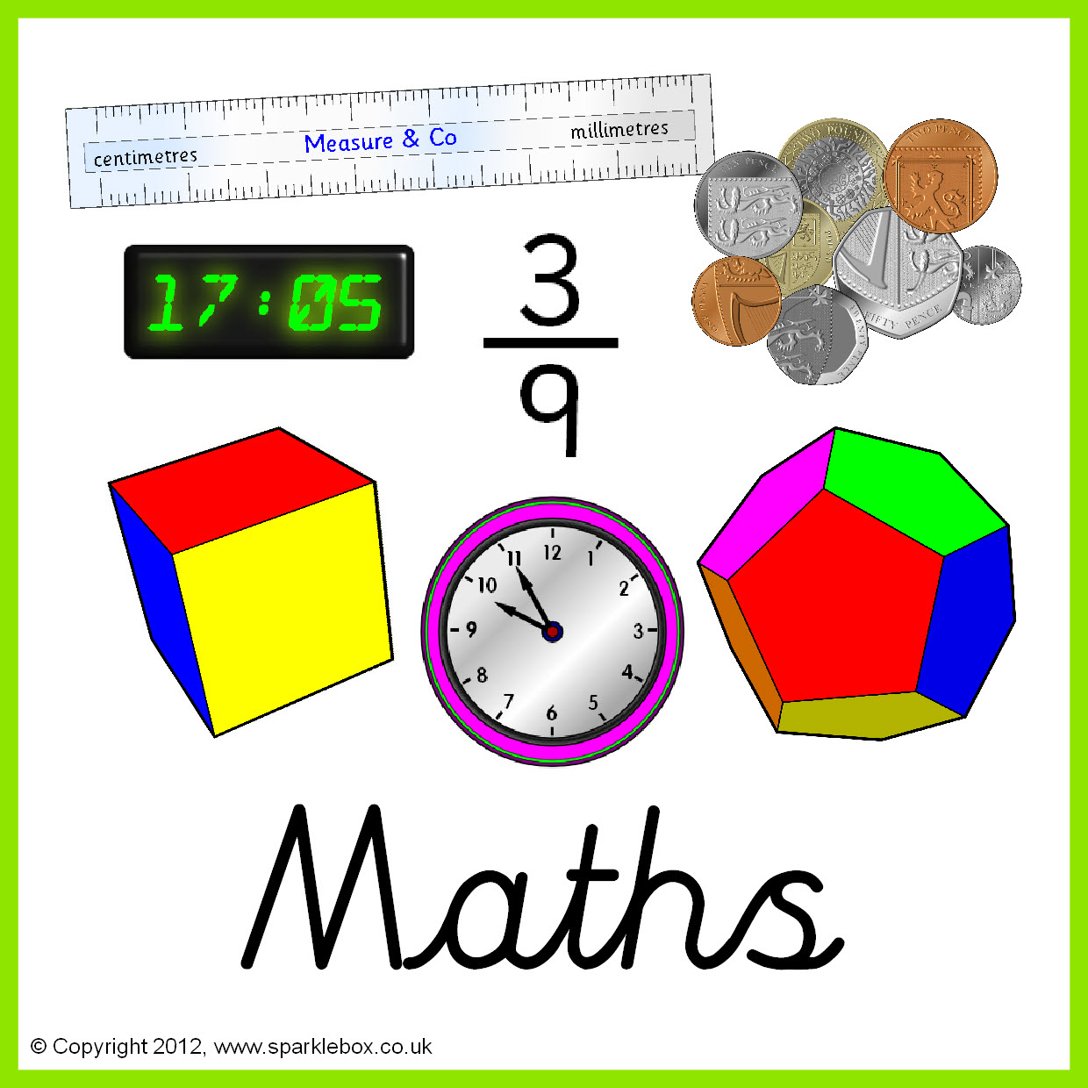

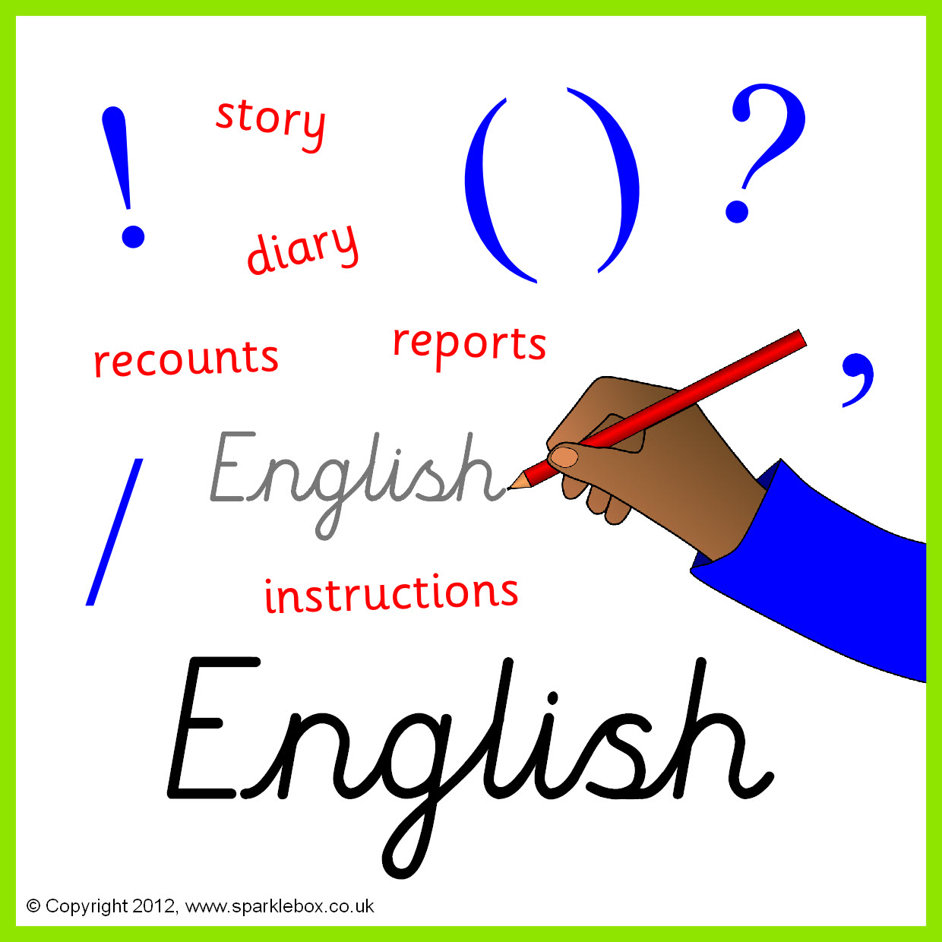

**Topics**

**Spring 1** - Lifecycles and reproduction (mammals, amphibians, insects and birds).

**Spring 2** – Energy. Physical Processes.

**Topics**

**Spring 1** - E-safety and Data.

**Spring 2** - Multimedia: Photos; Sound & Music; eBooks.

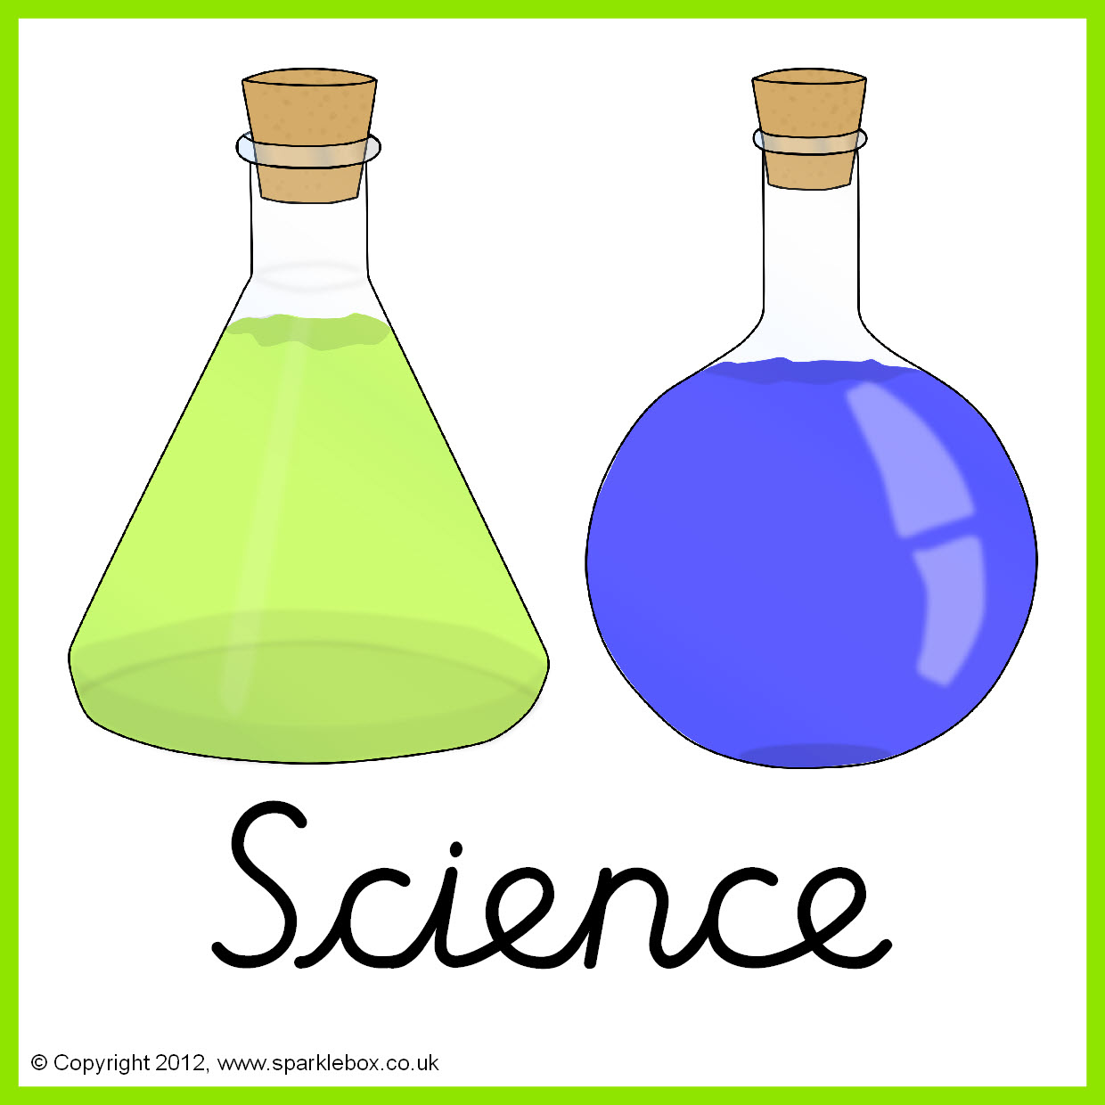

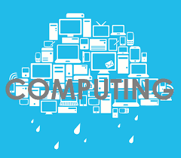

**Topics** - Taught by L. Fernyhough

**Spring 1 –** Famous landmarks around the world.

**Spring 2 –** Exploring Scandinavia.

**Topics** – Taught by L.Fernyhough

**Spring 1 –** Journeys through traditional and contemporary Aboriginal artists.

**Spring 2 –** World of animals.

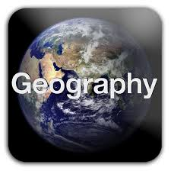

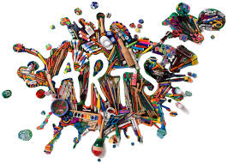

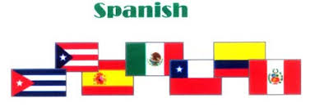

**Topic** -Taught by L. Fernyhough

The Anglo-Saxon invasion.

**Topics**

**Spring 1** - Numbers to 25- How old are you? How are you?

**Spring 2** – Spanish instrument/music. Months of the year.

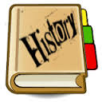

**Topics**

**Spring 1** – Gymnastics

**Spring 2** – Basketball

**Topics**

**Spring 1** – Creation: Creation stories from different religions.

**Spring 2** –Places of worship and the Easter Story.

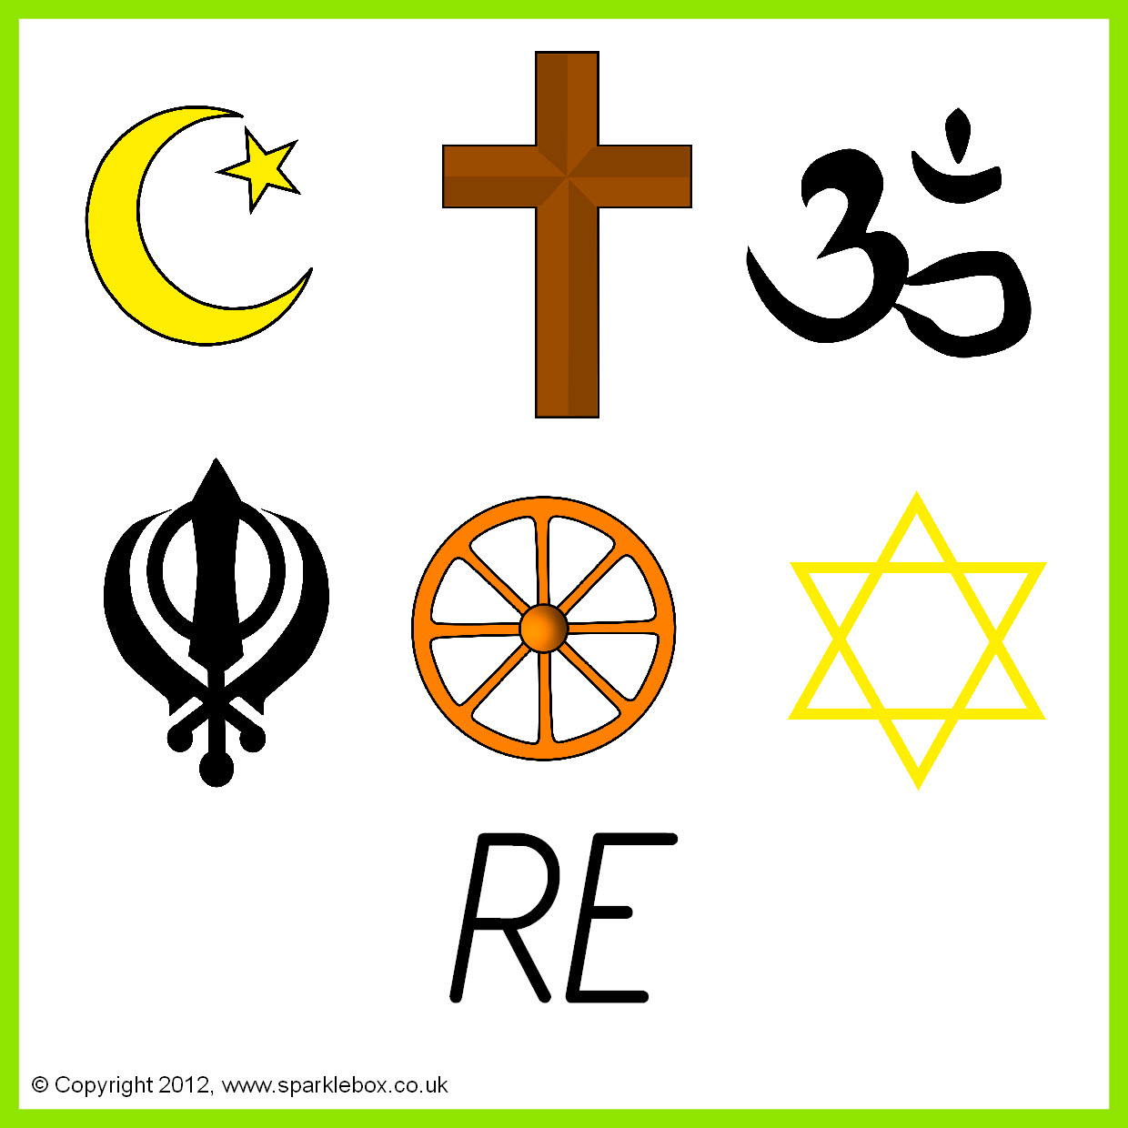



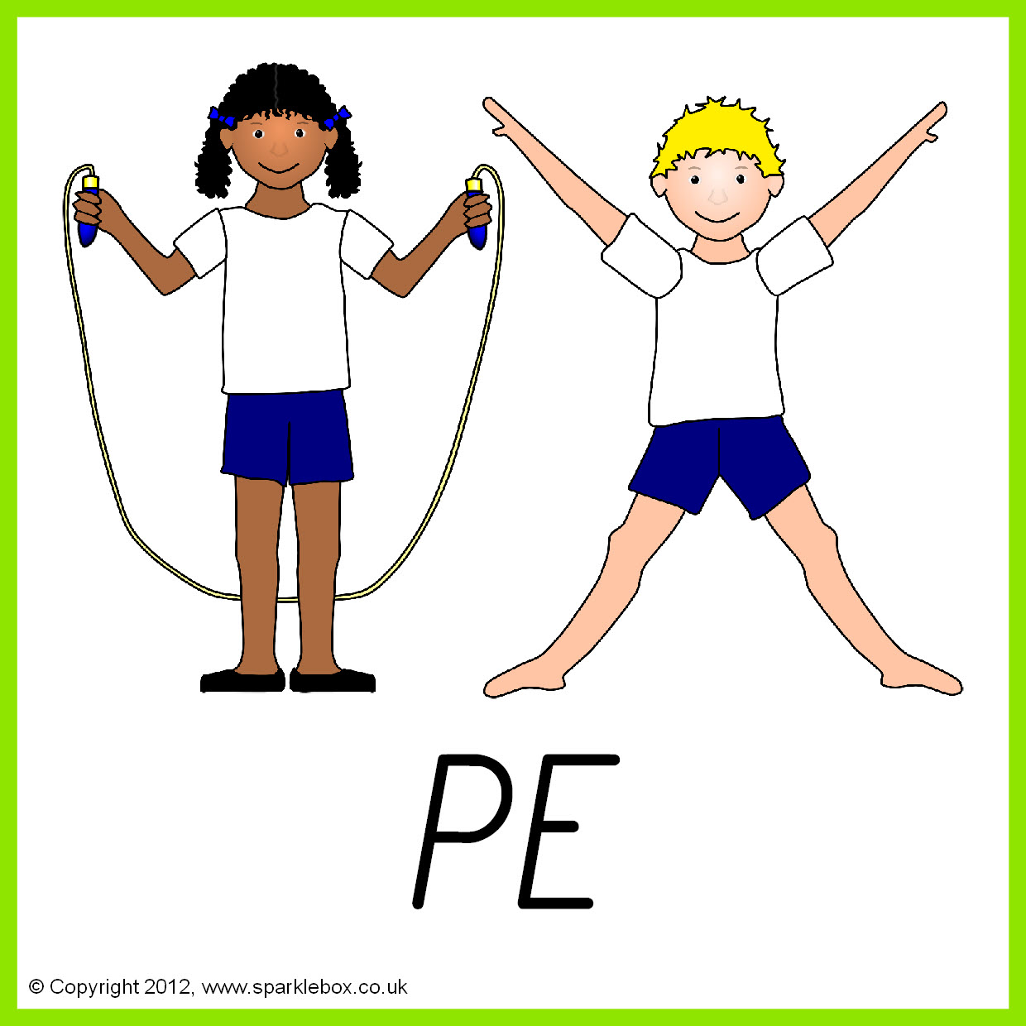

**Topics**

**Spring 1** – Textiles, how things fasten.

**Spring 2** – Potatoes

**Topics**

**Spring 1** – Relationships with others.

**Spring 2** – Being safe in relationships.

.

