Class 3N 2020/21

Using PECS/ Makaton to make requests.

Identifying naming words and action words.

Learning to listen.

Initiating communications.

Making choices.

Learning to cooperate with others.

Learning to communicate.

Learning to self-regulate.

Communication and language.

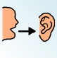

Personal, Social and emotional development.



POPAT / Letters and sounds.

Nursery rhymes, songs, stories, non-fiction books, cultural stories, traditional tales. Enjoying books.

Developing fine and gross motor skills.

Using the O.T. room / sensory room.

Developing mark making skills.

Literacy

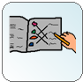

Physical Development

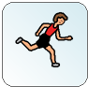

Colours of nature

Celebrations

Sea creatures

Growing food

Trees, leaves, forest animals

Animals that live in a zoo

Zoo Animals

Numbers, counting, making amounts.

Shapes, colours, patterns, position, coins, sorting, size.

Knowledge and understanding of the world.

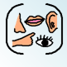

Mathematics

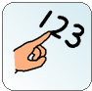

Mixing and using colours.

Using different tools and media.

Moving to music.

Making music.

Using my senses.

Colours

Celebrations

Under the sea

Plants and flowers

Woods and Forests

Zoo Animals

SCERTS

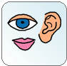

Expressive Arts

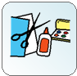

A Unique child + Positive + Enabling = Learning and

relationships environments development