Green Lane School

Health & Safety Guidance

2023

Contents
What is health and safety? 3
Staff responsibilities 4
Key Staff 6
Medication Team 7
First Aid 8
Manual Handling 9
Fire Safety 10
Bomb and Lockdown Management 13
Risk assessments 14
Working at height 15
Appendix 1 HSA1 17
Appendix 2 HSA4 23
Appendix 3 Cause for Concern 26
Appendix 4 Five Ways to Save a Life 27
Appendix 5 Adult CPR 28
Appendix 6 Recovery Position 29
Appendix 7 Burns and Scolds 30

What is health and safety?
- Health and safety is the responsibility of all members of staff, and is vital to keep staff, pupils and visitors safe from harm
- We must consider health and safety needs in school, out of school, and for particular pupils
- We must consider health and safety as part of curriculum planning
- All staff must be familiar with relevant policies (e.g. health and safety, first aid) and risk assessment procedures
- Schools have a statutory duty to consider health and safety

Key Legislation:
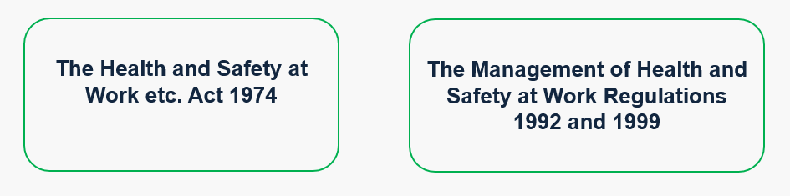
School requirements:
We must …
  - Have a named ‘competent person’
  - Comply with legislation (including in our policy)
  - Regularly review and update risk assessments
  - Train staff
  - Keep clear records of injuries and accidents

Staff responsibilities
All staff must:
- Read the school Health and Safety Policy
- Participate in the school’s risk assessment process and comply with findings
- Report any defects in the condition of the school or equipment of which they become aware
- Report all accidents/incidents in accordance with procedures
- Be familiar with the procedure to be followed in the event of a fire/emergency
- Make use, where relevant, of personal protective equipment provided for safety or health reasons
- To follow all relevant codes of safe working practice which apply to the school
- To report any unsafe working practices to their line manager IMMEDIATELY
- To use a fob to enter and exit the building, making sure that the door is firmly closed so that pupils cannot exit the building
- Inform the Site Manager if you are working late (lone working)
- Be familiar with fire evacuation procedures

Annual paperwork to be completed by class teachers and updated as needed:
- Classroom Risk Assessments
- Individual Pupil Risk Assessments
- Personal Evacuation plans (PEEPs)

Near Misses and Cause for Concern
Near miss: an event not causing harm but has the potential to cause injury or ill health.
- In the case of a ‘near miss’, report the incident to SLT. A call to the parent may be made at this stage – but only after consent from SLT.
- If you spot a ‘near miss’ you must complete a ‘near miss’ form (HSA4 – see appendix 2) so it can be investigated.
- Any general causes of concern please complete a cause for concern form (see appendix 3).
Health and safety in the classroom
Always keep an eye out for potential health and safety hazards in school. You can help mitigate these by:
- Keeping things tidy
- Regularly testing electronic equipment
- Reporting injuries, accidents and near misses as soon as possible
- Keeping an eye out for wear and tear
- Having a ‘walk, don’t run’ policy indoors

Health and safety in the curriculum
All subjects may have health and safety hazards. When planning, think about:
- How physically demanding the activities are
- The need for any special equipment
- The need to handle sharp objects and/or hazardous materials

Mitigate risks by:
- Teaching pupils how to use equipment safely
- Supervising risky activities closely
- Making sure all physical activity begins with a suitable warm-up
- Having clear medical records and procedures for providing emergency medication (e.g. inhalers)

Health and safety on school trips
Higher risk level is associated with:
- Distance from school
- Type of activity
- Location
- A need for staff with specialist skills
- Individual pupils
There is a clear process for managing trips out
- To plan our trips and visits we use an online system called EVOLVE
- Trips need to be planned at least 2 WEEKS in advance
- A Trip Notification form must be completed
- The Evolve Coordinator is Lynne Ledgard

Key Staff
Premises Manager  Jo Mullineux (HT) | Site Manager  Ian Wilcock
Health & Safety Team

Jo Mullineux (HT)* Ian Wilcock* Lynne Ledgard (DHT)* Tracey Dey (TA)

*Health & Safety Level 3 Trained

*The Health & Safety team meet half termly

Medication Team
In school, staff act in ‘loco-parentis’. Trained members of staff will give medication when required, with the correct information provided.
There are normally 3 sets of circumstances in which staff may be requested by a parent/guardian to give medication to a pupil during school hours:
- Cases of chronic illness such as asthma, diabetes or epilepsy.
- Pupil has a medical condition which requires them to have ongoing medication.
- Cases where a pupil is recovering from a short term illness and is able to return to school but is completing a course of antibiotics/or similar treatment.
All staff administering medication will have received training.
In all cases, parents will be required to complete a medication form giving specific details of the medicine to be given and permission for school staff to administer. Medication should not be given without this.
Medication is stored in locked cupboard or in a locked medication fridge. (This could be in class or the medical room depending on medication)
Staff will sign a form (and have it countersigned) when a pupil is given medication.
If a pupil refuses medication we will notify the parent and try again (no more than twice), paperwork will be signed and countersigned each time.
Any medication that is no longer required will be sent home for safe disposal at a pharmacy.

Medication Team Members:
Julie Barker | Stacy Beechall | Emma Bourque | Hayley Chadwick* | Jo Milnes
*Hayley Chadwick also has responsibility for:
Monitoring expiring medication, updating the medication pupil list, overseeing medication paperwork, writing, updating and distribution of care plans, booking medical training (supported by Stacy Beechall).

First Aid
The correct action to be taken should there be an accident to a pupil whilst on school premises is as follows:
- Seek the assistance of the qualified First-Aiders. There are posters around school detailing these First Aiders.
- Report to SLT. A call to the parent may be made at this stage – but only after consent from the SLT.
- Accidents are recorded on behaviour watch. There is an accident book kept in reception to record accidents for any visitors or contractors.
- As a rule ALL head injuries, no matter how trivial, should be reported and a head injury letter/phone call should be sent home to parents/carers.
- If any person goes to hospital as a result of an accident then an HSA1 form (see appendix 1) will need to be completed as soon as possible and given to the Headteacher or Deputy Headteacher.
- First Aid Boxes are kept in the staff room, the medical room, the kitchen and are carried by the first aiders. If it is found necessary to take a pupil to hospital for treatment, the Headteacher or Deputy Headteacher and the parent(s)/carers to be informed. If it is a serious injury then the Ambulance Service must be contacted immediately by calling 999.
First Aiders (Paediatric first aider):
Stacy Beechall | Hayley Chadwick | Emma Davies
Lisa Donnelly | Andrei Lipovan | Jo Milnes | Aimee Robertson
Claire Robinson | Kit Sherratt | Ian Wilcock* | Hannah Williams
*Responsibility for checking the defibrillator, ordering and monitoring expiry dates of first aid stock.

Manual Handling
- You must use manual handling equipment to move, carry, push and pull objects where it is provided.
- Contact the Site Manager (Ian Wilcock) if you would like any heavy object to be moved in your classroom.
- You must carry out a risk assessment before all medium and high risk handling activities.
- In case of any injury, please make sure to inform your line manager.

Manual Handling Assessors:
Jo Milnes | Megan Roblin (College)

Responsibilities:
- Completing manual handling risk assessments in the work place.
- Creating manual handling plans for pupils when needed.
- Training staff to safely use manual handling equipment.

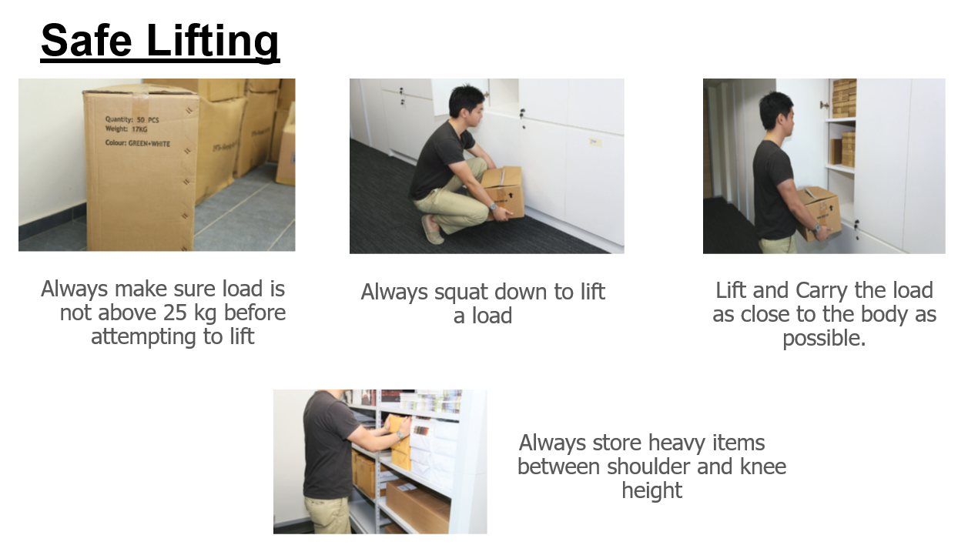

Fire Safety
Fire Drill in School Sequence:
- Activate the alarm system (if it’s not already activated)
- Shout and make noise to alert others to the fire
- Evacuate the building using the nearest exit, making sure children remain calm and quiet
- Keep calm, don’t stop to pick up belongings, and don’t run
- Make your way to the assembly point (KS4 assemble outside the KS4 building, otherwise go to the main school yard)
- Take part in the roll call
- TACKLE THE FIRE only if you are in the position to do so whilst prioritising the safety of pupils and other staff.

Trained Fire Wardens:
Chris Beeton | Luke Bennett | Lesley Fernyhough | Amanda Harrison
Sue Jones | Beth Law | Lynne Ledgard | Jo Milnes
Jo Mullineux | Kerryjane White | Ian Wilcock

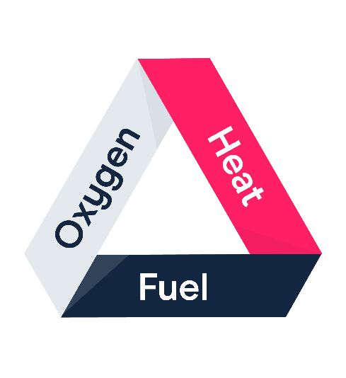
The fire triangle
In order to exist, a fire needs 3 things:
- Oxygen comes from the air around us
- Heat is any source of ignition, e.g. heaters, lighters, cigarettes, electrical equipment
- Fuel is anything that burns, e.g. wood, paper, oil
Most fires are preventable
Housekeeping is vital to minimise the risk of fire. We can all help by:
- Following the ‘no smoking on site’ policy
- Regularly testing electronic equipment
- Keeping fire exits clear
- Keeping rooms tidy with fuel away from heat sources (e.g. paper and heaters)
- Following risk assessments and safe systems of work
Using fire extinguishers
You should only use a fire extinguisher if it’s safe and you feel confident to do so.
Different types of fire should be tackled with different fire extinguishers:
 | Class A (combustible materials) | Class B (flammable liquids) | Class C (flammable gases) | Class D (flammable metals) | Electrical | Class F (deep fat fryers)
WATER (red label)
FOAM (cream label)
DRY POWDER (blue label)
CO2 (black label)
WET CHEMICAL (yellow label)

Remember …
- Most fires are preventable – the best way to fight fires is to prevent them from starting
- If you discover a fire, raise the alarm by shouting and following our procedures
- Always treat fire drills as if they’re real
- Know your evacuation plan
- Use fire extinguishers only if you feel safe and confident to do so

Bomb and Lockdown Management
Bomb Threats
In the event of a bomb threat or suspicious package, you may be given…
- Verbal instruction to evacuate to a different part of the building
- Verbal instruction to evacuate to the sports hall and await further instruction
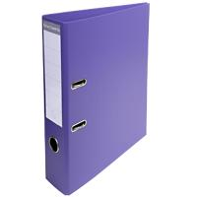
- Verbal instruction to evacuate to an alternative assembly point (500m away)
All these instructions will be made apparent by a repeated phrase
‘Purple folder to (location)’
This will be repeated 3 times – the location telling you where to go to

Lockdown
Lockdown procedures respond to any external or internal incident with the potential to pose a threat to safety of staff and pupils.
There are two types of lock down: full or partial. You will be alerted via the tannoy. All pupils must come inside the building.
Partial Lockdown | Full Lockdown
- Alerted via tannoy  - pupils outside should be brought in as quickly as possible  - Remain indoors and all external doors/windows to be locked  - No one to enter or leave the building  - Teaching can continue but keep pupils and staff within own classroom | - Alerted via tannoy  - pupils outside should be brought in as quickly as possible  - All external windows/doors locked  - Blinds drawn and windows on internal doors covered  - Alert office of any pupils not accounted for this will instigate an immediate search  - Keep pupils calm and in class  - If evacuation is needed then fire alarm will sound  - Staff should await further instruction  - Keep lines of communication open but no unnecessary calls  - Will only be lifted by SLT or Emergency Services

Risk assessments

We have a legal requirement to assess risks and put control measures in place to protect staff, pupils and visitors from harm.
Risks and hazards
- A hazard is something that can cause harm
- A risk is the possibility of that harm happening
- Where possible, we want to remove the hazard. If we can’t, we need to control the risk
Hierarchy of controls
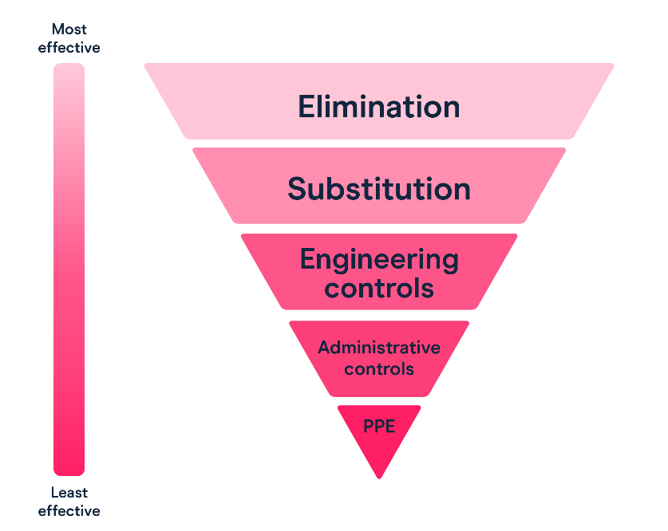
Risk assessment must-haves
- What the hazard is
- What the associated risks are
- What measures have been put in place to minimise the risk
5 principles of good risk assessment
- Identify the hazards (water on the floor, electric wires, etc.)
- Identify who may be at risk of harm (pupils, staff, etc.)
- Put in suitable controls to manage the hazard (e.g. cleaning schedule)
- Document your findings
- Review at suitable intervals (at least annually or more frequently if changes occur) and pass on for SLT for review

Working at height
What do we mean by ‘working at height’?
The risk of falling:
- Off something
- Through something
- Down something
How to work safely at height
- Avoid working at height where you can
  - Do as much as you can from the ground
- Consider if you’re the right person for the job. Think about asking:
  - Your caretaker to handle it for you
  - Someone with specialist training
- Get the right equipment
  - Make sure it’s suitable and stable
  - Minimise the distance and consequences of a fall
- Don’t overload or overreach yourself
  - Make sure you can reach comfortably

Before you use a ladder
Only use it for quick jobs (less than 30 minutes)
Make sure it’s:
  - Level
  - Stable
  - Secure
Check the ladder is safe before you use it

6 things to check before using a ladder
- Check the stiles
- These are essentially the legs of the ladder
- Make sure they’re not bent or damaged as this can cause the ladder to collapse
- Check the feet
- Make sure they’re not missing, worn, damaged or dirty as the ladder could slip
- Check the platform
- Make sure this isn’t split or buckled as the ladder could collapse
- Check it locks in place
- Make sure the mechanism works properly and isn’t bent, worn or damaged
- Check the rungs
- Make sure they’re not bent, worn, missing or loose
- Check the treads on the steps
- Make sure they’re not dirty, slippery or loose

Stay safe while using a ladder
Do:
- Avoid holding items while climbing (i.e. use a tool belt)
- Check the label on the ladder for advisory information
- Grip the ladder and face the rungs while climbing and descending
- Make sure all feet are in contact with the ground and the steps are level
- Try to position the ladder face-on and not side-on if you can (but sometimes if you’re working somewhere narrow, it might be safer to work side-on if the ladder can only be secure that way)
- Make sure you maintain 3 points of contact (2 feet and 1 hand) while using it – if you need to use both hands briefly, make sure your body is supported by the step ladder
Don’t:
- Carry heavy materials and tools
- Overload the ladder
- Try to move the ladder while standing on it
- Work off the top 3 rungs
- Stand ladders on movable/unstable objects

Appendix 1 HSA1
(all forms stored by reception)
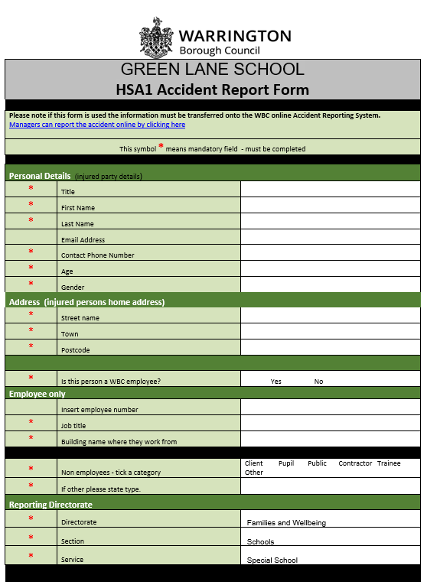
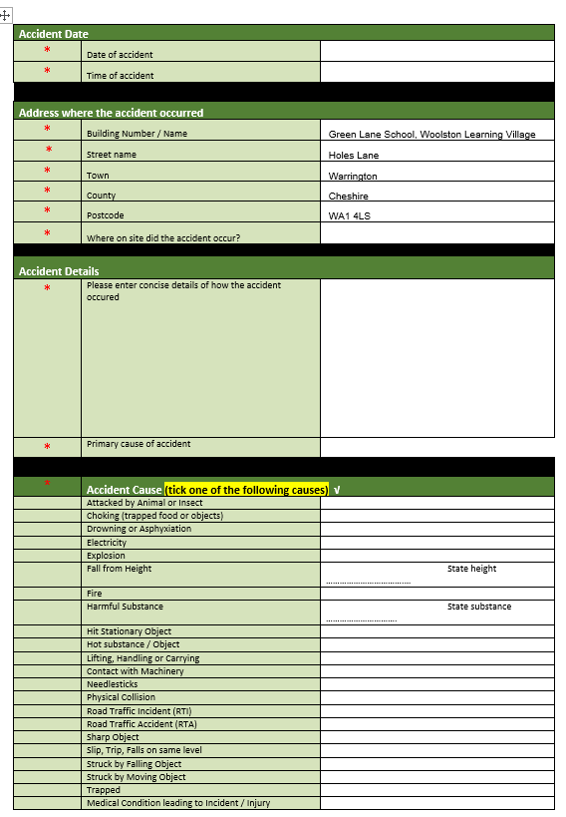

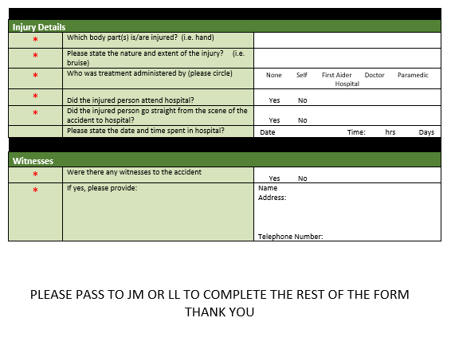

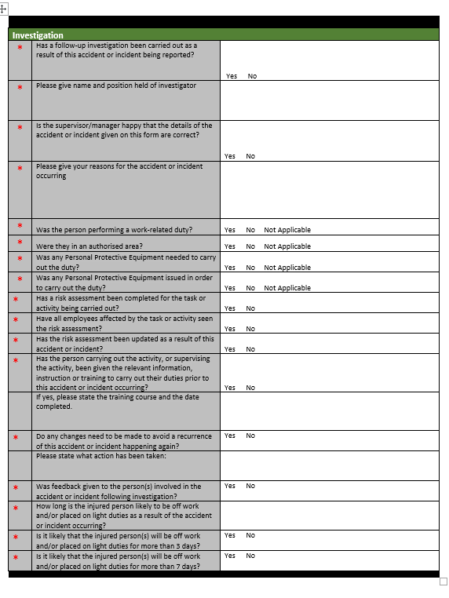
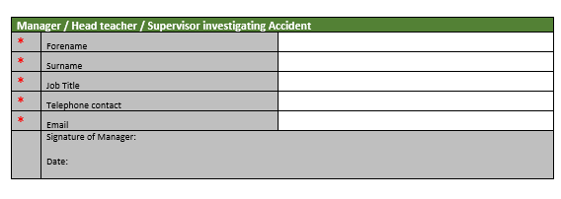

Appendix 2 HSA4
(all forms stored by reception)
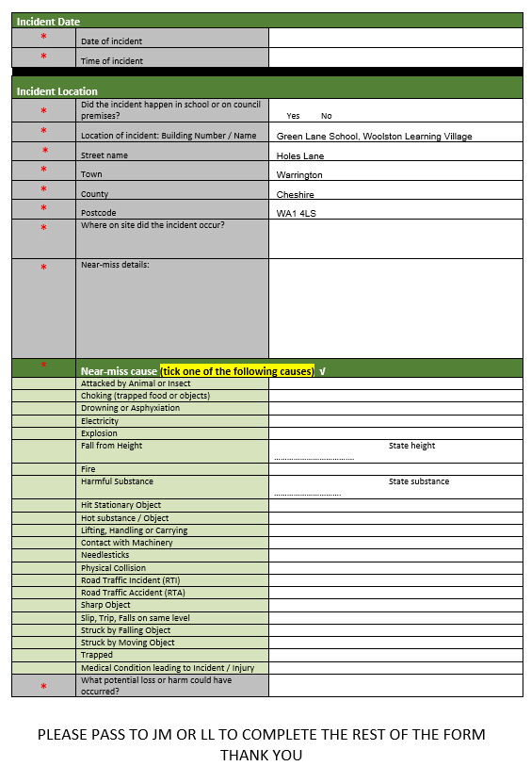
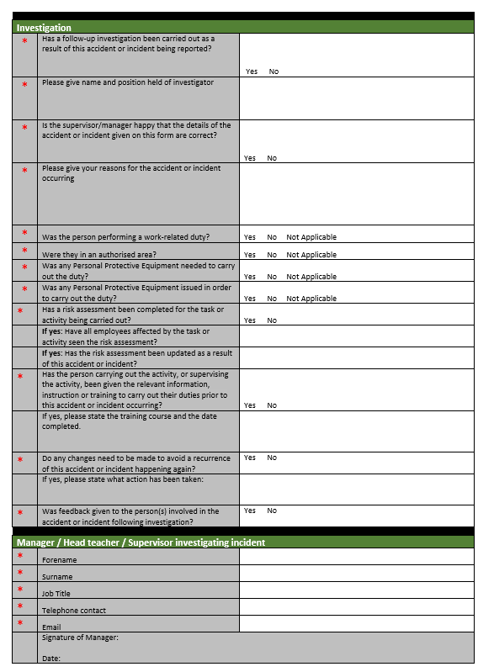

Appendix 3 Cause for Concern
(all forms stored by reception)
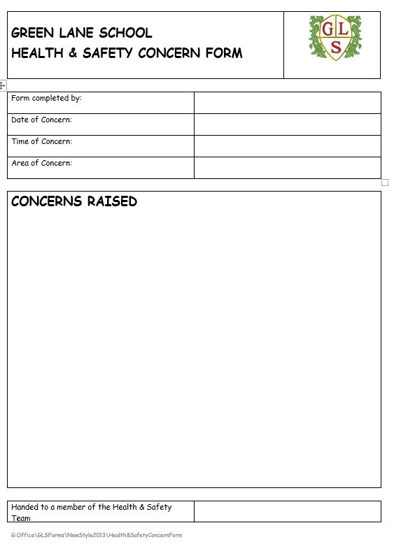

Appendix 4 Five Ways to Save a Life
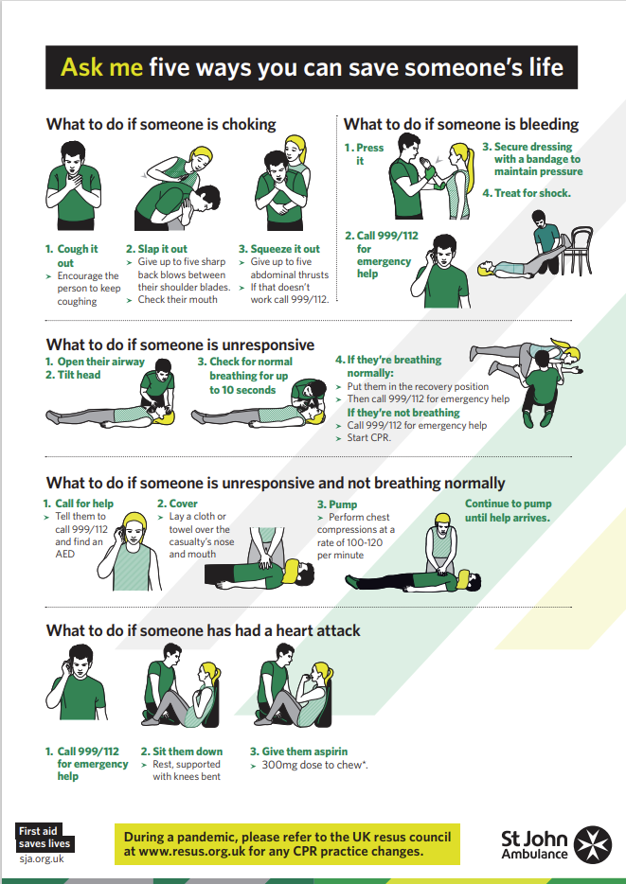

Appendix 5 CPR
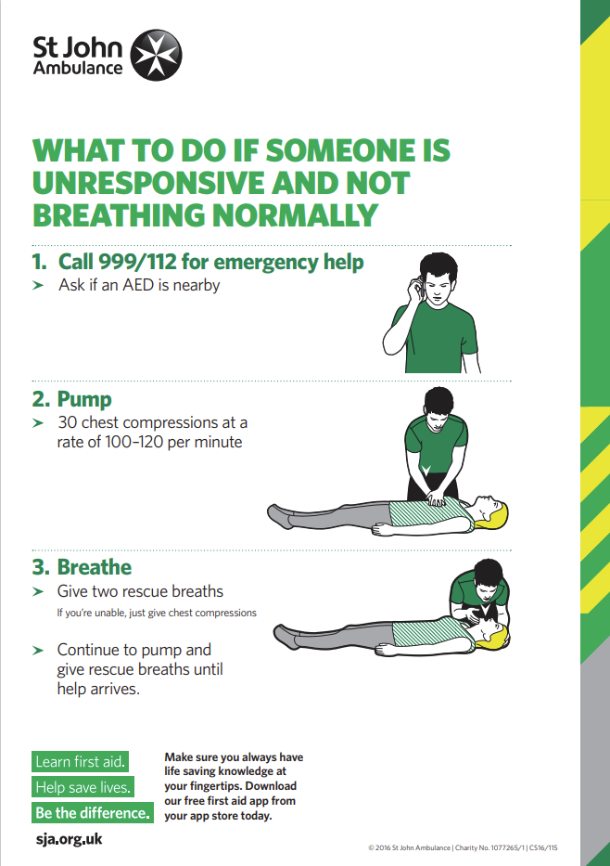

Appendix 6 Recovery Position
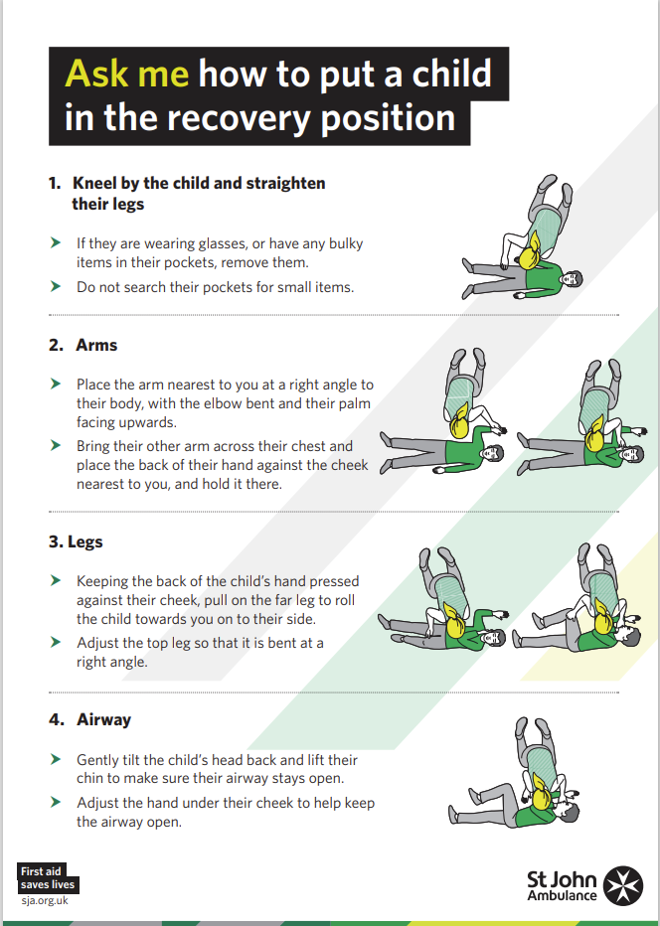

Appendix 7 Burns and Scolds
