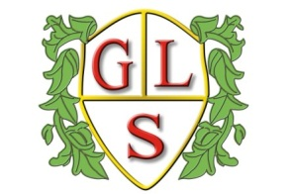
Class Poppy Topics

Spring Term
Overview 2023-2024

Maths
Number
Shape
Measure: Mass & Time
Fractions

English
Newspaper Recounts
Myths & Legends

Science
Rocks in Space
Testing Magnets

Computing
Data
Multimedia: EBooks

History
Holidays through time

Geography
England and Ireland

RE
Christianity: Bible Stories
Christianity: Easter Story

Spanish
Greetings
Numbers to 10

Art
Pointillism

DT
Where food comes from

PSHE
Making choices to stay healthy
Staying safe: saying no to strangers

PE
Wolves Foundation

