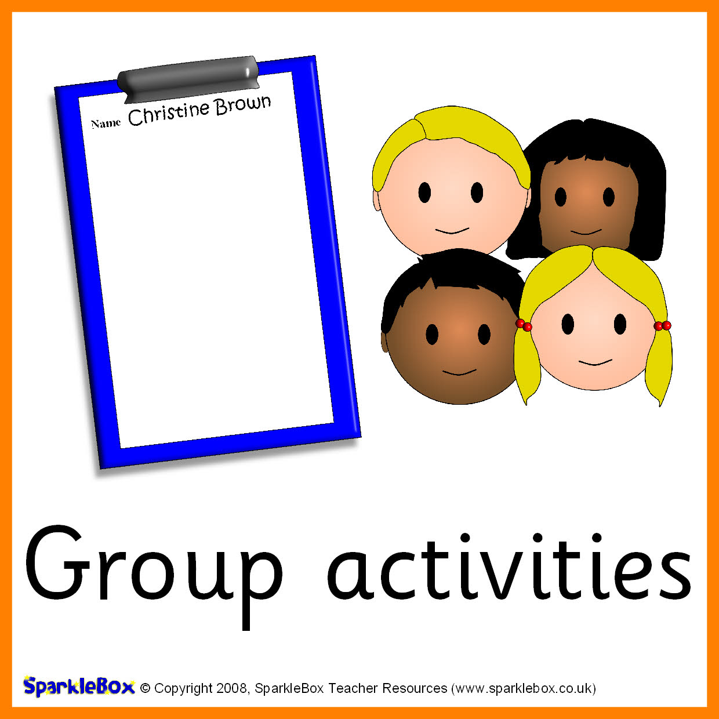

6P Staff
Miss Barnes Mr Gaskell Mrs Dey
Mrs Cronie
Miss Little

Class 6P Topics Summer 2019
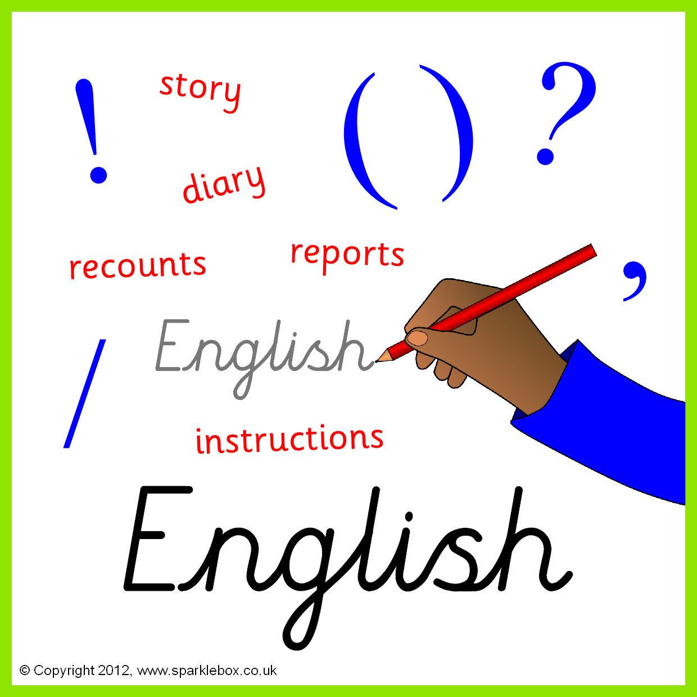

Poetry (Classic narrative)
Recounts: Biographies
Letters and Sounds
Popat
Fuzzbuzz
Visiting the library

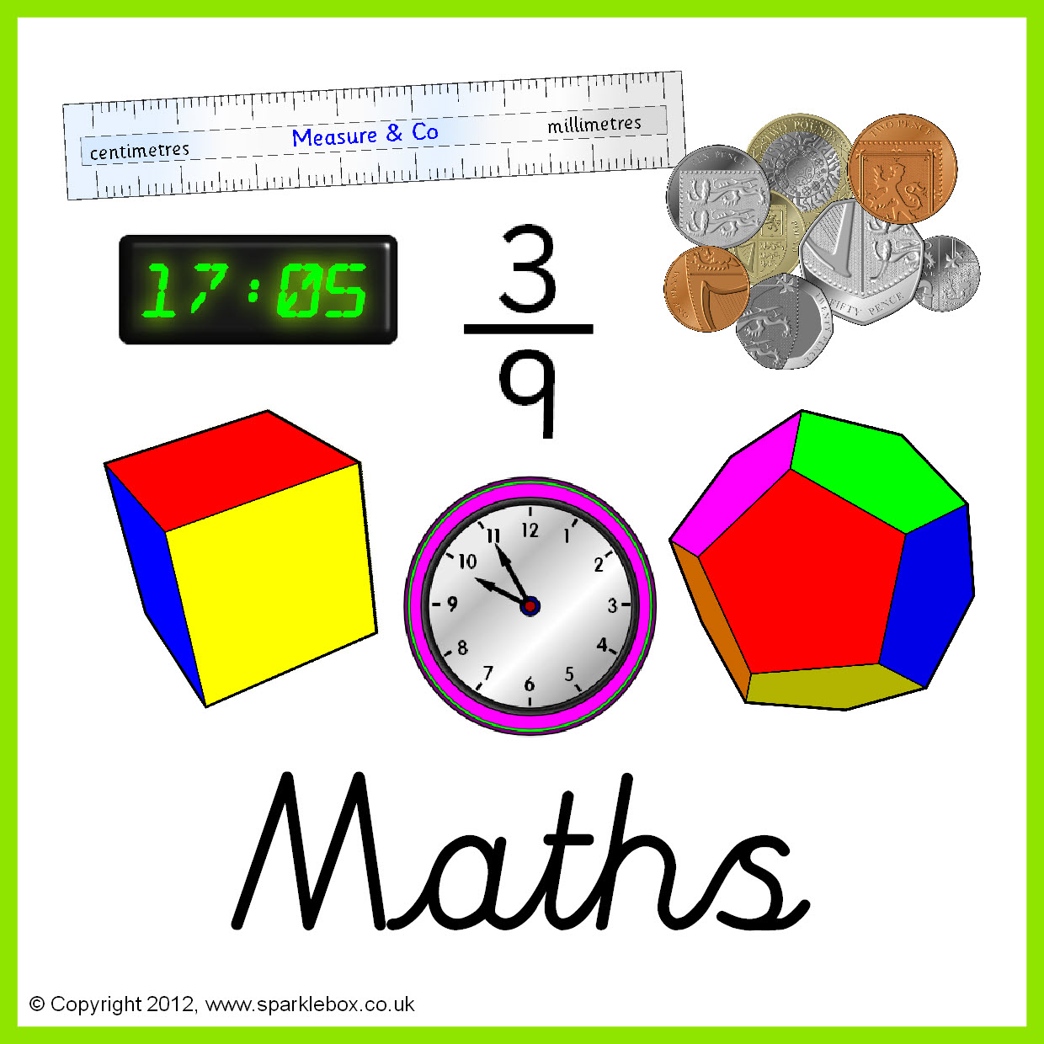

Number
Data handling
3D shapes
Measures

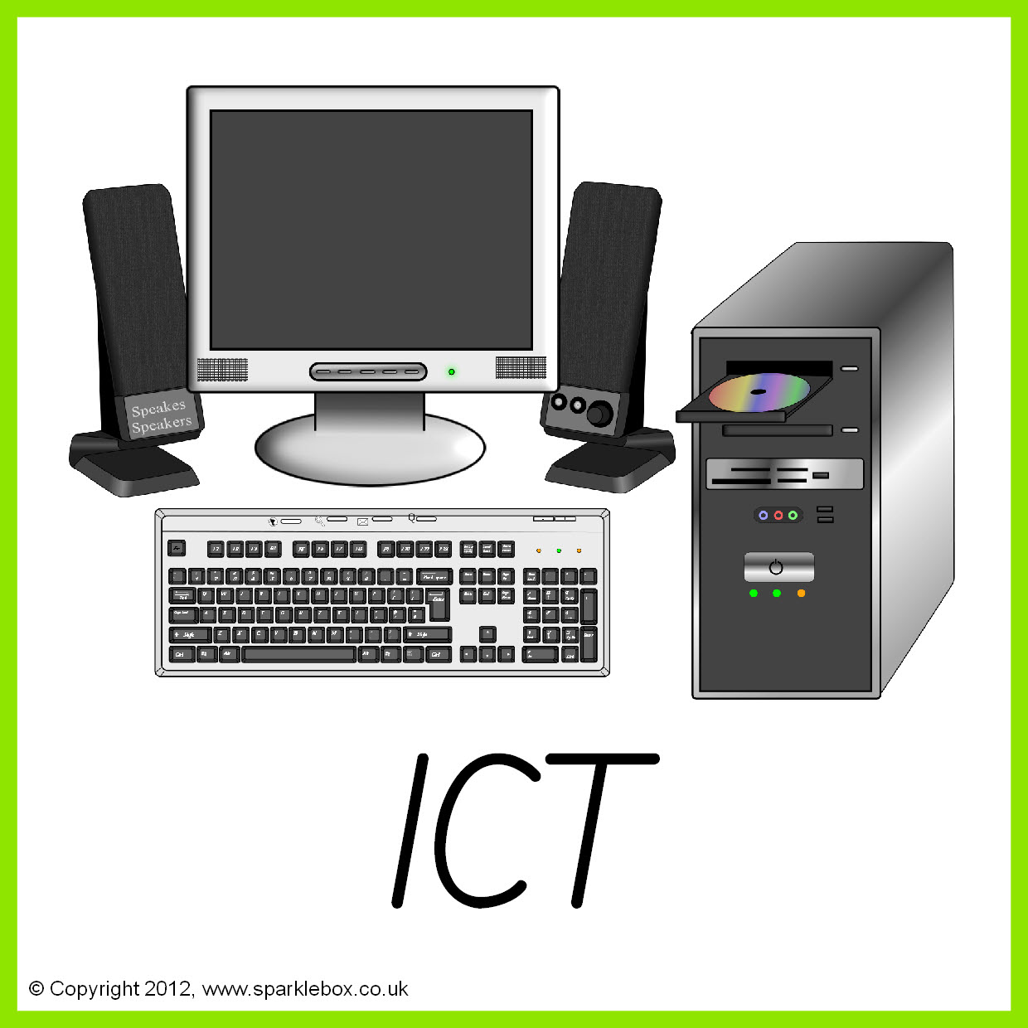



Topic
Watching plants grow
Describing Materials
The world
Exploring & Using Media

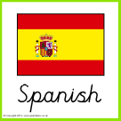

Numbers to 10
Colours- The Spanish flag

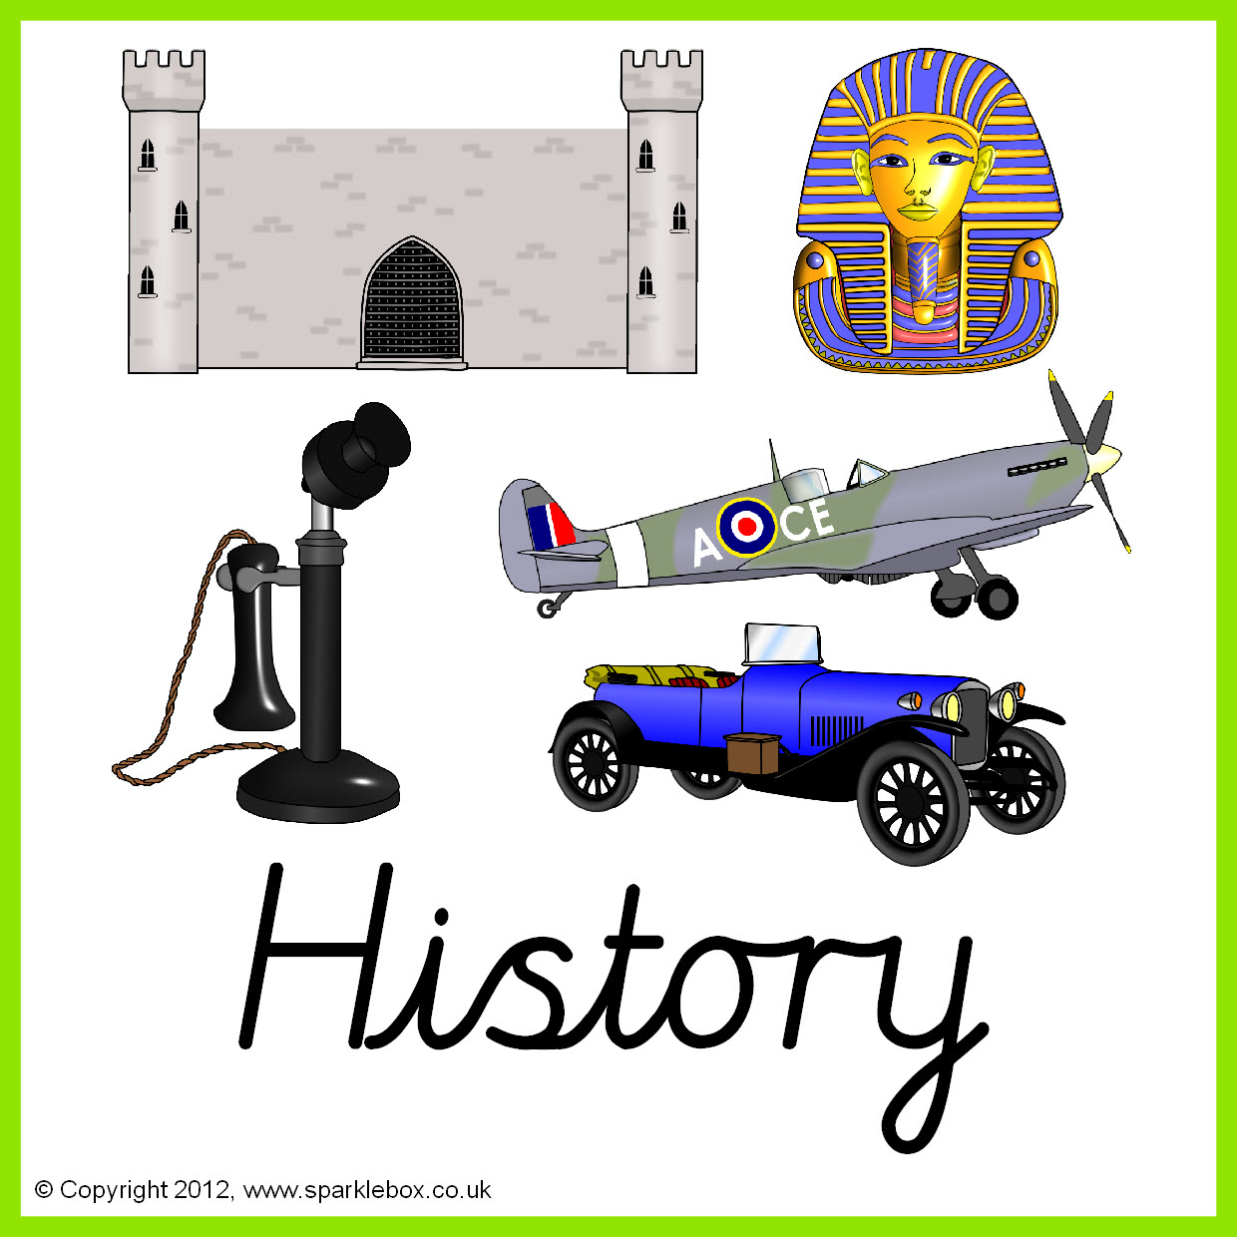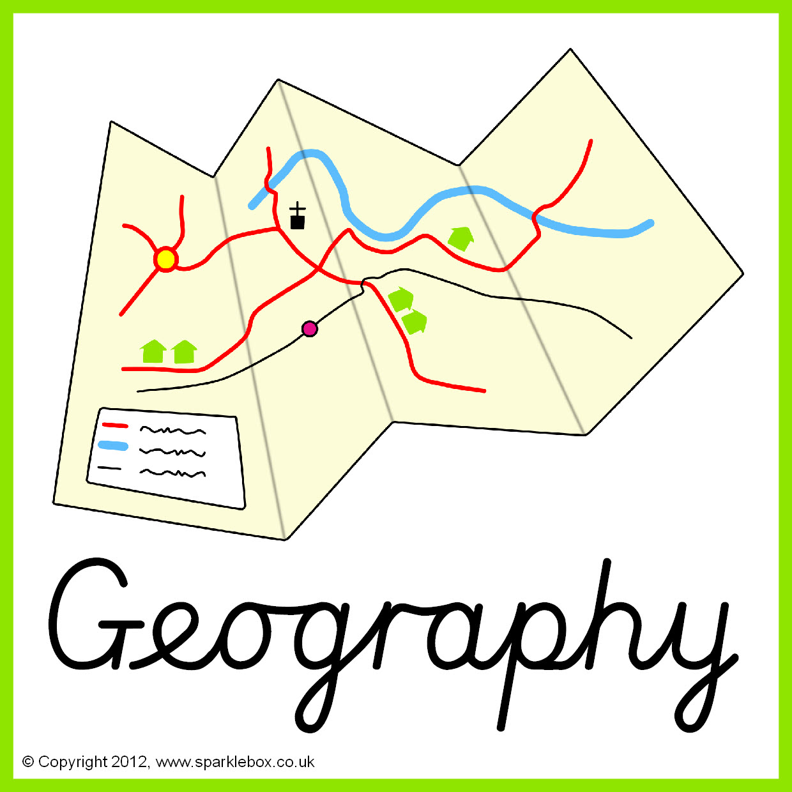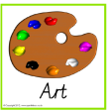
Portraits
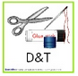
Where do Kings and Queens live?
England and Australia
Images
Religious texts and teachings
Some important stories
Cakes and treats

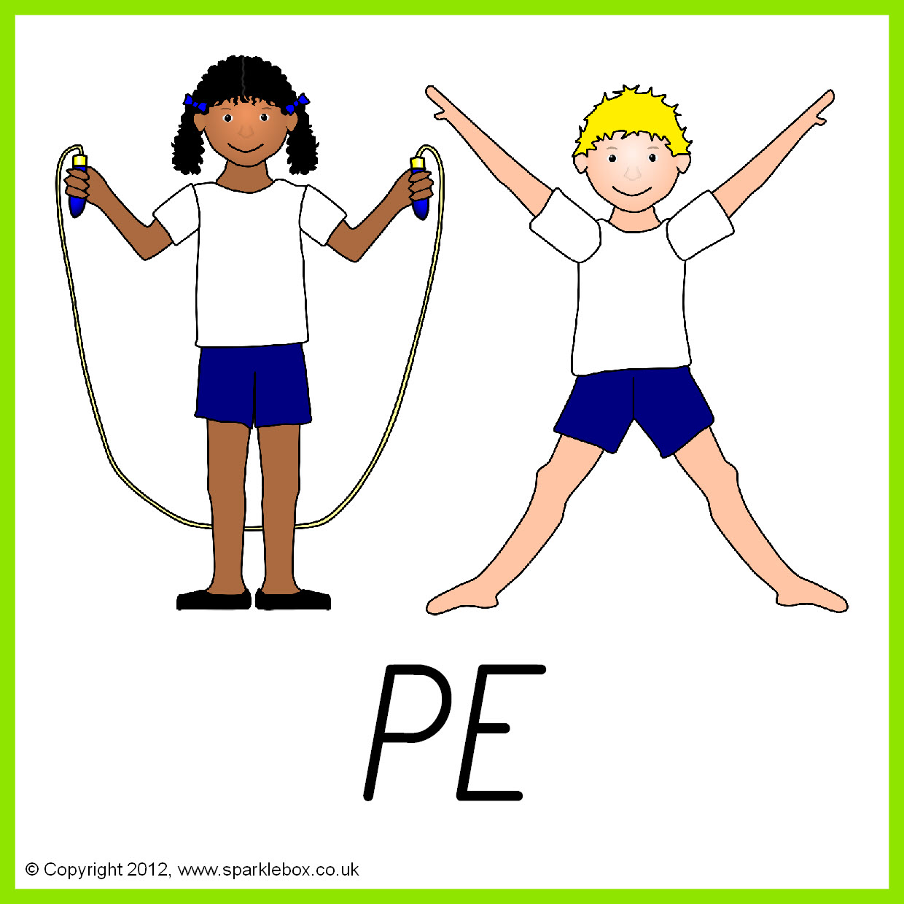

Health and Fitness
Athletics

