Autumn/Winter 2019 MENU – WEEK 1
OPTION | MONDAY |  | TUESDAY |  |  | WEDNESDAY |  |  | THURSDAY |  |  | FRIDAY
1 | Selection of pizza with various toppings. Jacket wedged potatoes, sweetcorn and broccoli |  | Homemade chicken korma  served with 50/50 rice |  |  | Sliced Turkey with sage and onion stuffing, carrots, garden peas, Brussel sprouts, creamed and roast potatoes, gravy |  |  | Cooks choice homemade minced beef hot pot served with carrot and peas | 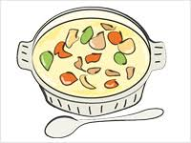 |  | Chicken poppers served with chipped potatoes, peas or baked beans
2 | Cooks choice homemade tuna pasta bake served with broccoli and sweetcorn |  |  |  |  |  |  |  |  |  |  | Cheese flan served with chipped potatoes, peas or baked beans
V | Selection of pizza with various toppings. Jacket wedged potatoes, sweetcorn |  | Tomato and cheese pasta with garlic bread, peas and sweetcorn | 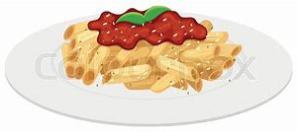 |  | Vegetarian Country Bake |  |  | Oven baked vegetarian sausage roll, served with sauté potatoes and baked beans |  |  | Oven baked battered salmon served with chipped potatoes, peas or baked beans
JP | Jacket Potato with cheese |  | Jacket Potato with tuna and mayonnaise |  |  | PLEASE NOTE:  NO SANDWICHES/  JACKET POTATOES TODAY |  |  | Jacket Potato with tuna mayonnaise and sweetcorn |  |  | Jacket Potato with beans
PL | Available daily as an alternative: - Sandwiches served with vegetables, a dessert and drink
DESSERTS
 | Homemade rice pudding with berries or ice cream |  | Fruit salad |  | Christmas pudding & custard  or choc ice |  |  | Eves pudding and custard |  |  | Cookie
Available daily as an alternative:- Fruit yoghurt, a selection seasonal fresh fruit, soreen and cheese & biscuits available everyday
Unlimited fresh salad and unlimited wholemeal bread
LUNCH WILL BE SERVED WITH FRESH MILK OR WATER
Menu Cycle Week 1: 4th Nov, 25th Nov, 16th Dec, 6th Jan, 27th Jan, 17th Feb, 9th Mar, 30th Mar

