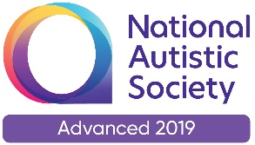 |  | Paul King  Headteacher  Joanne Mullineux  Deputy Headteacher

22nd September 2020

Dear Parents / Carers

As Warrington enters its local restrictions I thought I would write to you and explain what further measures we will be taking in school. From today:

- All adults (unless exempt) will wear a face covering when visiting or entering the school premises. This includes when dropping off and collecting your children.
- All parents/carers to leave site as soon as their children are dropped off, and do not congregate together for any reason.
- Staff (unless exempt) to wear a face covering when they come out to collect/drop off students.
- Staff operating walkie-talkies may not wear masks but will socially distance from others whilst completing this duty.
- Ensure that you follow the guidance we have distributed relating to Covid-19 absence, including self-isolating where this is necessary, and keeping us updated.
- All pupils in Upper School will wear face masks when on the going onto or coming from the playground. They will wear a face mask on the playground.
- All Upper School pupils to wear a face mask when coming into or going from the school building and to wear that face mask on school transport.

We will keep you fully informed of any updates to these arrangements.
Yours sincerely

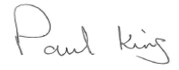
Paul King
Headteacher

