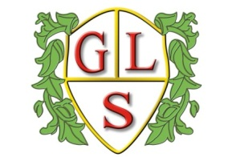
Class P1 Topics Autumn Term 2021

Maths
Place Value and methods of addition, subtraction, multiplication and division

English
Instructions and magazine and newspaper articles

Science
Earth and Space and Properties and changes of materials

History
Stone Age to Iron Age

Geography
Counties in the UK

ICT
E safety and algorithms and programming

Design Technology
Making a mobile and basic food hygiene

Spanish
Colours, songs, conversations, food

Art
Exploring drawing and Spanish tiles

PSHE
Different types of families and Health and Fitness

PE
Fitness training and inclusive sports

