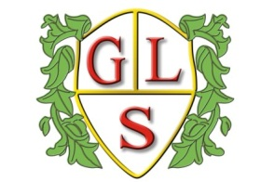
Class 6 Topics Autumn 2017

Science
Suitability of Materials

History
The Spanish Armada (Autumn 1)

Geography
UK and Sicily (Autumn 2)

ICT
Create an E Book (Autumn 1)
Keeping Devices Safe (Autumn 2)

Spanish
Number to 20/Number Games (Autumn 1)
Days of the Week/Christmas (Autumn 2)

RE
The Church (Autumn 1)
Celebrating Christmas (Autumn 2)

Art
Matisse

Design Technology
Where Food Comes From - Grains

PSHE
Relationships (Autumn 1)
Health and Wellbeing (Autumn 2)

PE
Physical Education with the Wolves Foundation

