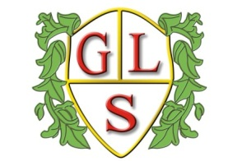
Class P3 Topics Summer 2022

Science
Particle matter
Structure and function of living organisms

History
World War II

Geography
The local environment – Padgate and Warrington

ICT
E-Safety
Algorithms and programming

Spanish
Greetings and conversation skills
Spanish weather

RE
Festivals and inspirational leaders

Art
Day of the Dead
View through a Door

Design Technology
Structures – Building with materials
Meals with pasta

PSHE
British values
The environment

PE
Volleyball
Athletics

