Badger Class Autumn Term 2023

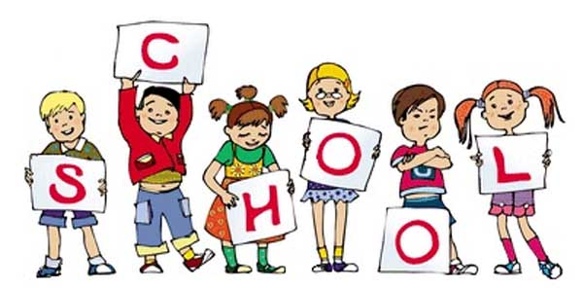

Badger class staff.

Ms K.White

Ms J.Forrest

**Topics**

**Autumn 1 -**

**Number**

Place value of a digit in a number.

Solve practical problems involving place value.

**Autumn 2 -** Add and subtract numbers using a formal written method and mental. Solve real life problems.

**Topics**

**Autumn 1**

Myths and Legends.

**Autumn 2**

Letter Writing.

**Ongoing** - Spelling and Phonics, Guided Reading, Guided Writing, Handwriting.

Speech and language work.

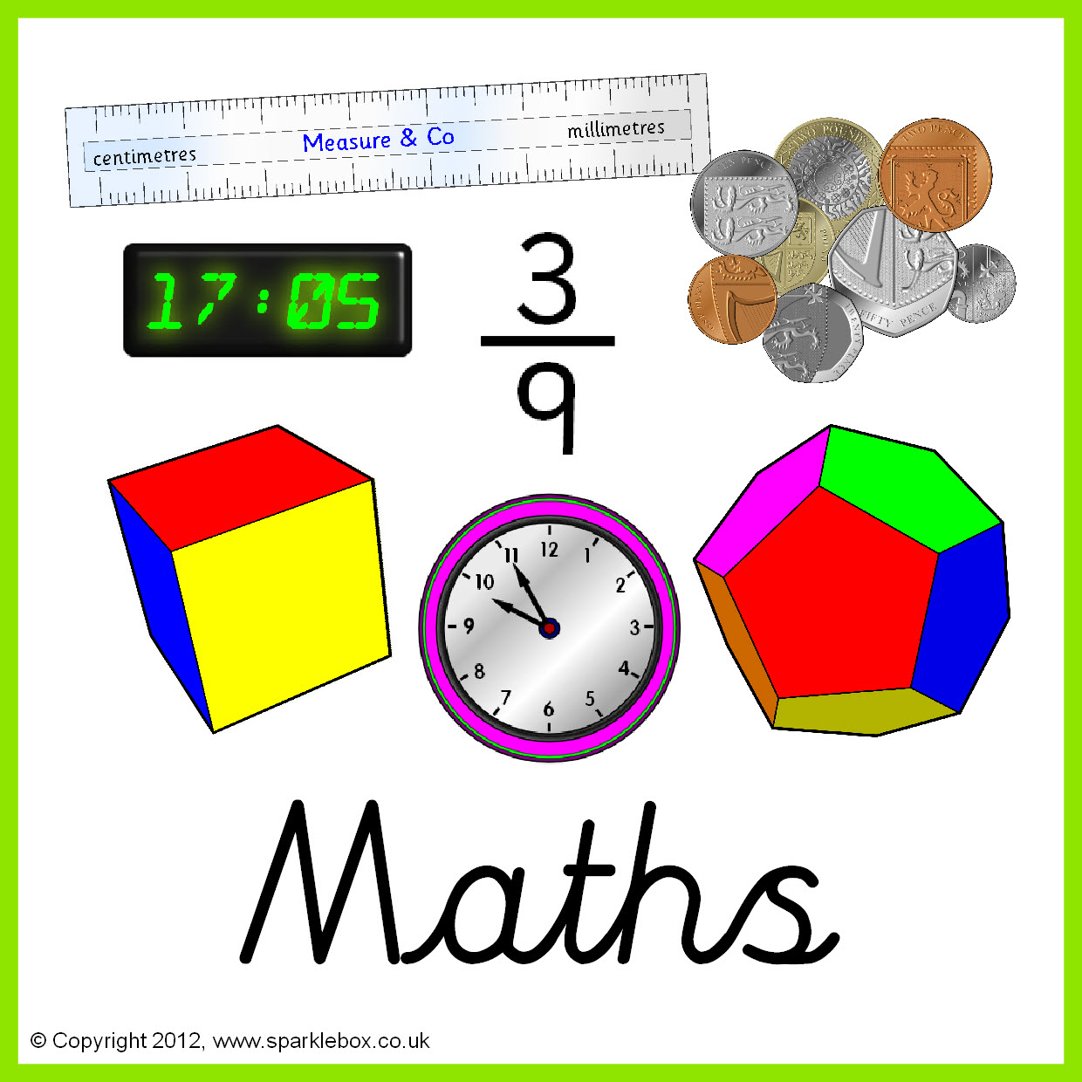

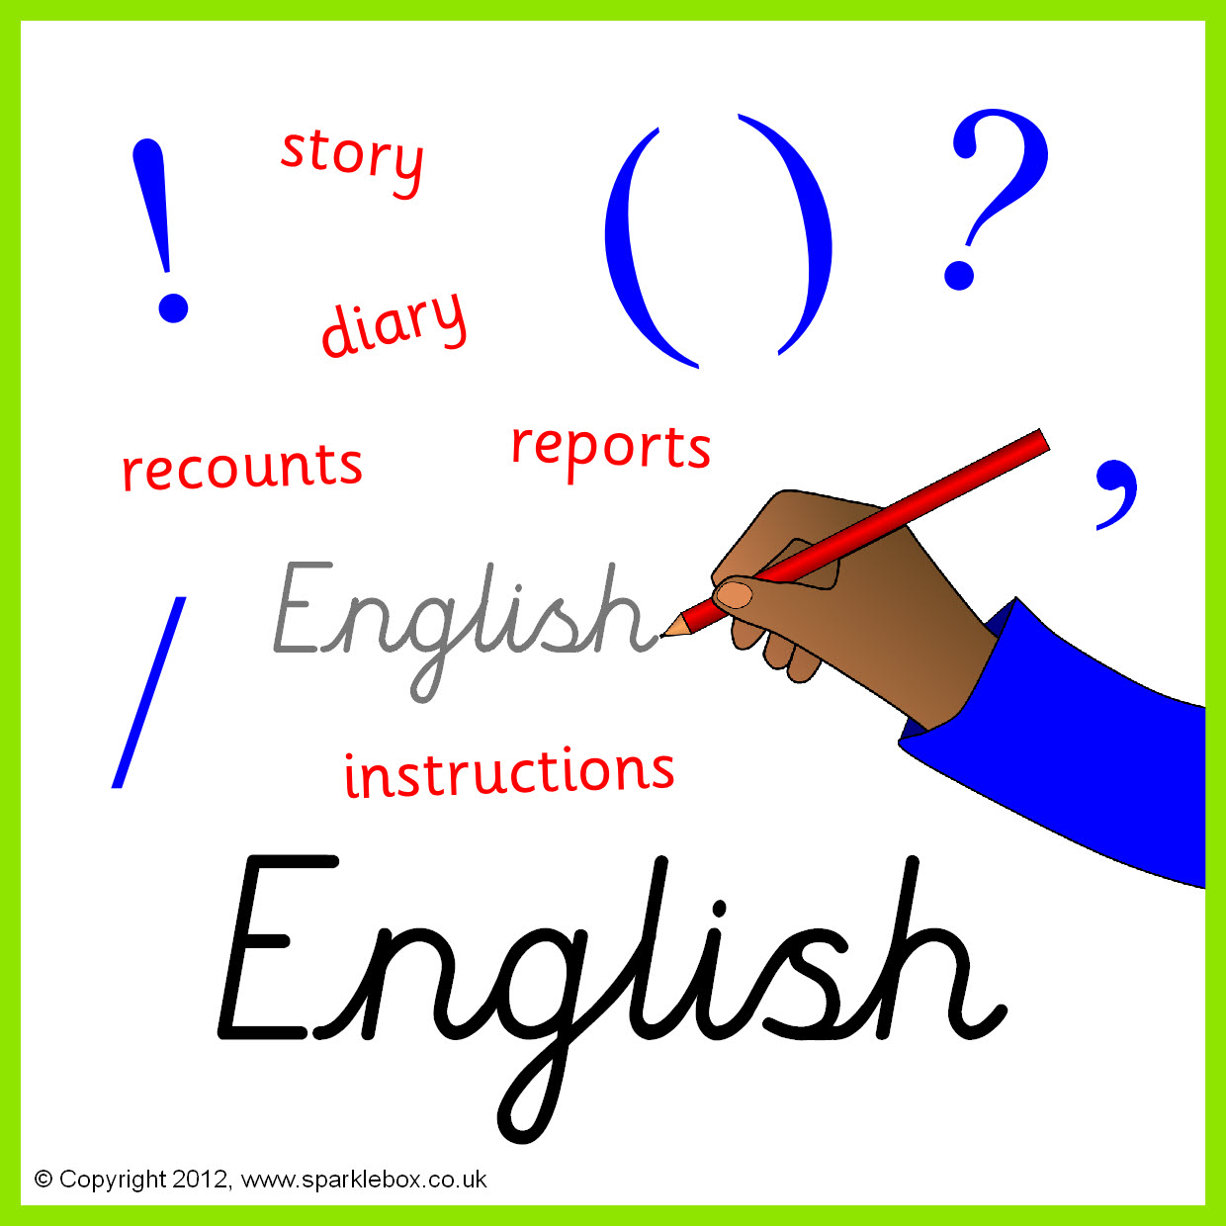

**Topics**

**Autumn 1 –** Natural light vs electricity**.**

**Autumn 2 -** The Water Cycle.

**Topics**

**Autumn 1** – Key skills – typing, copy and paste etc.

**Autumn 2** - E-safety.

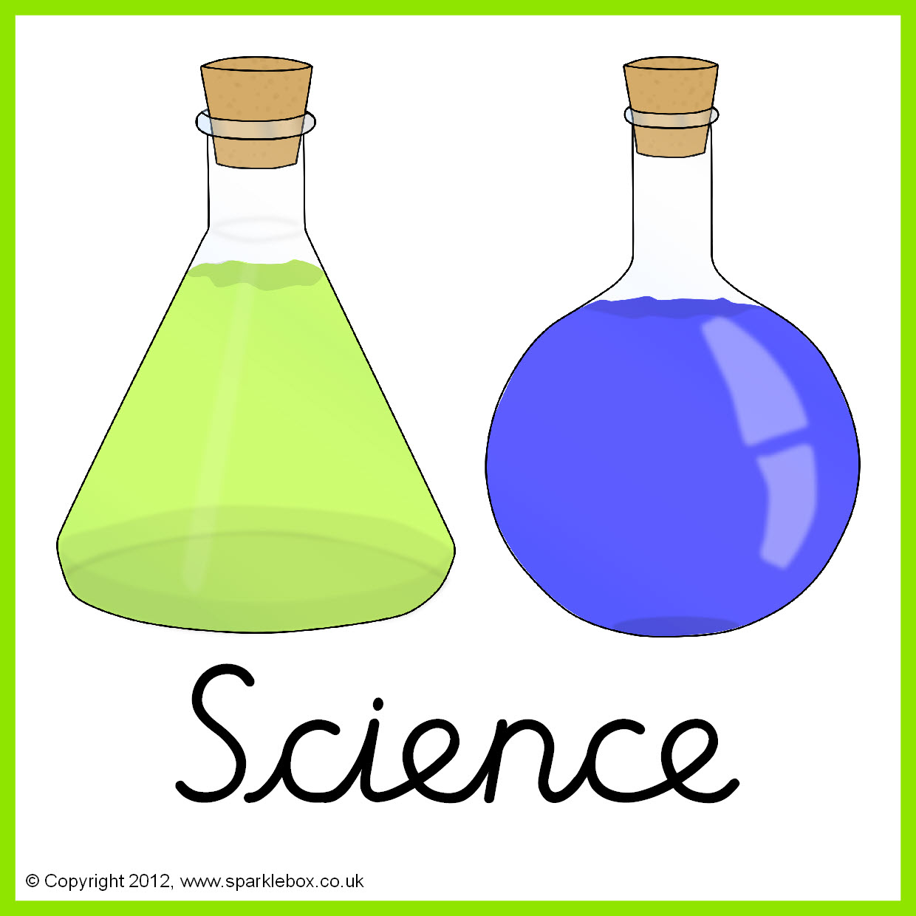



**Topics –**

**Autumn 1** - Introduction to formal elements of art. Sculpture and 3D form.

**Autumn 2** - Masquerade Masks

**Topics** -

Europe.







**Topics -**

**Autumn 1** - Body parts – labelling. Numbers to 20.

**Autumn 2** – Celebrations: Spanish Christmas and fiestas.

**Topic** -

The Viking invasion of Britain.

(What did the Vikings change?)



**Topics -**

**Autumn 1** – Hockey.

**Autumn 2** – Volleyball.

**Topics**

**Autumn 1** – Various Religions- What makes a community?

**Autumn 2** – Christianity and celebrations.





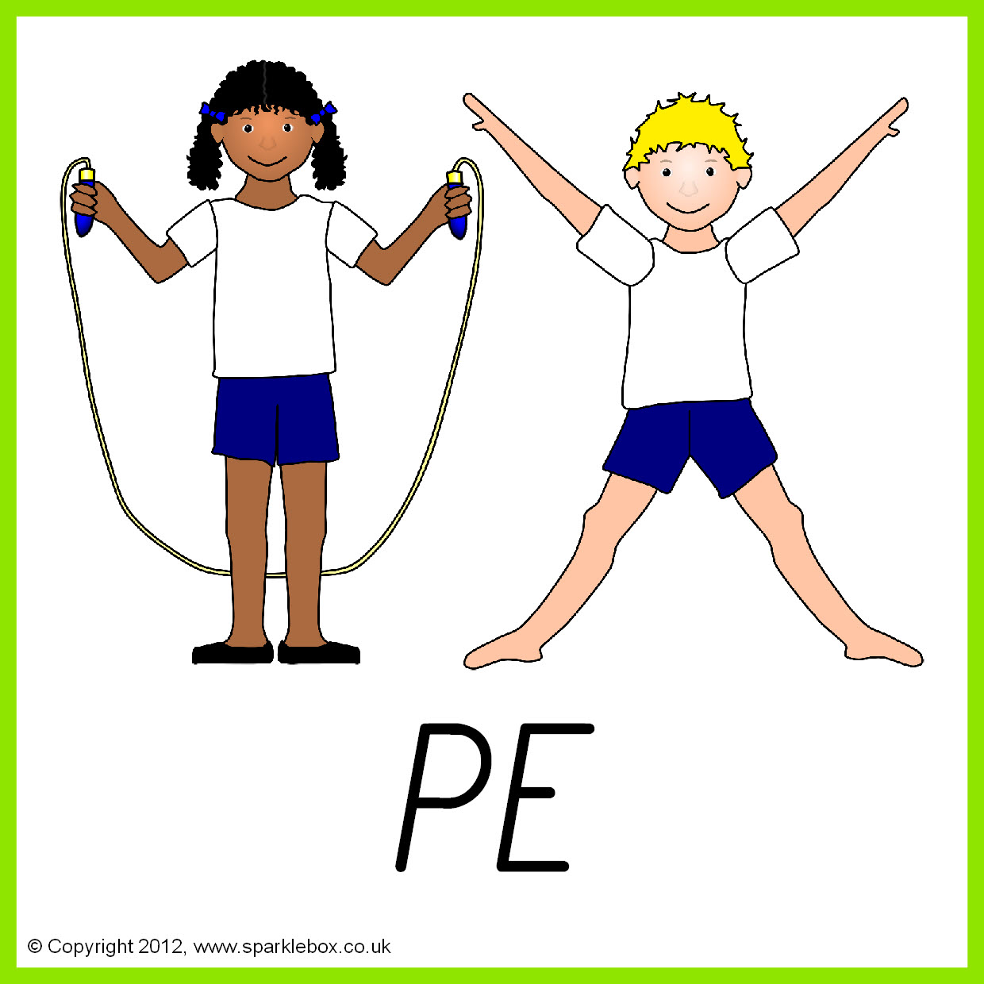

**Topics**

**Autumn 1 –** Personal hygiene.

**Autumn 2** – Relationships and friendships.

**Topics -**

**Autumn 1 –** Designing & Making a Bag.

**Autumn 2 -** Basic Food Hygine.

**Autumn 2 – Basic food hygiene – Winter warmers.**

