Topics 2SH Spring term 2021-22

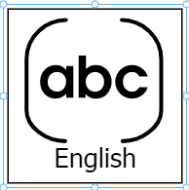

Recounts: Newspapers

Myths & Legends


Data:
Counting, sorting, pictograms

Multimedia:
EBooks


Natural art


Greetings: Que tal? (How are you?)

Numbers to 10- number games

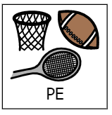
Invasion games
Striking/fielding games

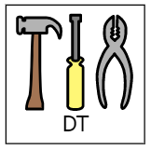
Structure (shell structures)- packaging and boxes

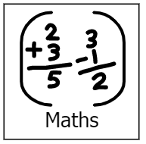
Number
Shape
Measure
Data Handling


Rocks in space
Testing magnets
Prehistoric Animals


England and Ireland

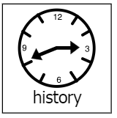
Holidays through time

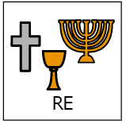
What can Bible Stories teach us?
Easter-what qualities make a good leader?

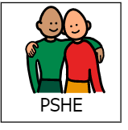
Manners-being polite
Personal hygiene and growing and changing

