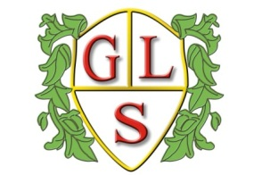
Class 2MC Topics Summer 2022

Science
Natural vs Man-made Light
Why are we Alive?

History
Explorers!

Geography
Compass Directions

ICT
Data: Pictograms
Programming and Algorithms

Spanish
Spanish Greetings
Spanish Fiestas

RE
Hindu Dharma

Art
Masks
Art Exhibition

Design Technology
Simple Mechanisms

PSHE
Respecting different cultures
Identity – Looking to the Future

PE
Warrington Wolves Foundation

