08/02/2021
Hello Class 5
I just want to thank you all for taking the time to complete the work last week and upload to evidence for learning! I really enjoy seeing what you have all got up to and you look like you’re all working super, super hard! Keep it up! This week’s project is all about festivals.
Tips for this week:
- 12th February is Chinese New Year – the year of the ox
- 14th February is valentine’s day
- 16th pancake day
- Enjoy half term!
Please could you record any work you have completed on evidence for learning, these do not have to be daily. Adding pictures will be great for us to see in school, it will also allow me to comment back and add any extra ideas or challenges that are personalised to your child. =)
Thank you for your ongoing support
Mrs Williams

Home Learning Activities
Class: 5 Week: 6 08/02/2021
Monday | Tuesday | Wednesday | Thursday | Friday
Maths  Measurement  This week we are looking at measurement. Watch the video about heavy and light.  https://classroom.thenational.academy/lessons/comparing-the-weights-of-objects-and-using-language-about-weight-crt3cc?activity=video&step=1  Challenge  Can you find something heavier than you?  Can you find something lighter than a computer?  Can you order 4 objects from the heaviest to the lightest? | Maths  Measurement  Today we are going to be comparing weights using more, equal to or less than symbols. < > =  https://www.bbc.co.uk/bitesize/articles/z428wty  Challenge  Can you use some bathroom or kitchen scales to weigh an object?  Look closely at he scales. What are your objects measured in? grams, kilograms or pounds? | Maths  Measurement  Today we are carrying on the theme of heavier and lighter. Watch the video below.  https://classroom.thenational.academy/lessons/differentiating-between-heavier-and-lighter-cgwpad?activity=video&step=1  Challenge  Which do you think is the heaviest:  Elephant  Cat  Rhino  Tiger  Bus  Which of the above animals do you think is the lighest?  How do you know? | Maths  Measurement  Today we are going to do 2 tasks.  Can you order the pictures from heaviest to lightest? Choose 3 different pictures at a time and order them. Try different combinations. Which do you think is the heaviest from al of the pictures?  Try the practical measurement experiment.  All the resources you need are under week 6 day 4 maths. | Maths  IEP targets  Can you work on your measurement IEP targets?
English  Reading – inference  Todays English session is a reading session. Download the week 6 reading task. You don’t need to print this off. Look through the cards, can you answer the questions by just using the pictures to help you.  Challenge  Can you spot and read labels or words in your environment?  Play I spy in your house with a family member. | English  Handwriting  Warm up – you will need some play doh or something you can squeeze.  https://www.youtube.com/watch?v=ocFu_ZFgQi4&list=PL7stXD3f711Ol-NCT6ry2TwsrKoQp1COy&index=8  Watch the video on correctly forming each letter of the alphabet. Whilst you watch try to copy along with each letter.  https://www.youtube.com/watch?v=TYYSBProJH4  Challenge  Have fun!  Try writing outside today! Have you got a paintbrush? Try writing on the floor with water and a paintbrush. Have you got any paint? Try writing with paint using a brush or your finger!  Have you got any chalk, try writing in chalk.  Have you got any sand or rice? Try writing in sand or rice in a tray! | English  Writing and communication targets  Today we are going to work on your individual IEP targets. Can you tick off any of your writing and communication targets? | English  Silly poetry  This lesson we are looking at silly rhyming poems. Watch the video below.  https://www.youtube.com/watch?v=TRuz6fadjEw  How many rhyming pairs could you find? What rhymes with socks in the poem?  Can you write your own silly poem using the following rhyming pairs?  Box and socks  Ball and fall  Jump and pump  Snake and shake | English  Nouns  Today we are looking at nouns. Watch the videos bellow.  https://www.bbc.co.uk/bitesize/topics/zrqqtfr/articles/zpd8ng8  Can you identify the nouns in these sentences?  In the jungle it is hot.  My cat is very naughty.  The big green dragon flies high.  John is my friend.  Challenge  Can you go on a noun hunt? Use the sheet to help you find people (mum), places (kitchen) and things (dog).
PSHE  Worries  Times are very strange at the moment, it can make us feel worried and have funny feelings. Today our lesson is all about worries.  https://classroom.thenational.academy/lessons/dont-worry-about-a-thing-68u32d  Challenge  Do you have any worries?  You could write down a worry you have and share it with an adult.  What can you do to make yourself feel less worried? | Art and design  Drawing a friend or family member  As we are missing seeing our friends and family, this week we are going to draw a friend or family member. Watch the video and join in to create your piece of art.  https://www.tate.org.uk/kids/make/paint-draw/draw-friend  Challenge  Can you draw more than one friend or family member?  You could even post your drawing to your friend or family member as a nice surprise. | ICT  Coding  Can you use 2code rockets on purple mash to write code instructions and create your own Chinese New Year firework display?  Challenge  Can you use another 2code programme to practice writing instructions? | RE  Holi festival  Today we are going to learn about holi festival. Holi festival is a Hindu festival celebrated in March. They use lots of bright colours, have bonfires and celebrate as a family. Watch the videos about Holi.  https://www.bbc.co.uk/bitesize/topics/zh86n39/articles/z4qqy9q  Challenge  Can you colour in the holi festival colouring page? | Science  Absorbent/not absorbent  Today we are experimenting with absorbent and non absorbent materials  You will need some different objects and materials to experiment with.  https://classroom.thenational.academy/lessons/which-materials-are-absorbent-6tk3er  Challenge  What can object you find that is absorbent?  What object can you find that repels water?  Is a towel absorbent? Why do we need towels to be absorbent?  Would a plastic bag make a good mop?
Phonics  Lets go over our sounds. Join in with the jolly phonics songs and try the actions.  https://www.youtube.com/watch?v=_s-1sxzjPX8 | Phonics  Sound of the day:  ‘oo’  Can you think of any words with the sound ‘oo’ in them?  Word of the day:  zoom  Can you write a sentence with the word ‘zoom’ in it? | Phonics  Sound of the day:  ‘ar’  Can you think of any words with the sound ‘ar’ in them?  Word of the day:  Farm  Can you write a sentence with the word ‘farm’ in it? | Phonics  Sound of the day:  ‘ay’  Can you think of any words with the sound ‘ay’ in them?  Word of the day:  day  Can you write a sentence with the word ‘day’ in it? | Phonics  Sound of the day:  ‘wh’  Can you think of any words with the sound ‘wh’ in them?  Word of the day:  when  Can you write a sentence with the word ‘when’ in it?

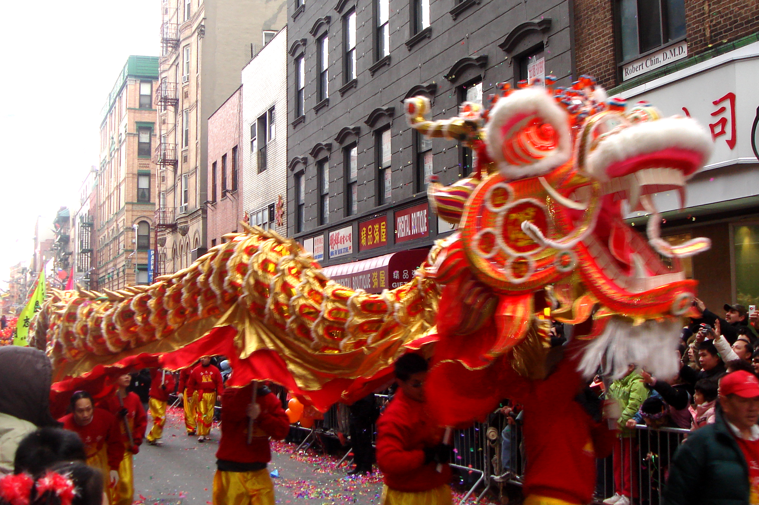
Week 6 project
Festivals – purple mash has lots of activities to help you with all 3 of these festivals
Chinese New Year
– try some of these activities https://www.bbc.co.uk/cbeebies/watch/chinese-new-year
- why don’t you try cooking and eating some Chinese food?
- this year is the year of the ox can you research what Chinese New Year you were born in?
- Can you research how people celebrate Chinese New Year?
- why is the colour red important in Chinese culture?
- can you make a firework picture?
- can you use purple mash to create something or learn about Chinese New Year? Type in Chinese New Year into purple mash.
Valentine’s day
- https://www.bbc.co.uk/cbbc/curations/valentines-day
- Can you create a valentine’s card for someone in your house?
- Why do we celebrate valentine’s day?
- Can you make a snack or drink for someone you care about?
- Can you make chocolate dipped fruit? You can use strawberries, banana or any of your favourite fruits
- Can you use purple mash to create something valentine’s day themed?

Pancake day
- Can you find out all about pancake day https://www.bbc.co.uk/newsround/47154807
- Who celebrates pancake day?
- Do other countries celebrate pancake day in a different way?
- What is another name is used for pancake day?
- Can you help to make and flip a pancake?
- Can you design your favourite pancake topping?

