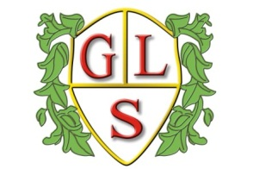
Class P5 Topics Autumn 2018

Our topic theme this term is ‘Going Global’

English
Instructions

Maths
Number- Place value, Ordering, Counting, one more and one less,
Addition and Subtraction

Science
Investigating Rocks
Same and Different- genetics

History
The Roman Empire and its impact on Britain

Geography
Comparison to life in Spain
Ecosystems/Biomes

ICT
Safety with devices
Effective searching

Spanish
All about Spain
Songs and Stories
Spanish Christmas

RE
Special times and celebrations
Christmas

Art
Global Art

Design Technology
Making Spanish musical instruments

PSHE
Around the Globe
Different Cultures

