P2 Summer Term 2019

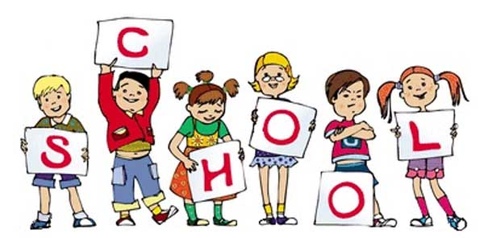

P2 staff Ms K.White

Mrs K.Dickson/Mr McLoughlin

Mrs L. Stewart (Wed)

Miss S.Beechall (a.m)

**Topics**

Shape (e.g angles, reflections, rotations)

Area

Perimeter

Data handling Consolidation of what has been taught.

**Topics**

Stories-Adventure/ Scary.

Poetry – Oral performance, riddles & Children’s Authors.

Spelling, Guided Reading,

Guided Writing, Handwriting.

Speech and language work.

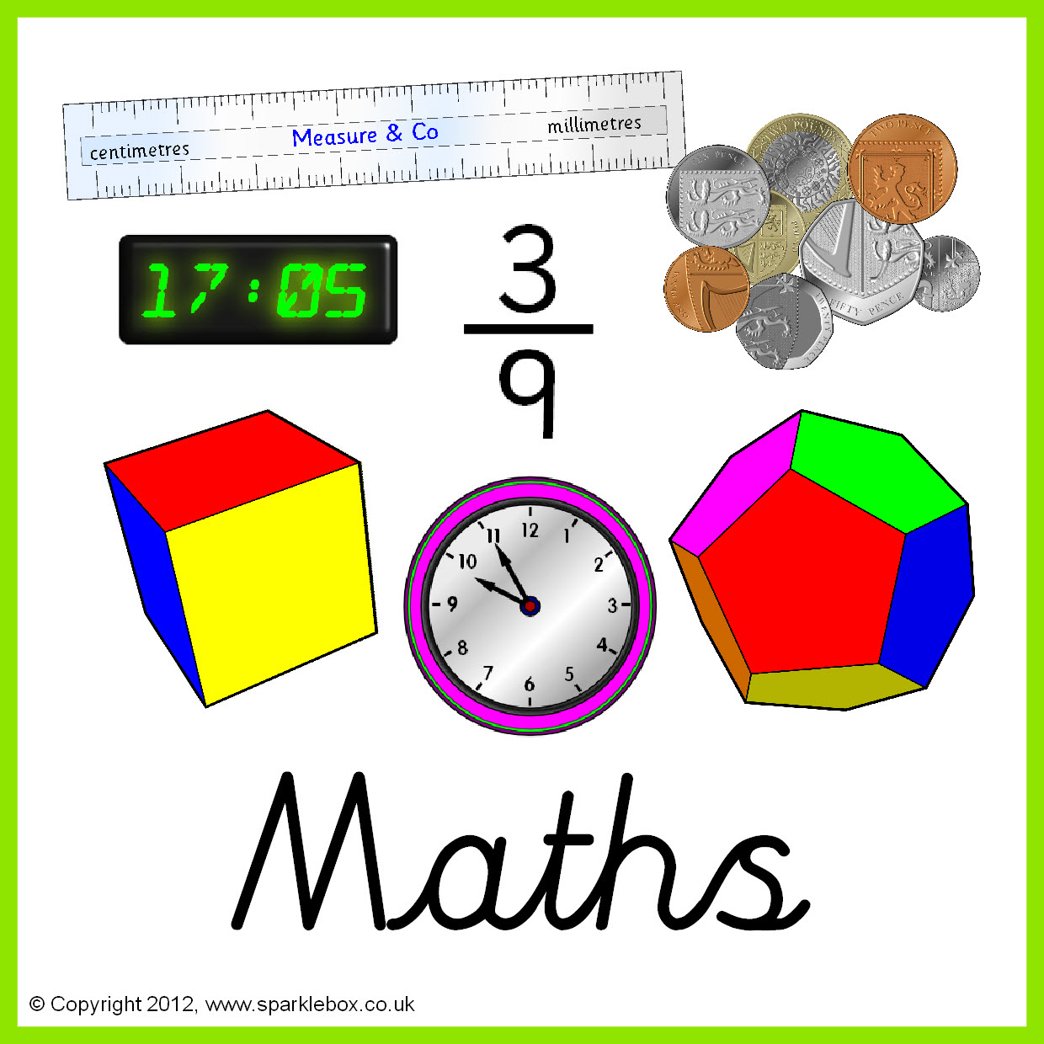

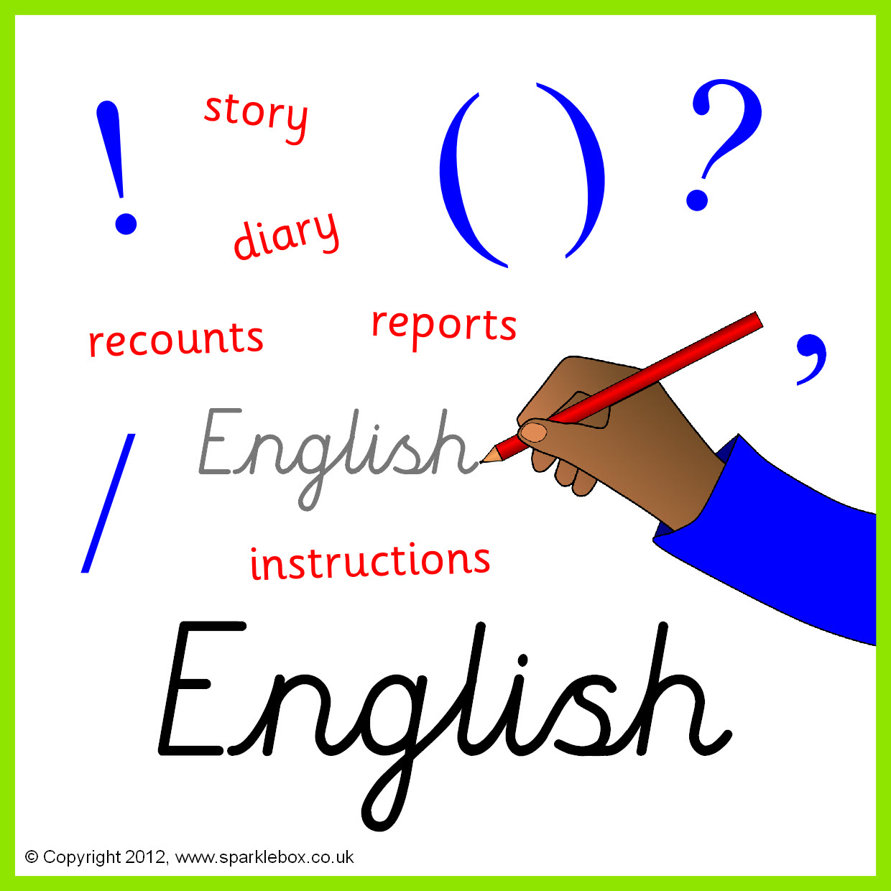

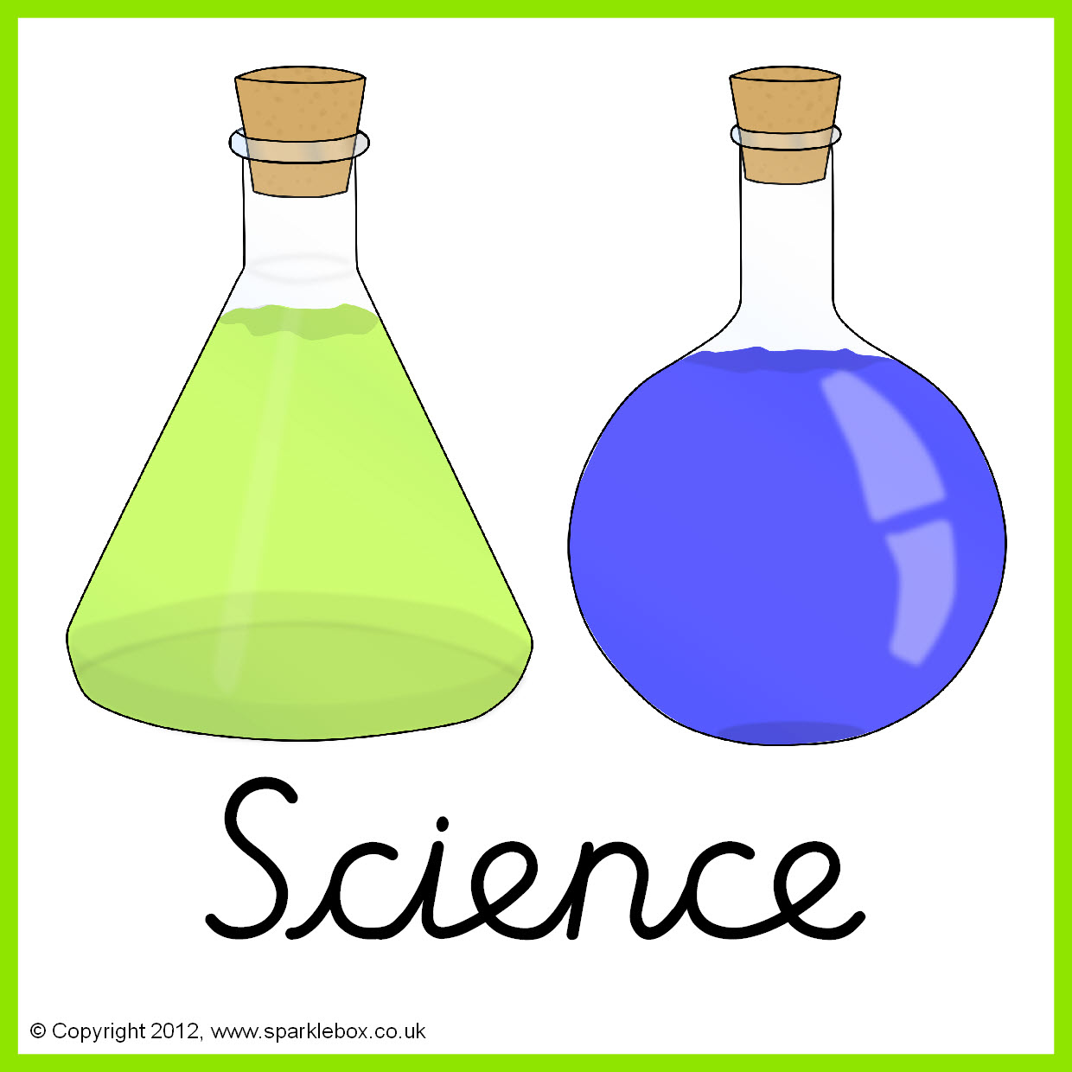

**Topics**

Investigating circuits and Plants.

**Topics -** Taught by D. Taylor

Data bases

3D Modelling

Concept Maps



**Topic** Taught by L. Fernyhough

Where does our food come from? Exploring Asia.

**Topic** -Taught by L. Fernyhough

Day of the dead – Masks.

Bright pots – Ceramic and clay.

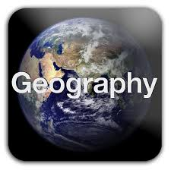

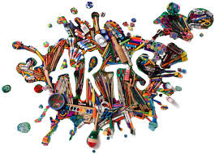

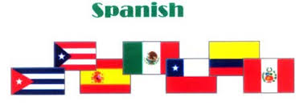

**Topic**-Taught by L. Fernyhough

Numbers to 20 – How old are you?

Spanish instruments and music.

**Topic** -Taught by L. Fernyhough

Compare life to an aspect of life in Iraq today.

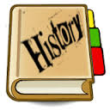

**Topics**

Festivals, religious communities and inspirational leaders. Bible stories and sacred texts.

**Topics** Taught by M.King

Trampolining.

Tag rugby.





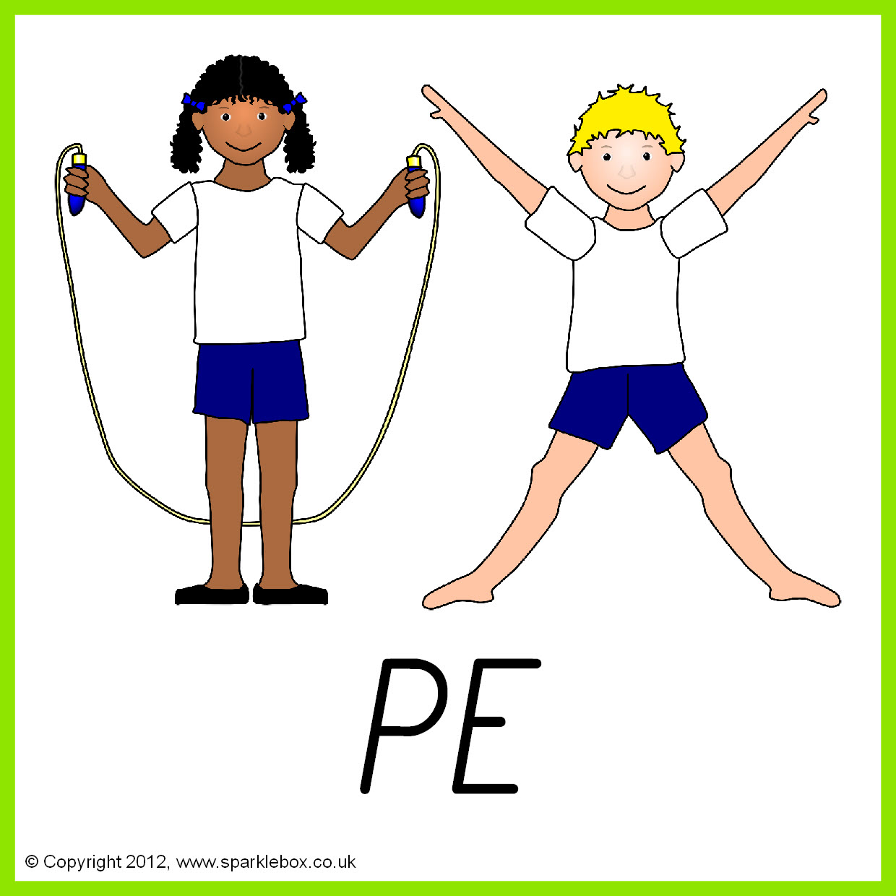

**Topic**

Living in the wider world.-Our world Different languages. Traditions and cultures.Enterprise project and business.

**Topic** Taught by A.Davey

Summer salads. Independent travel training.

