Home Learning Activities
Class: P4 Week: 3
Monday | Tuesday | Wednesday | Thursday | Friday
Maths  L.O. To start to recognise doubling  On a piece of paper paint some dots on the page- how many dots have you painted? then fold the paper over- how many dots are there now? When dry stick down the painted piece of paper and rite down your calculation in your book e.g. 2+2=4.  Alternative- if you don’t have any paint then draw some dots on one side of the page and count then draw some dots on the other side of the page and count- how many altogether?  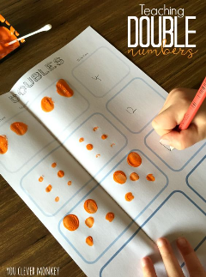 | Maths  L.O to recognise doubles to 10.  Turn over one of your number cards to 10 and put that many objects on a plate. Then put the same amount on another plate. How many altogether?  Write down your calculations in your book e.g. 4+4= 8  2+2=4 | Maths  L.O. To know doubles to 10  Archery Doubles - mobile friendly (ictgames.com)  Today this uses the language double 8- remember that this just means 8+8. For each question write out the calculation if it helps and use objects to add if you need to then select the correct answer.  Extension challenge: Maths Fishing - Multiplication - Mathsframe You have to be quick with this game so only try when you are confident! | Maths  L.O. To know doubles to 10  L.O. To know doubles to 20  Choose either sheet depending on how you have found doubling this week. You will find the sheets labelled in the pack that has been sent to you for this week. Both are ladybird themed and are either doubling to 10 or doubling to 20. | Maths  On a Friday we are going to be looking at some basic maths skills. I would like you to choose one of the sheets in your packs sent out this week to complete. They are activities that you have been working on so far this year in class that I think you need more practice with. These link to your targets.
English  L.O. To write about my favourite story.  With an adult think about your favourite story. Write a couple of sentences telling me about the story. Answer the questions:  What is the story about?  Who is your favourite character in the story?  Why do you like the story?  Does the story have a happy ending?  Remember to write in full sentences, write on the line and try to use your neatest handwriting. | English  L.O. To practice my handwriting  Today spend some time practicing your handwriting. Use one of the sheets in your handwriting book to practice your writing. Remember to write on the line, keep your writing small and take your time! | English  L.O. To answer questions about a story.  Choose one of the reading comprehensions from the pack and answer the questions. Remember to write in full sentences to answer the questions. | English  L.O. To predict what might happen next in the story  Read the first page of the Treasure Island story (it can be shortened if an adult thinks it necessary). Talk about what is happening in the story. What is the story about? Then read the second page. What do you think is going to happen between Billy Bones and Black Dog? Who are they both? How do they know each other? What is Black Dog looking for?  Either answer the questions verbally with an adult or write down some of your answers. If support is needed then adult can offer ideas about what they think might happen next. | English  Today we are using phonics play which is currently free. The username is jan21 and the password is home  Phase 2 phonics-  Pick A Picture (phonicsplay.co.uk)  Phase 3 phonics-  Grab a Giggling Grapheme (phonicsplay.co.uk)  Click on phase 3 and then select the first 3 boxes (starting with j, y, ch)
Computing  L.O. to explore e-books  Purple Mash by 2Simple  Today we will be using purple mash (logins sent home in learning pack). Go to the 2do’s section where there is a lesson using 2create a story. Talk about your favourite story and see if you can make your own version on 2create a story. I will put a video of some examples on Evidence for Learning if you need some inspiration. | PSHE  L.O. To understand what makes a community  What is a community? Talk to an adult about what you think it is.  Then in the middle of your page draw a picture of your house. Around it use pictures or words/sentences or both to describe your local community under the following headings:  Places I shop  My school  My teams/clubs  Places I visit  My friends  Places I eat  My family nearby | Science  L.O. To investigate the suitability of materials  Today we are looking at the suitability of materials.  Test different materials around the house. I would like you to find out which material would make the best umbrella in the rain. Use different materials e.g. paper, glass, plastic, material to see which one lets in the least amount of water. Write down your results based on whether the material would make a good umbrella or not. | Art  L.O. To express through art my favourite place.  Draw a picture and colour it in of your favourite place. Somewhere that you feel safe and happy. Think about filling the page with your drawing and using the most appropriate colours. Remember to take your time when colouring. | PE  See if you can go outside today for some exercise. Can you think of different ways to move around your garden? E.g. walk, run, skip, hop.
Fine Motor Skills  Practice your scissor skills today- can you cut in a straight line? Can you cut out different shapes? | Fine Motor Skills  Wrap elastic bands around a tub | Fine Motor Skills  Practice pouring water from one container to another. How small can you get the containers to pour into? Did you spill any? | Fine Motor Skills  Thread pasta onto string  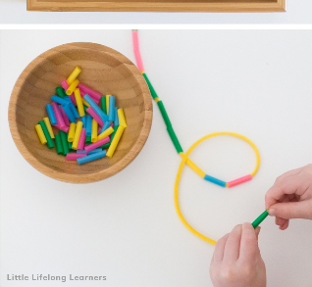 | Fine motor Skills  If you have playdough at home play with this today- (maybe you could even try making some?!) You can practice rolling it into a ball and squashing flat or get the scissors out to cut it up.

All these activities follow what we have planned for this half term in class. This work allows pupils to keep up to date with their learning. If you prefer to change days for topic work then that is fine. Maths and English progress each day and build upon previous days learning. We would like you to send in picture evidence as often as possible of your child’s work either when they are completing it or of the completed work so that we can see all the fantastic work that is being completed! If you want to physically send in via post any work then please feel free. If you are unsure of any activities please let me know and I can add a demonstration video to Evidence for Learning to support. Also if you need any extra resources particularly for fine motor skills please let me know and I can send some to you.

