P2 Summer Term 2022

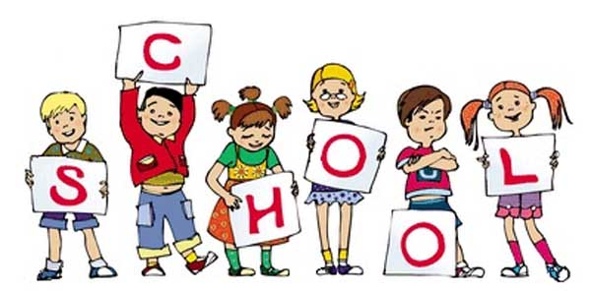

P2 staff

Ms K.White

Mrs K.Dickson

Ms J.Forrest

**Topics**

**Summer 1 -** Capacity, mass and length and real life problems.

Area and perimeter.

Temperature and negative numbers

**Summer 2 –** Revisit key areas of addition, subtraction, multiplication and division.

Revisit Statistics.

**Topics**

**Summer 1-**Scary/Adventure Stories

**Summer 2 –** Poetry – Oral & Performance, riddles.

**Ongoing** - Spelling and Phonics, Guided Reading, Guided Writing, Handwriting.

Speech and language work.

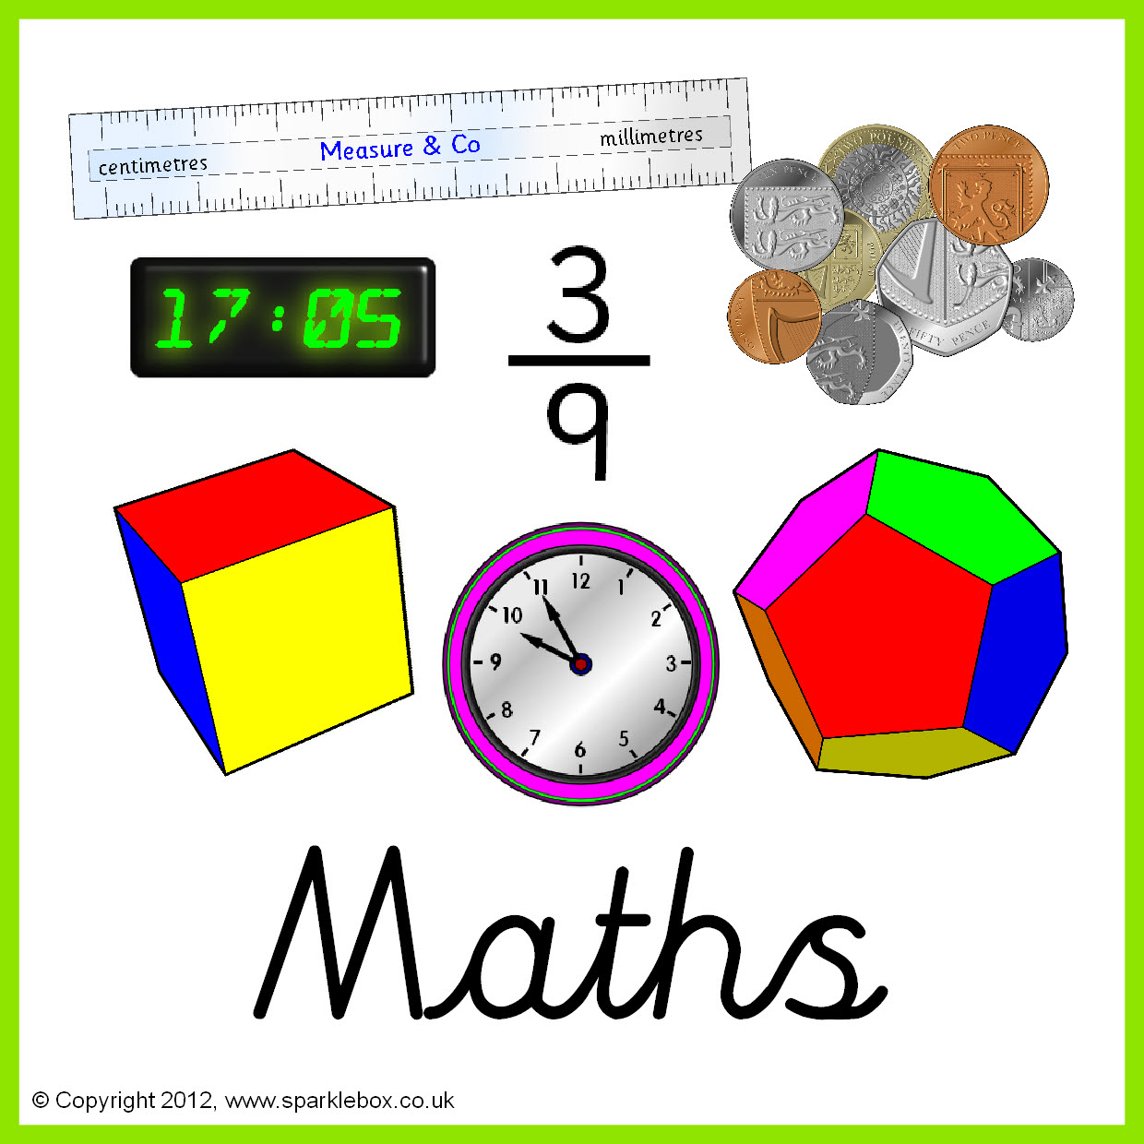

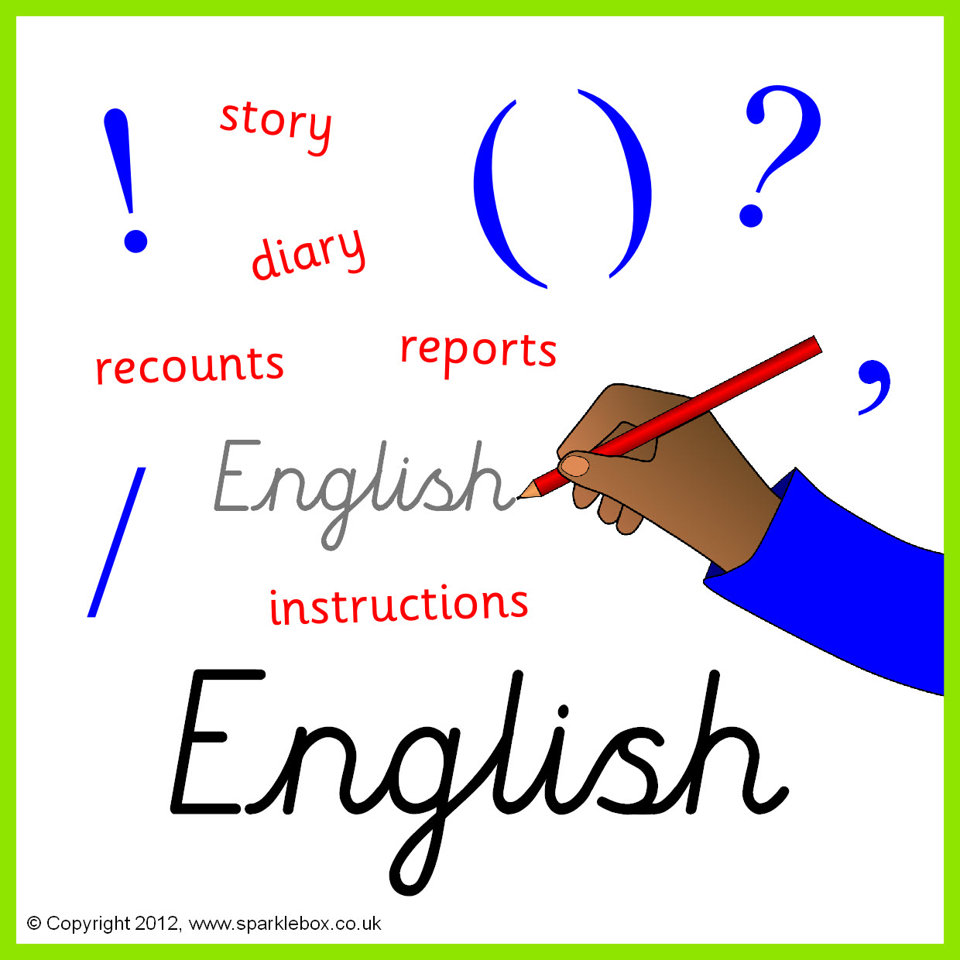

**Topics**

**Summer 1** - E-safety and Algorithms & Programming.

**Summer 2** - Multimedia: Art; Working with text.

**Topics**

**Summer 1** - Particle nature – Matter, Atoms, elements and compounds.

**Summer 2** – Structure and function of living organisms – Nutrition and digestion.

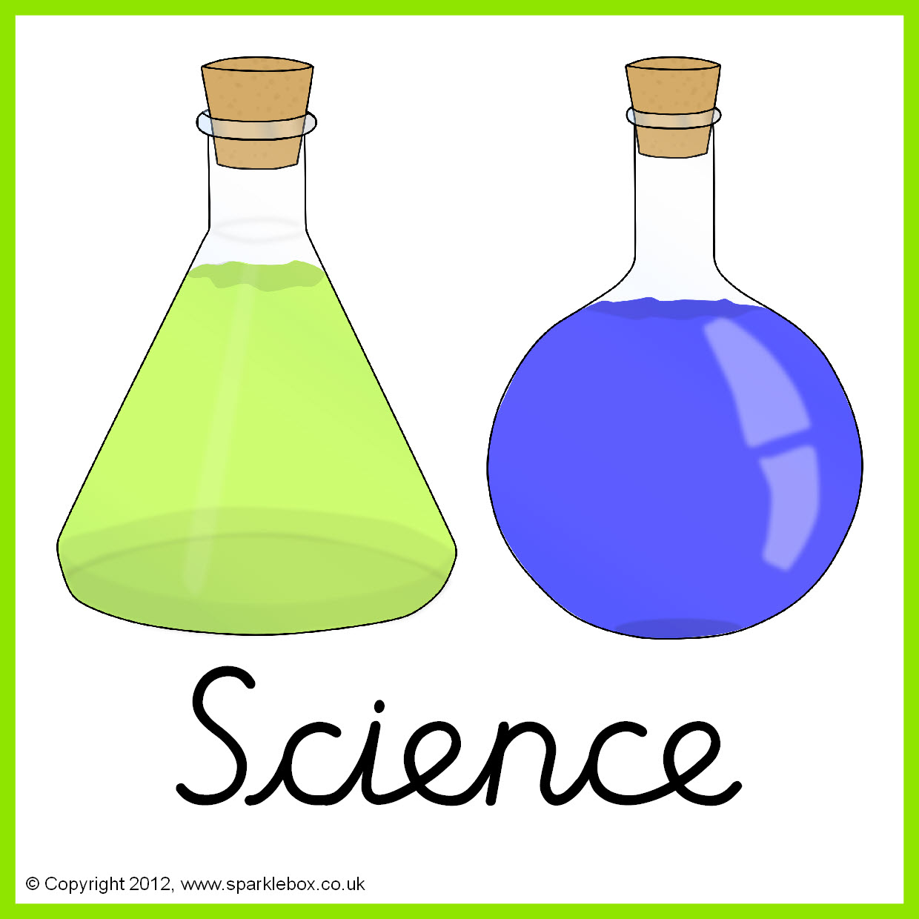



**Topics** – Taught by L. Fernyhough

**Summer 1 –** Day of the dead. Pattern, colour and 3D form.

**Summer 2 –** A view through a door. Surrealist art.



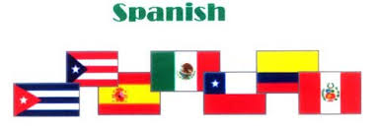

**Topics** - Taught by L. Fernyhough

**Summer 1 –** The local environment Padgate and Warrington.

**Summer 2 –** Ordinance Survey maps.

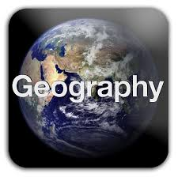

**Topic** -Taught by L. Fernyhough

Local History (within living memory).

**Topics**

**Summer 1 –** Colours. Comparing flags.

**Summer 2 –** Days of the week.



**Topics**

**Summer 1 –** Cricket.

**Summer 2 –** Athletics.

**Topics**

**Summer 1** – Buddhism. Key values and beliefs.

**Summer 2** – Christianity. Stories from the old and new testaments.





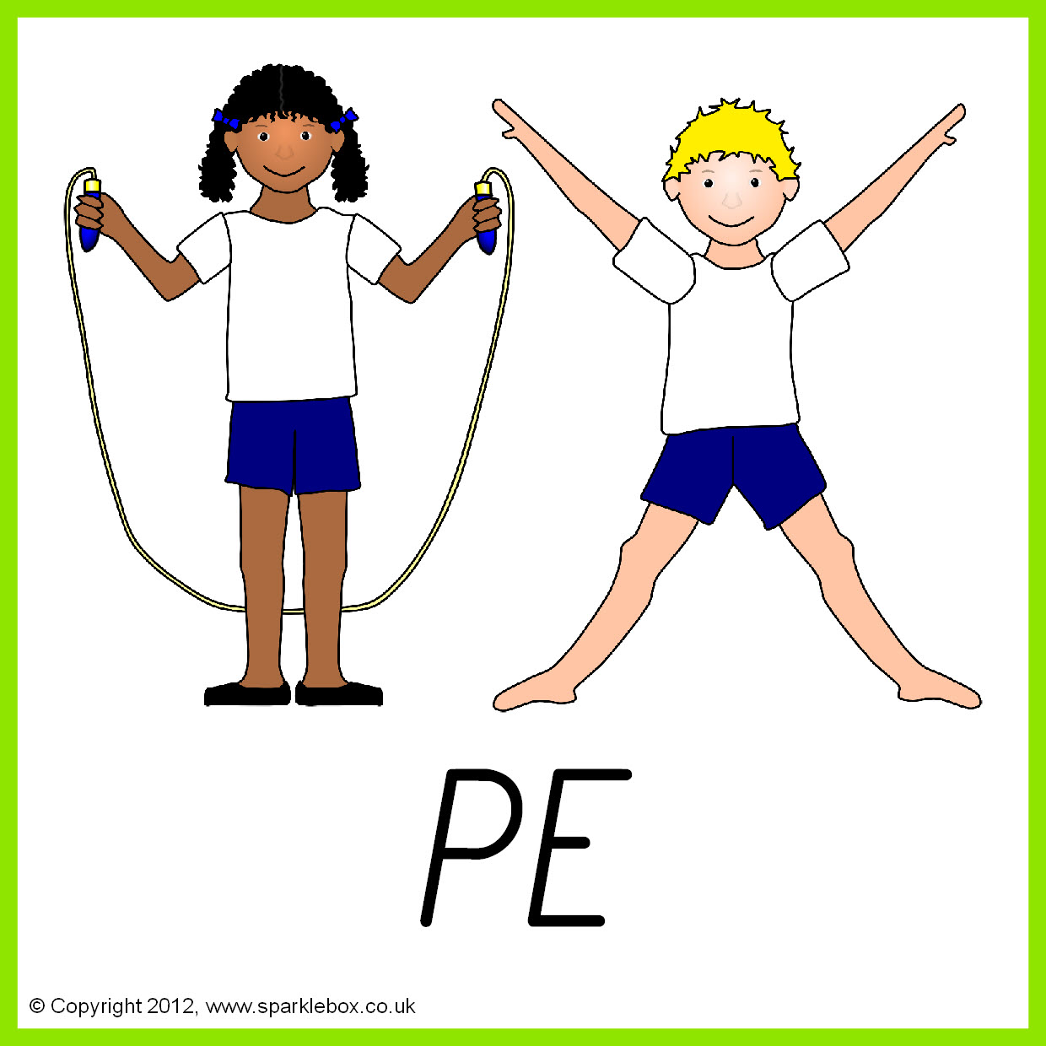

**Topics**

**Summer 1 –** Structures. Design and build a shelter.

**Summer 2 –** Pasta meals.

**Topics**

**Summer 1** – British values.

**Summer 2** – Environment.

.

