**Topics Summer 1**

**Time/Money:**

How long is.... ?

Planning a Journey

Map/Timetables

Distance

**Measures/Number:**

Temperature

Negative Numbers

**Data Handling:**

Venn/Carroll

Diagrams

Stem & Leaf

**Summer 2**

**Measures:**

Capacity, Length & Weight

Area & Perimeters

**Shape & Space:**

Angles, Pattern & Symmetry

Reflections

& Rotations

P2 Summer Term 2018

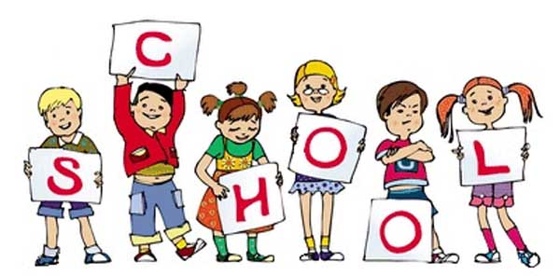

P2 staff Ms K.White

Mrs K.Dickson

Mrs R.Gould

Miss S.Beechall (p.m)

Non-chronological reports and letter writing.

Weekly spellings

Reading, sentence level work , guided writing and independent writing .

**Topics -** Information booklet with collection of non-fiction text types and Fantasy texts.

Letters and sounds and Popat phonics work.

Fuzzbuzz and letters and sounds reading skills.

Handwriting.

Speech and language work.

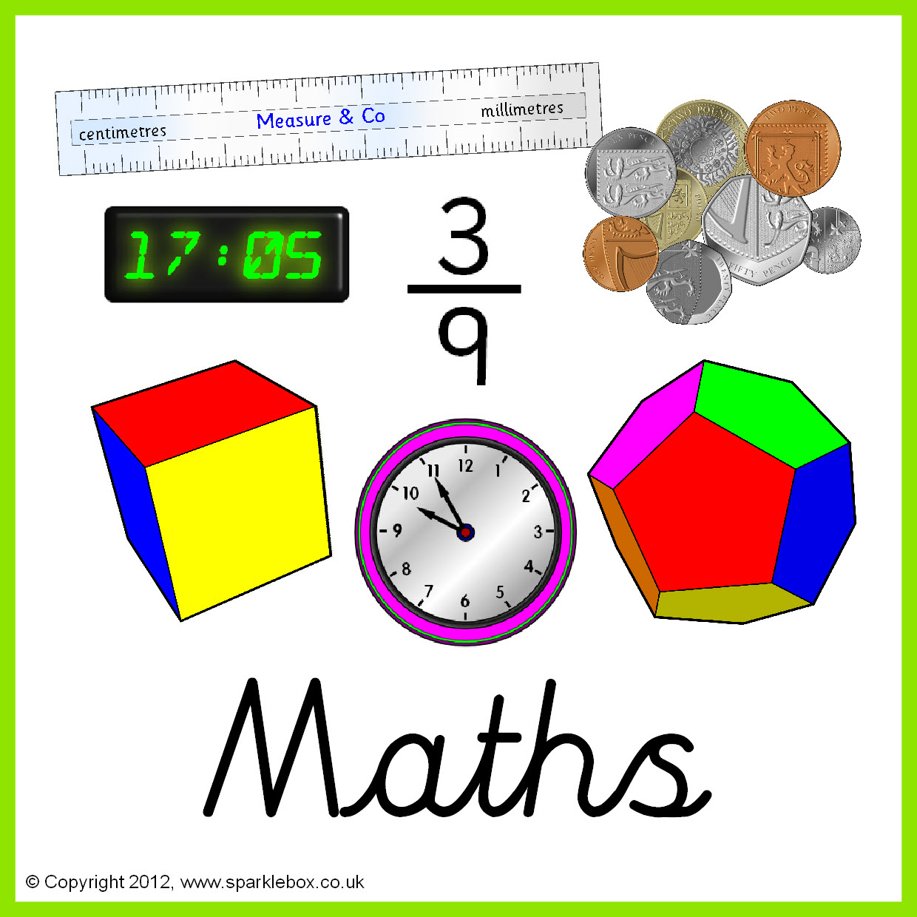

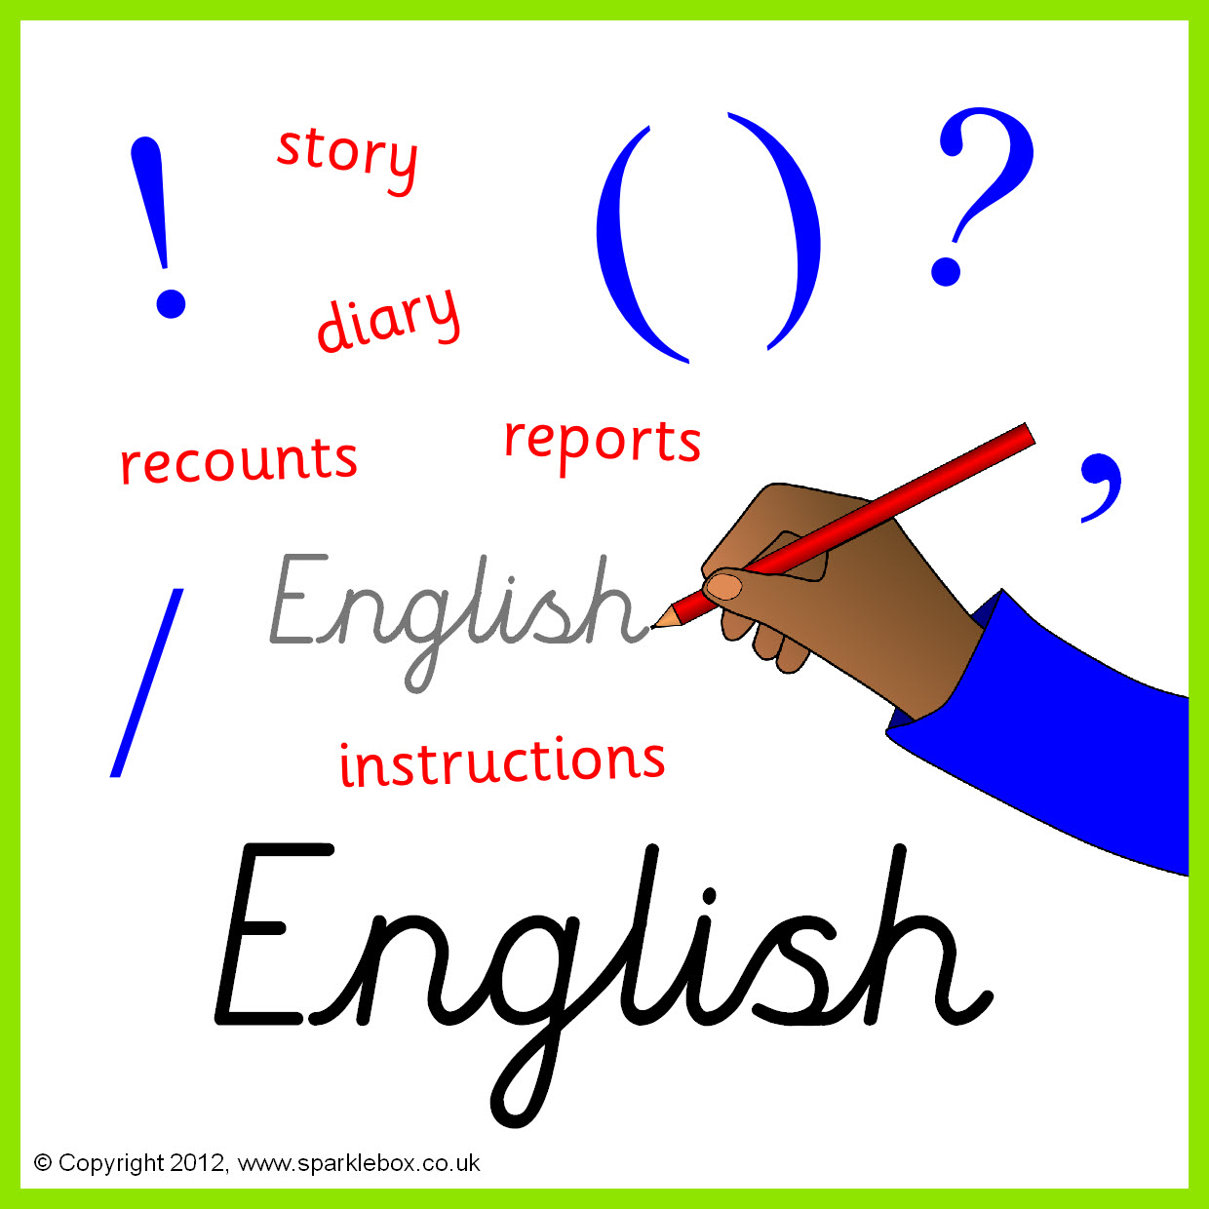

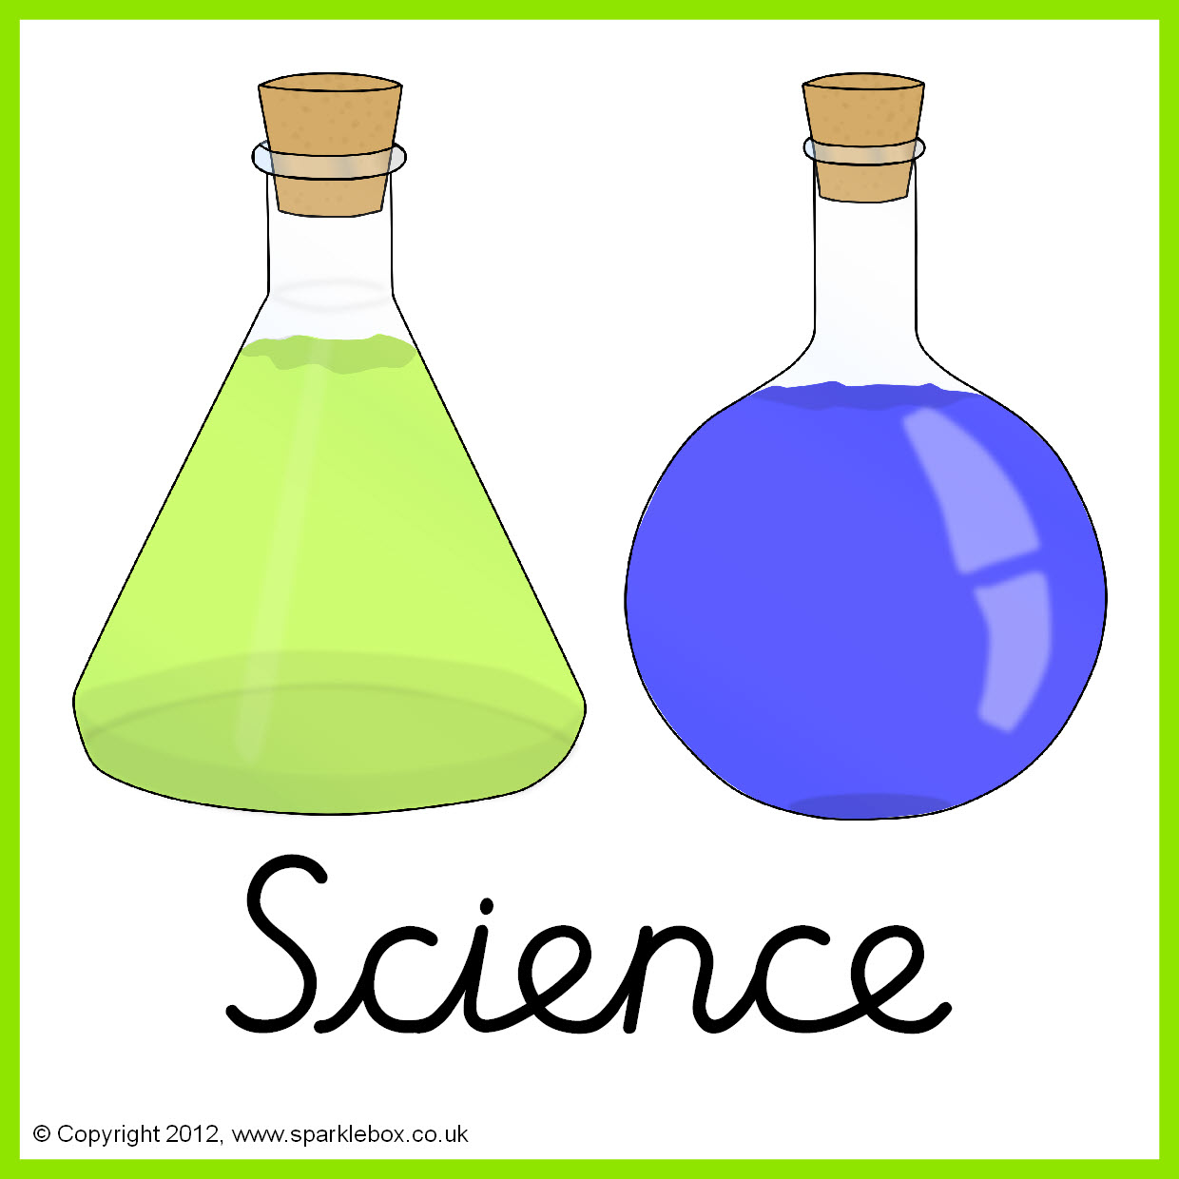

**Topic**

The Human Body – Organs and systems.

Pushes and pulls

What animals are found in different habitats?

**Topics** Taught by L.Leonard.

Algorithms

Cross curricular computing.



**Topic**

Somewhere over the rainbow -Taught by L.Fernyhough

**Topic** Taught by M.King

Extreme Earth and Natural Disasters.

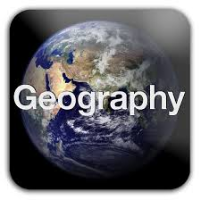





**Topic**

Spanish Food

Where do you live?

What’s in your house?

**Topic** Taught by M.King

Local History – Warrington R.L.



**Topics**

Symbols/signs.

Festivals - Eid/al Fitr.

**Topics** Taught by M.King

Rounders





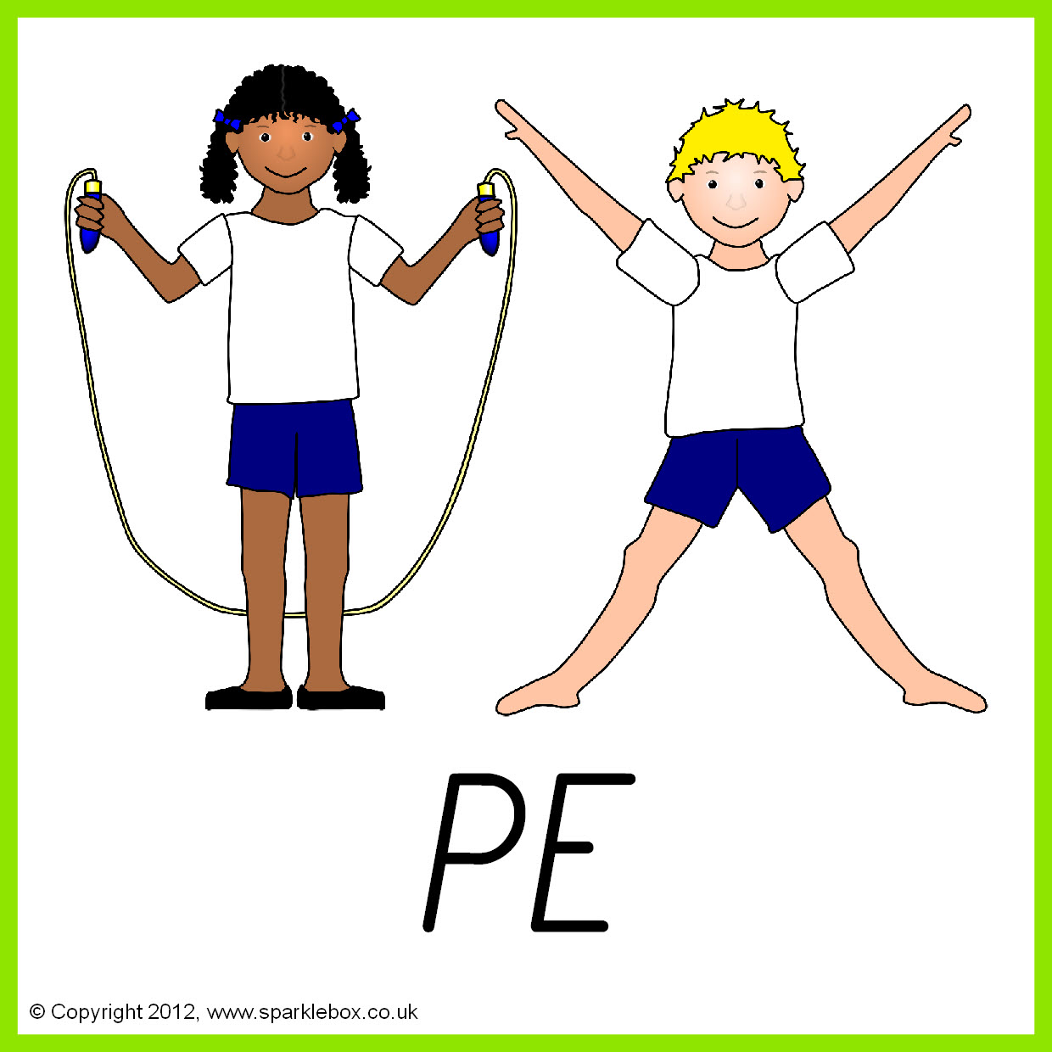

**Topic**

Living in the wider world – Personal finance and enterprise.

.

**Topic** Taught by A.Davey

Design and make a doorstop. Snack foods.

