Home Learning Activities Class P1 22.6.20
Maths (3 days)  https://classroom.thenational.academy/subjects-by-year/year-3/subjects/maths  Last week we tried the first three fractions lessons.  This week, please could we try lessons 4, 5 and 6?  The screen should look like this…  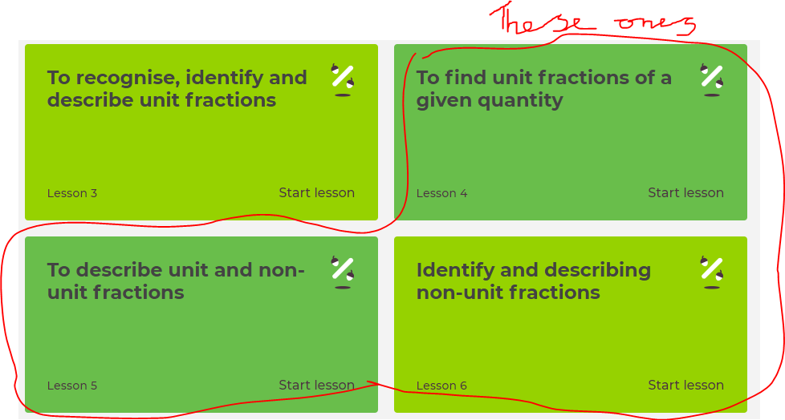 |  |  | Maths  Visit Maths Workout, Maths Whizz or Maths Warm Up and do 1 hour of activities.  (same as last week) | Maths  Find as many different ways as you can to make 200.
English (3 days of work)  https://classroom.thenational.academy/subjects-by-year/year-2/subjects/english  This week I would like to follow on from the Oak Academy lessons we did last week about the firework makers daughter.  I would like to try lessons 3, 4 and 5. It is all about writing instruction texts. Once again, this is aimed at Year 2 but I think the pitch is about right. Plus you get an actual teacher teaching you!  The screen should look like this:  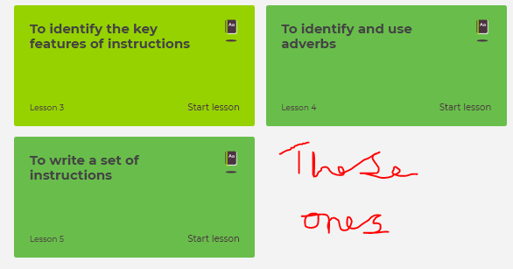 |  |  | English  Keep a daily diary of your time at home. What did you do today?  (continue from last week- this is an ongoing task) | English  Read some of your book  (continue from last week- ongoing task)
PSHE  A while ago in school we learnt all about plastic pollution. This week I’ve also attached some PDF files that are activities that are practical and fun to do. They are all about plastic pollution and what could be recycled. |  |  | PSHE  Telephone/facetime a friend and have a chat.  (keep as a weekly task) | PSHE  Play a game with someone in your house.  (ongoing task)
PE  https://www.youtube.com/watch?v=oc4QS2USKmk  This is a link to 2 avatars doing an aerobic workout!  Give it a go! | PE  Try the daily Joe Wicks PE lesson on You Tube | PE  How many of something can you do?  For example, how many keepy ups can you do with a football, how many bounces on a trampoline can you do in a row before getting tired? How many times can you thrown or bounce a ball without dropping it?  *KEEP THIS ACTIVITY FROM LAST WEEK- CAN YOU IMPROVE ON YOUR TOTAL?* | PE  Do a circuit – 20 star jumps, 10 press ups, 20 tuck jumps, 30 second wall sit. Repeat 3 times.  Keep this routine from last time BUT- can you add an extra 10 reps to each exercise?  Or, if you follow a physio programme, do some of the moves from it. | PE  Lift some weights. Use real ones if you have them or if not, use tins! Do exercises you have learned!  Continue from last week- can you do more repetitions than last week?
ART  https://www.youtube.com/watch?v=qJNSOte9h4I  This is a fun little video that shows you how to draw round you r hand and turn it into something else! | Geography  https://www.bbc.co.uk/bitesize/articles/z4qfbwx  This links to some lessons on biomes- we studied this in class earlier in the year. | History  https://www.bbc.co.uk/bitesize/articles/ztryxbk  This links to a lesson about the Romans and why they invaded Britain.  You could also go on You Tube and watch some horrible histories videos about the Romans. | SCIENCE  Honey Badgers!  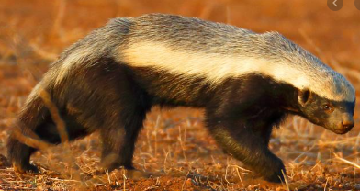  Can you find out as many facts as you can about these amazing creatures! | COMPUTING  Using e-safety rules, stay in touch and chat to your friends for an hour or two each day.  Continue from last week- it is important to maintain good relationships with friends.

****Grown-ups- please remember, do not put yourselves under lots of pressure to try and complete everything on this sheet. Do what you feel you can. If there is one particular area of interest, then do more on that and less on the other bits. I know how busy you all are in these strange times! Stay safe!****

