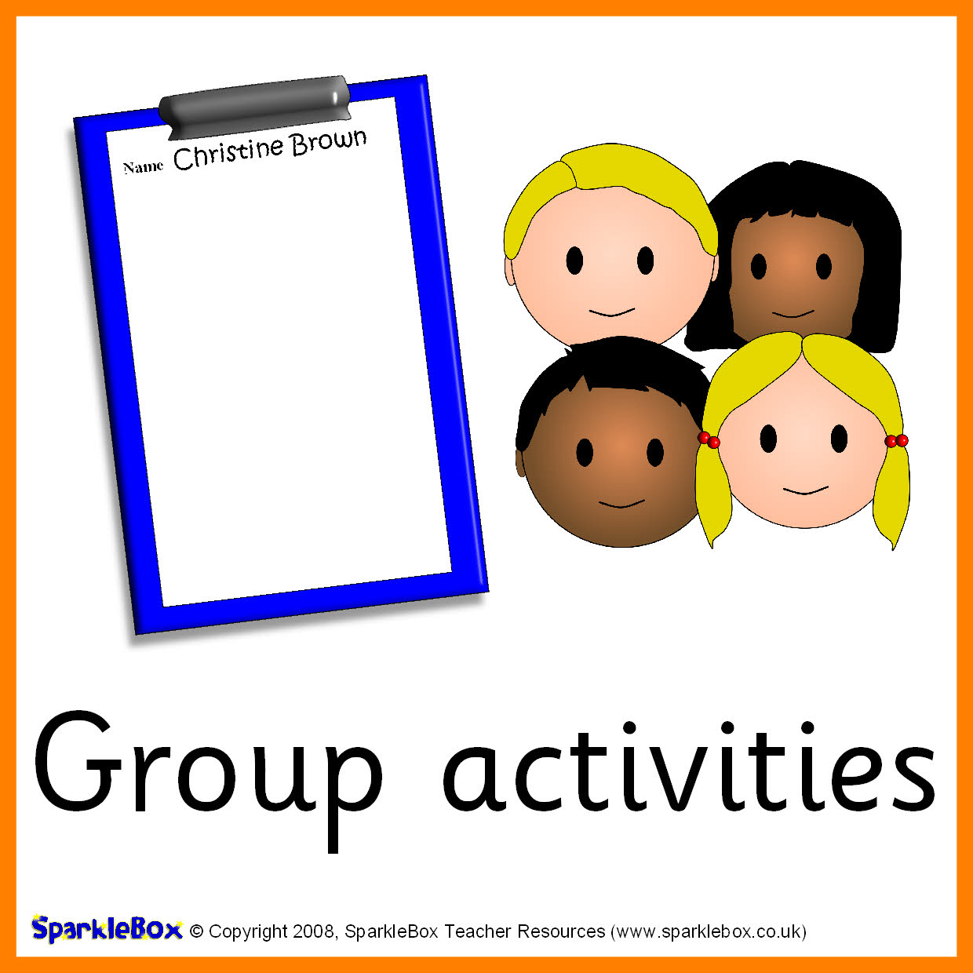

Class 3N Topics 2017/18

Reading, writing and using numbers,

Colours,

Shape,

Size,

Addition and subtraction,

Money

Time

Rhyme

Seasonal / Cultural non-fiction

Action Verses

Print around us

Recounts

Let’s write a story

Letters and sounds

Fuzzbuzz / POPAT

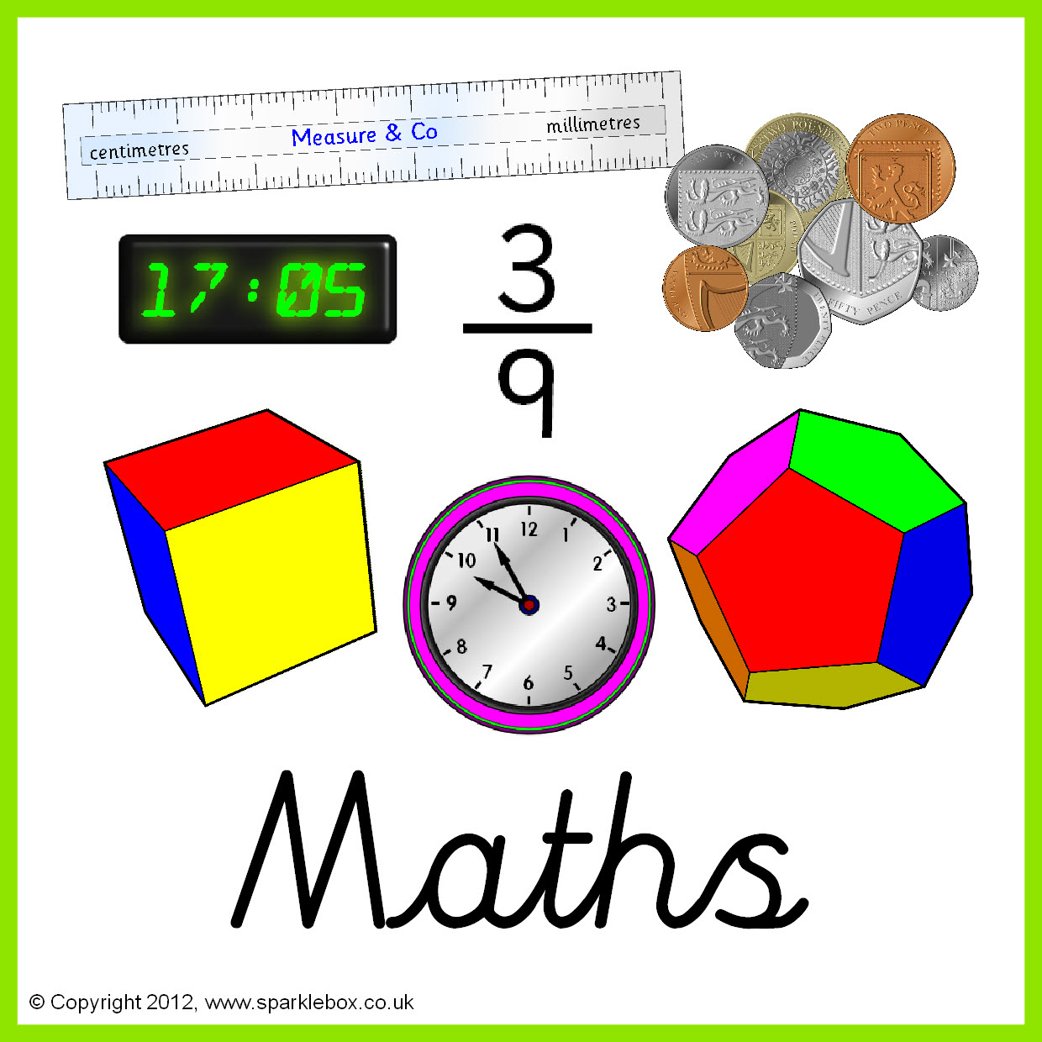

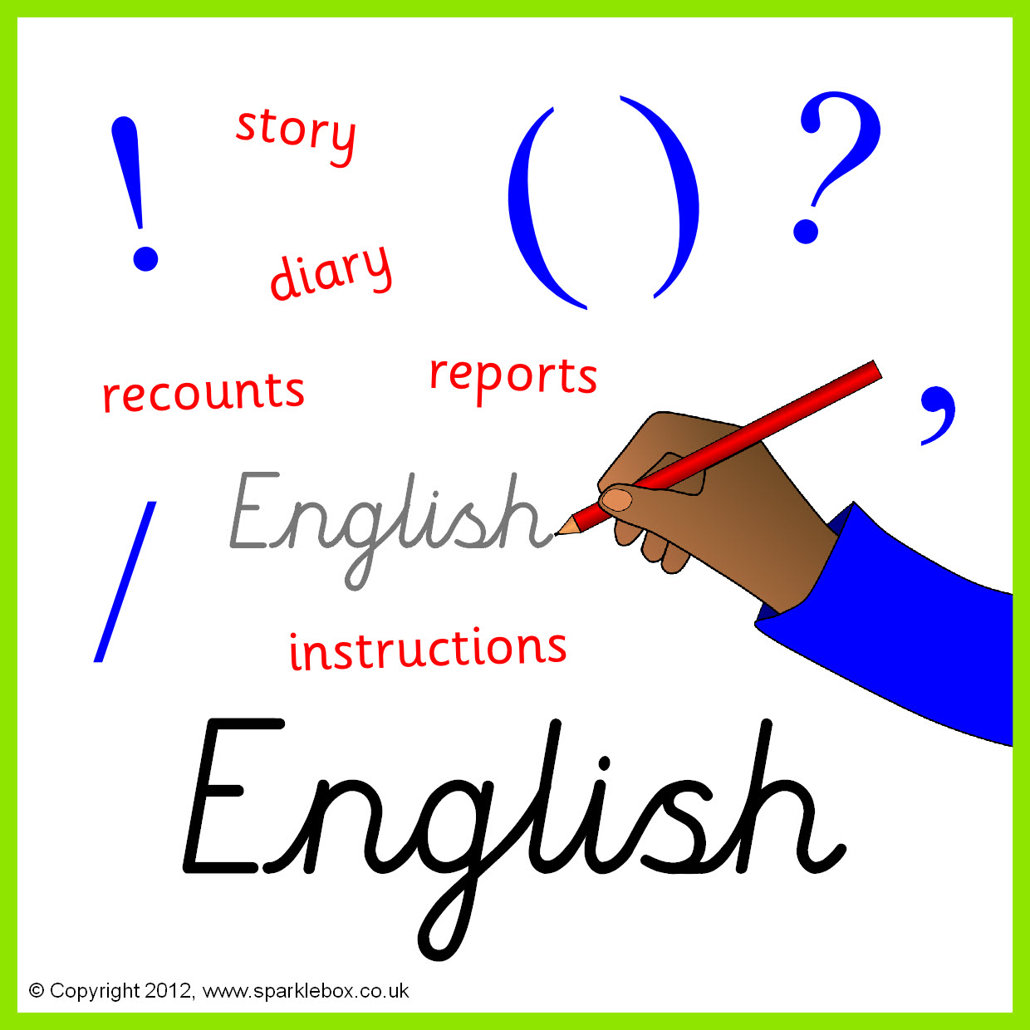

Using the touch screen

Inputting text

Using iPads / cameras

Cause and effect programmes

Using equipment in the sensory room

Senses

Time of our Life

All dressed up

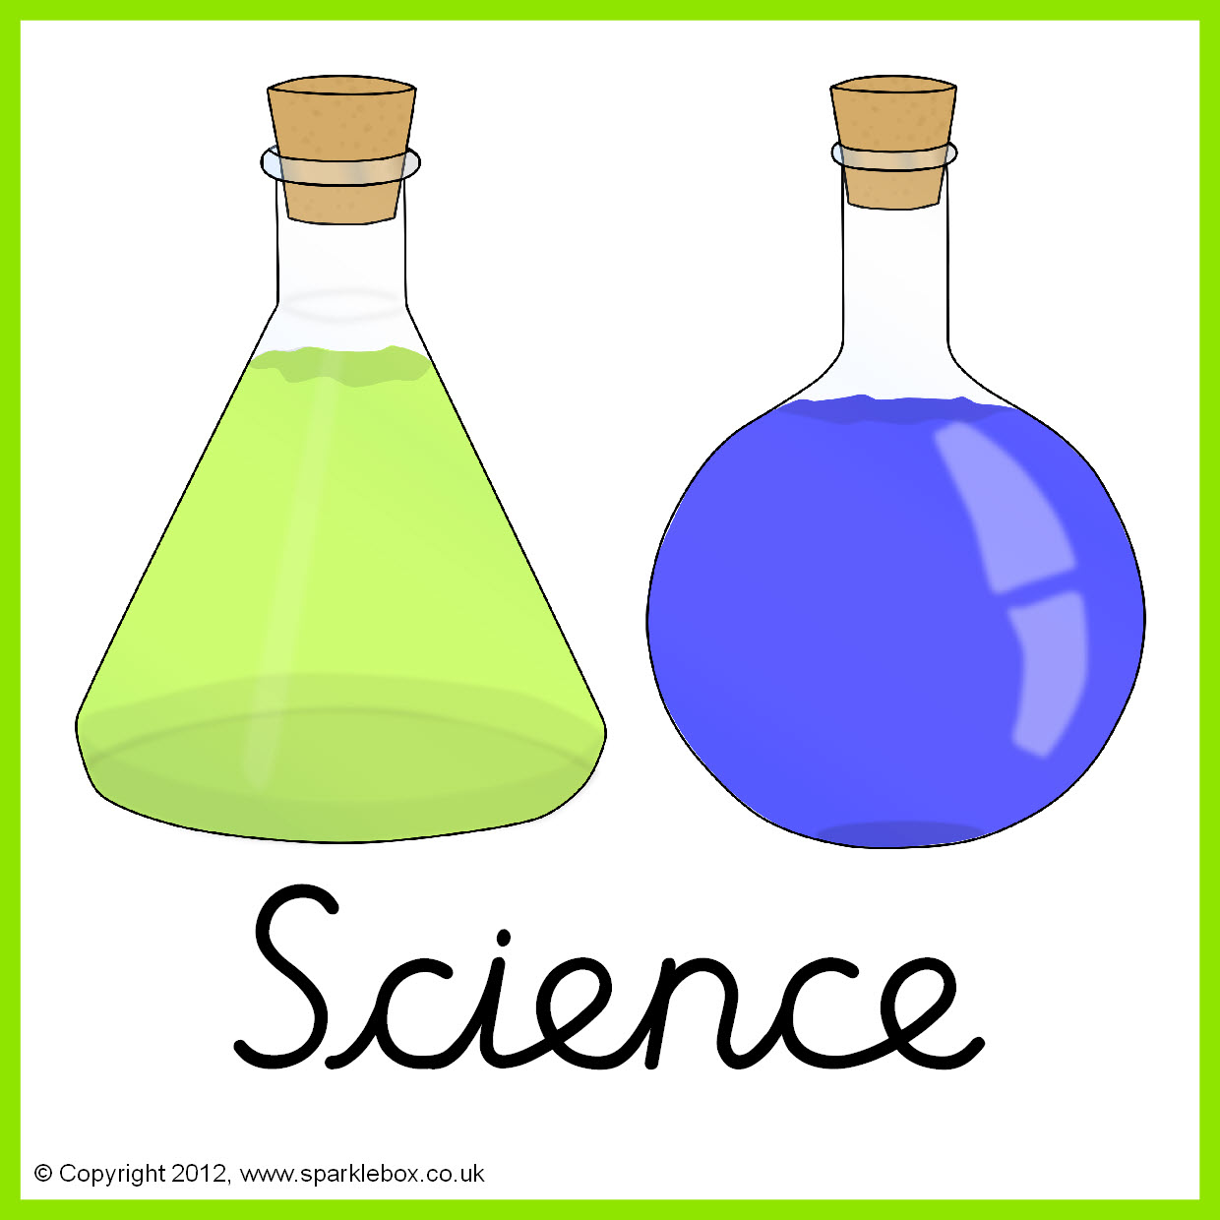



Colours

Celebrations

Under the Sea

Plants and Flowers

Zoo Animals

Woods and Forests

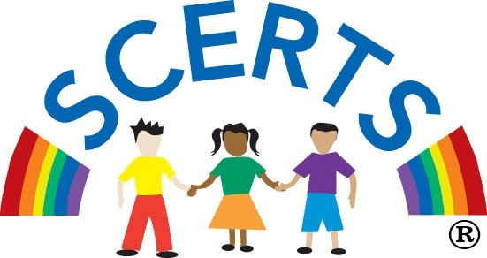

Essential skills e.g. new & old / my family/ my school / sequencing / handling artefacts etc

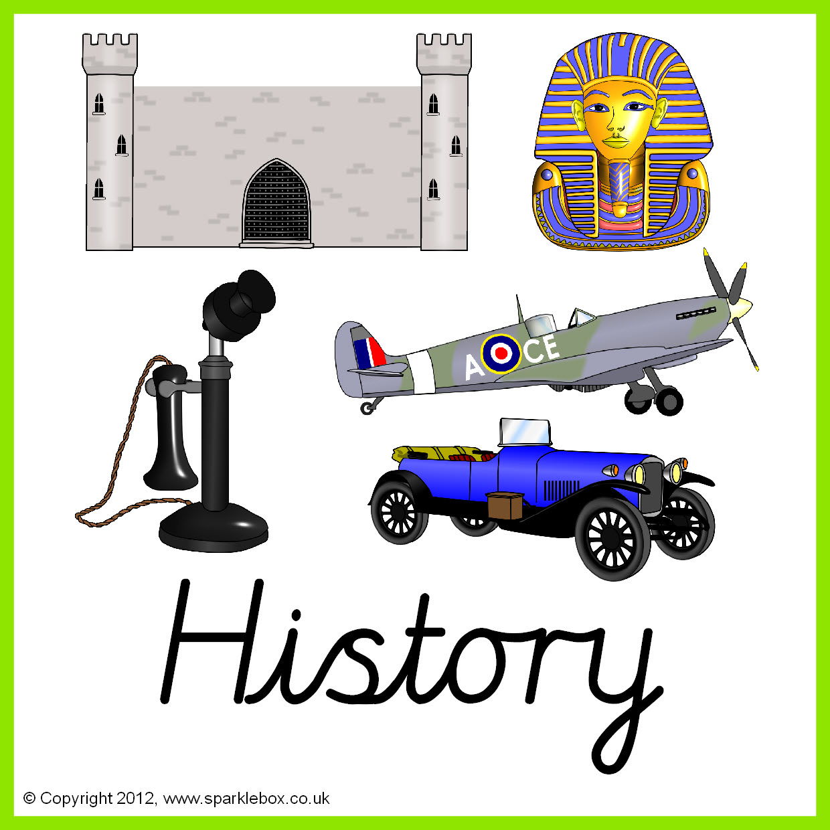

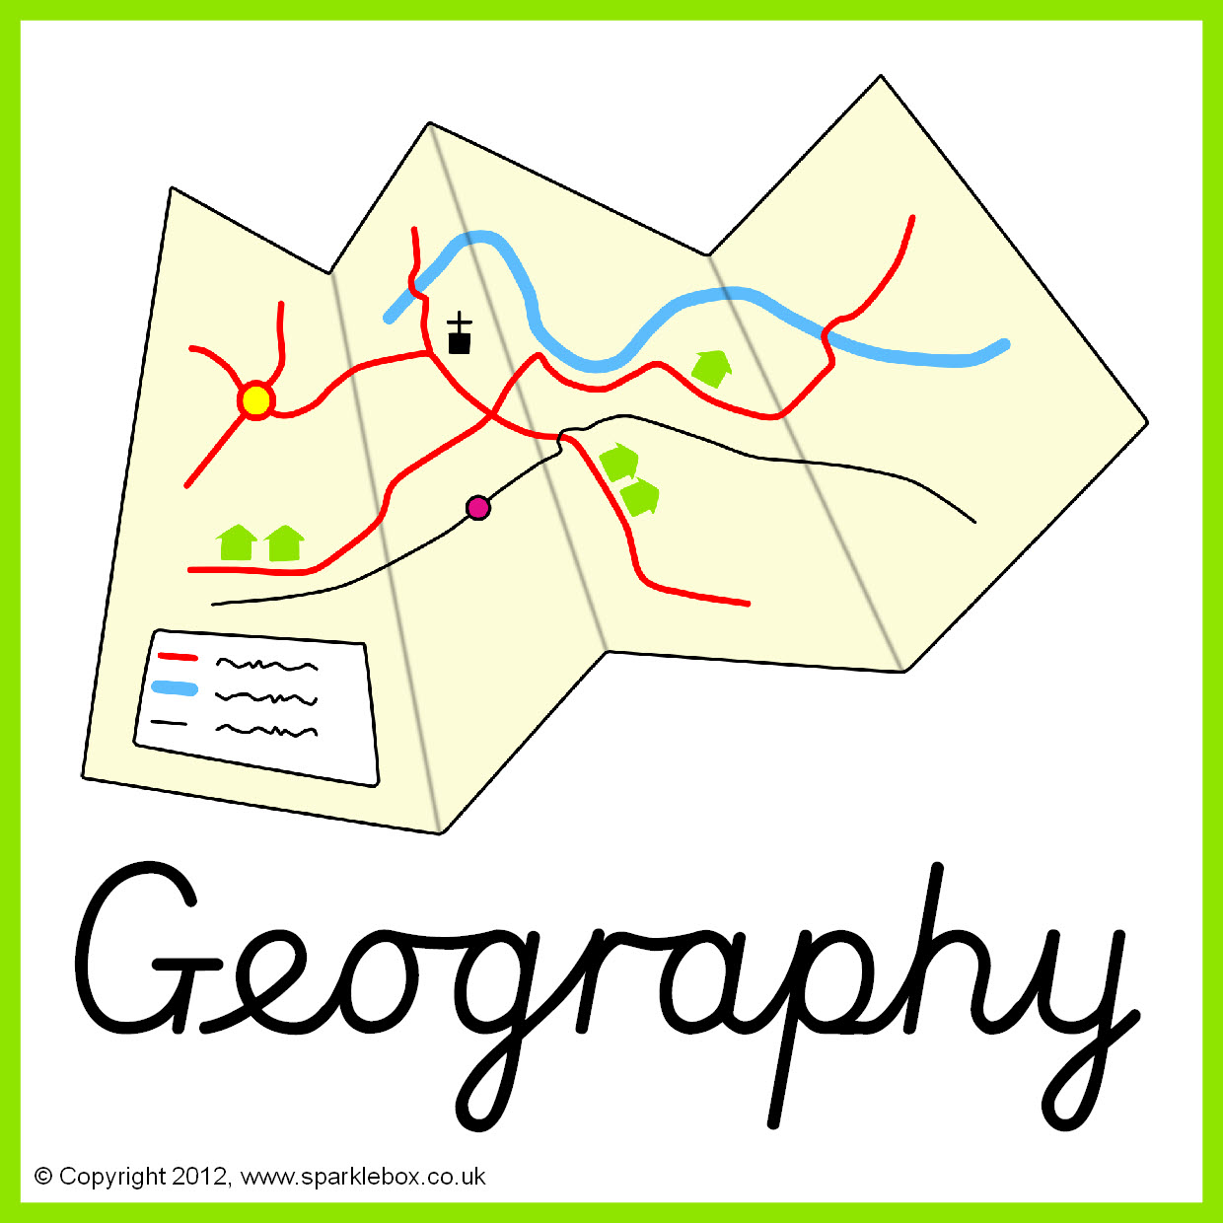

Essential skills e.g. moving around school / the local environment / using geographical language e.g. road, hill / visiting places / my home

Celebrations

Being a friend

My family

Being kind to others

Taking part in assembly / school performances

Essential skills e.g. moving safely, following instructions, jumping, rolling etc

Personal Care

