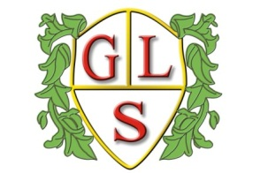
Class P1 Topics Spring 2019

Maths
Fractions, decimals, percentages, money

English
Class work based on the novel, ‘2 weeks with the Queen’

Science
Rocks and different rock jobs
Sounds and sound waves

History
Anglo Saxons (Spring 1)

Geography
Continents and famous landmarks (Autumn 2)

ICT
Databases (Spring 1)
Spreadsheet basic skills(Spring 2)

Design Technology
Jewellery (Spring 1)
‘Food in a hurry’ (Spring 2)

Spanish
Colours, songs, conversations, food

RE
Sacred Texts (Spring 1)
Easter Celebrations (Spring 2)

Art
‘Journeys’
‘Tim Burton creatures’

PSHE
Citizenship, nationalities, democracy, discussion

PE
Gymnastics

