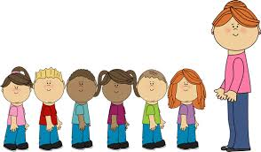

Letters and sounds

Animal Boogie

Walking through the jungle.

Rumble in the jungle.

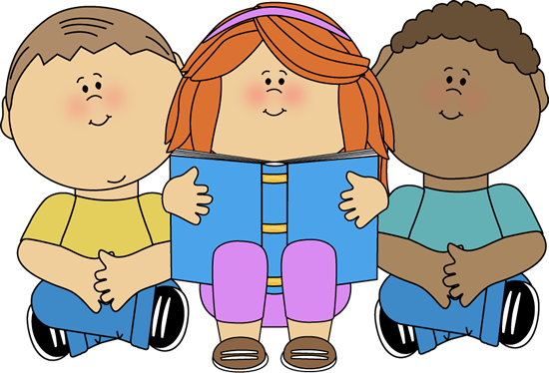

Dance.

Help with dressing and undressing.

Using the O.T. room.

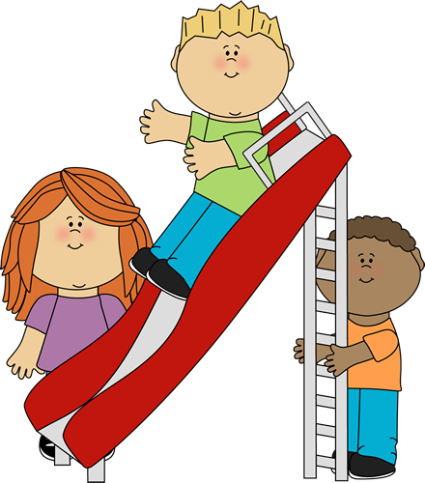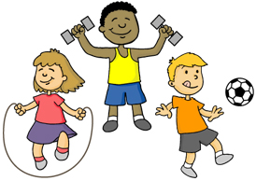

Using PECS/ Makaton

Identifying naming words and action words.

Copying familiar words and expressions.

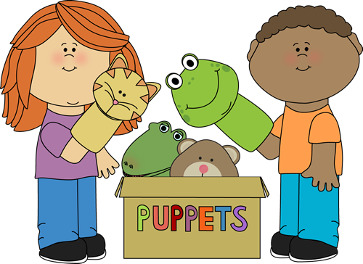

Expressing preferences

Being interested in others play and starting to join in.

Developing friendships with other children.

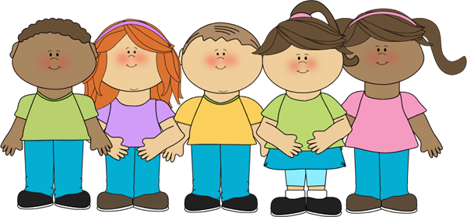

Physical Development

Communication and language.

Class 1 Staff

Mrs C Skermer

Miss H Chadwick

Mrs K Lothrop

Our curriculum is based on the EYFS strategy. We encourage the children to explore and learn through play.

Class 1 Spring 2019

Jungle crafts.

Jungle patterns

Dance.

Music.

Exploring using all the senses.

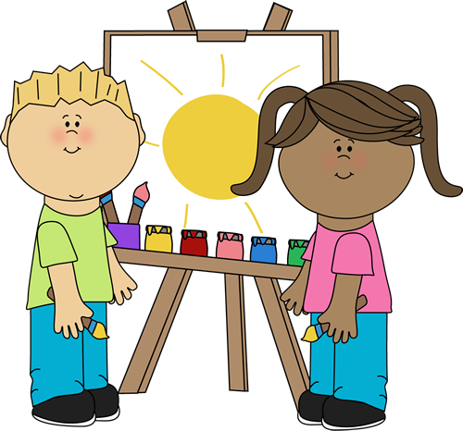

Jungle animals.

Jungle habitats

Chinese new year

Keep on moving.

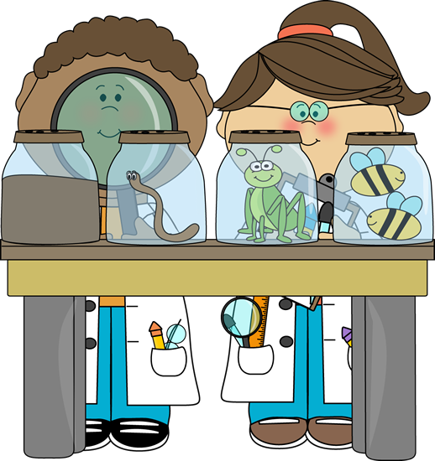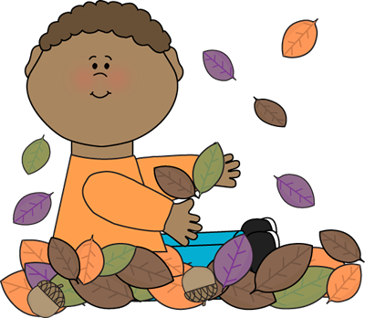

Learning and recognising numbers.

Organising sorting objects.

Sequences and routines.

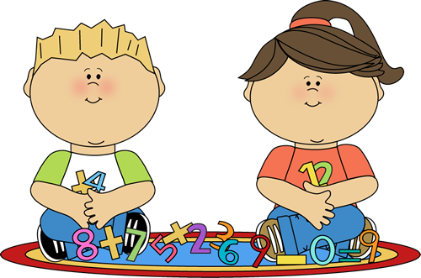

Personal, Social and emotional development.

Expressive Arts

Knowledge and understanding of the world.

Mathematics

Literacy

A Unique + Positive + Enabling = Learning and

child relationships environments development