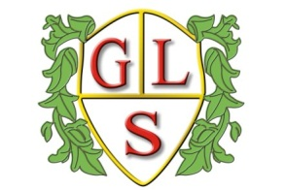
Class P5 Topics Spring 2019

Our topic theme this term is ‘Out of this world’

English
Poetry- oral performance and Children’s authors

Maths
Money
Number- ordering and comparing, estimating
Data Handling
Number- Addition and subtraction, fractions, times tables

Science
Forces
Space and the Solar System

History
Study beyond 1066- Man on the moon

Geography
The world-

ICT
Music using technology

Spanish
Where in the world?

RE
Signs and symbols- What lights our way?
Easter Story

Art
Out of this world

Design Technology
Making Rockets

PSHE
SRE
Personal Wellbeing- Looking to the future

