Class 5 Summer 2018

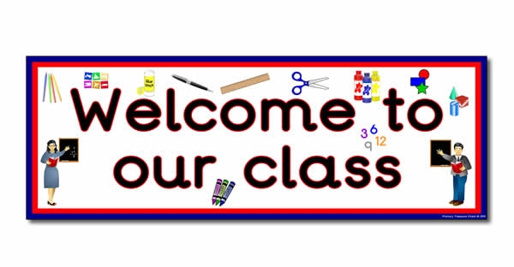

Class 5 staff

Mrs H. Williams

Mrs C. Dumican

Topics

**Number:** Number and place value, Comparing numbers. Addition and subtraction. Multiplication, (identify doubles to 20) Division (sharing and grouping)

**Shape:** combinations of shapes in patterns

**Measures:** time – dates, months, weeks, days

Capacity – volume full/empty

**Data handling:** interpret and construct simple pictograms, tally charts and graphs

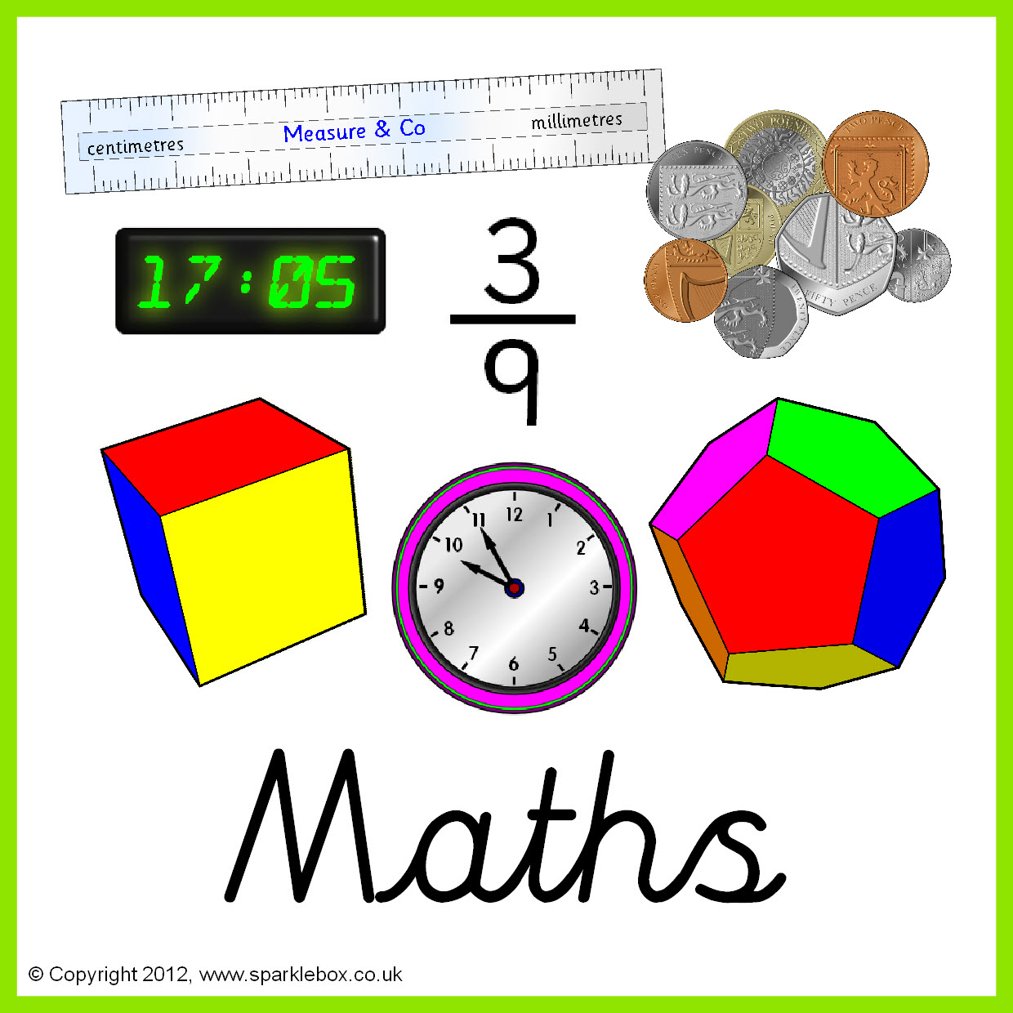

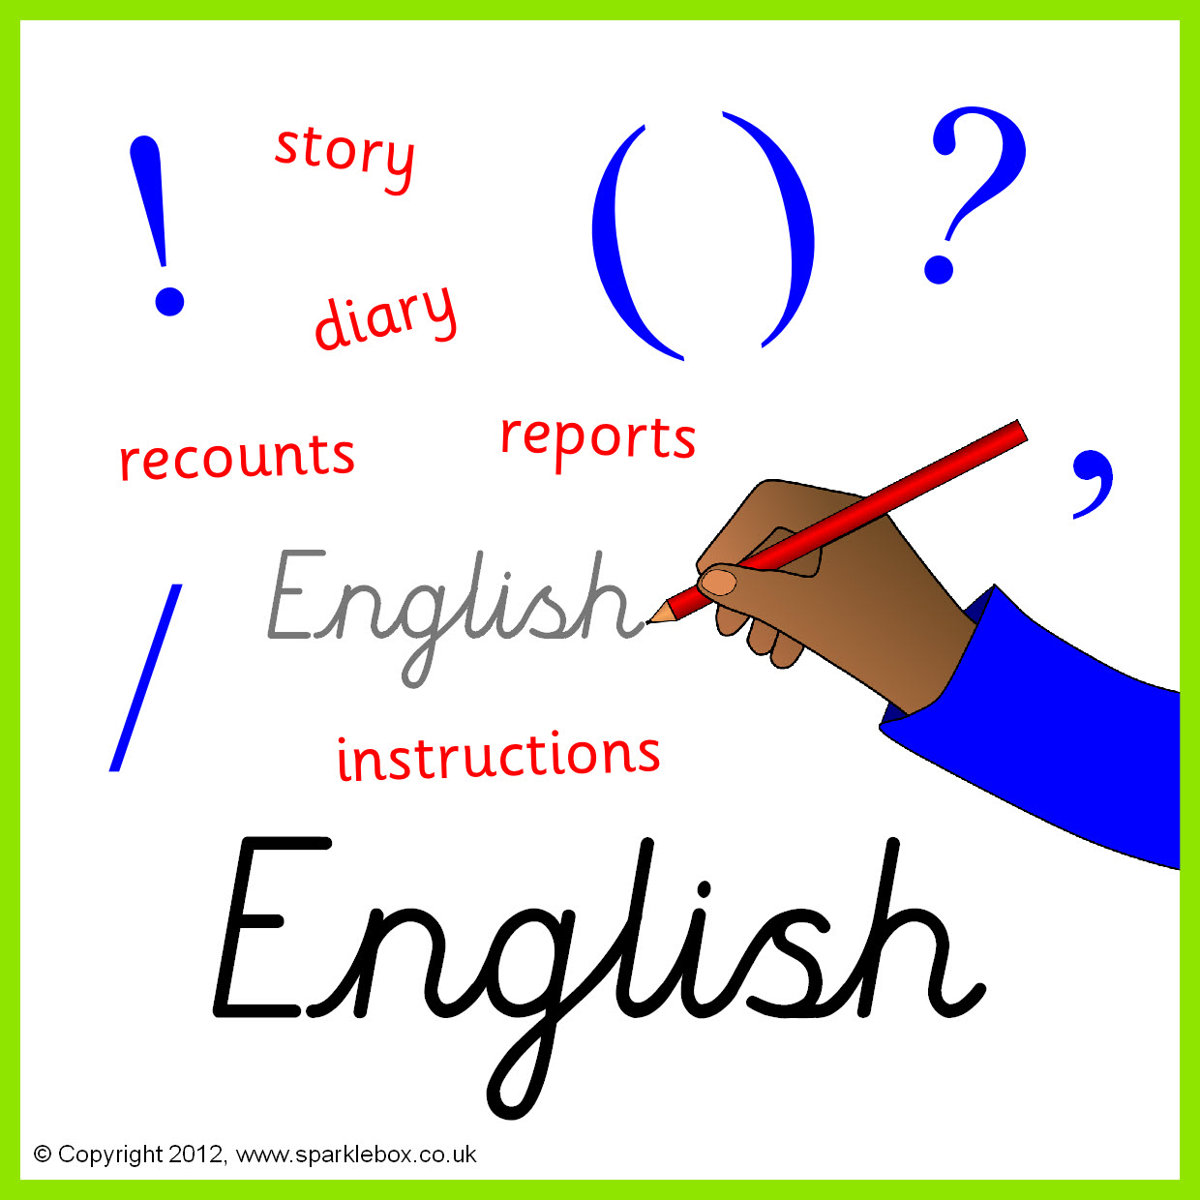

Topics

Persuasive writing

Film and play scripts

Letters and sounds and Popat phonics work, Guided Reading,

Handwriting.

Speech and language work.

Topics

Branching databases

Simulations

Graphing

Cross curricular computing.





Topic –

Forces

Electricity

**Topic**

Weather around the world





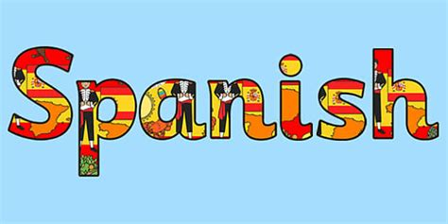

**Topic**  Collaging

Key Skills –using different materials to create pattern, precision, using technology to create art

Topic

The wright brothers



**Topic**

Fiestas, colours, Spanish flag

**Topics**

Islam – what can stories teach us?

Journeys – what is a good life, well lived?

**Topics**

Health and fitness, athletics





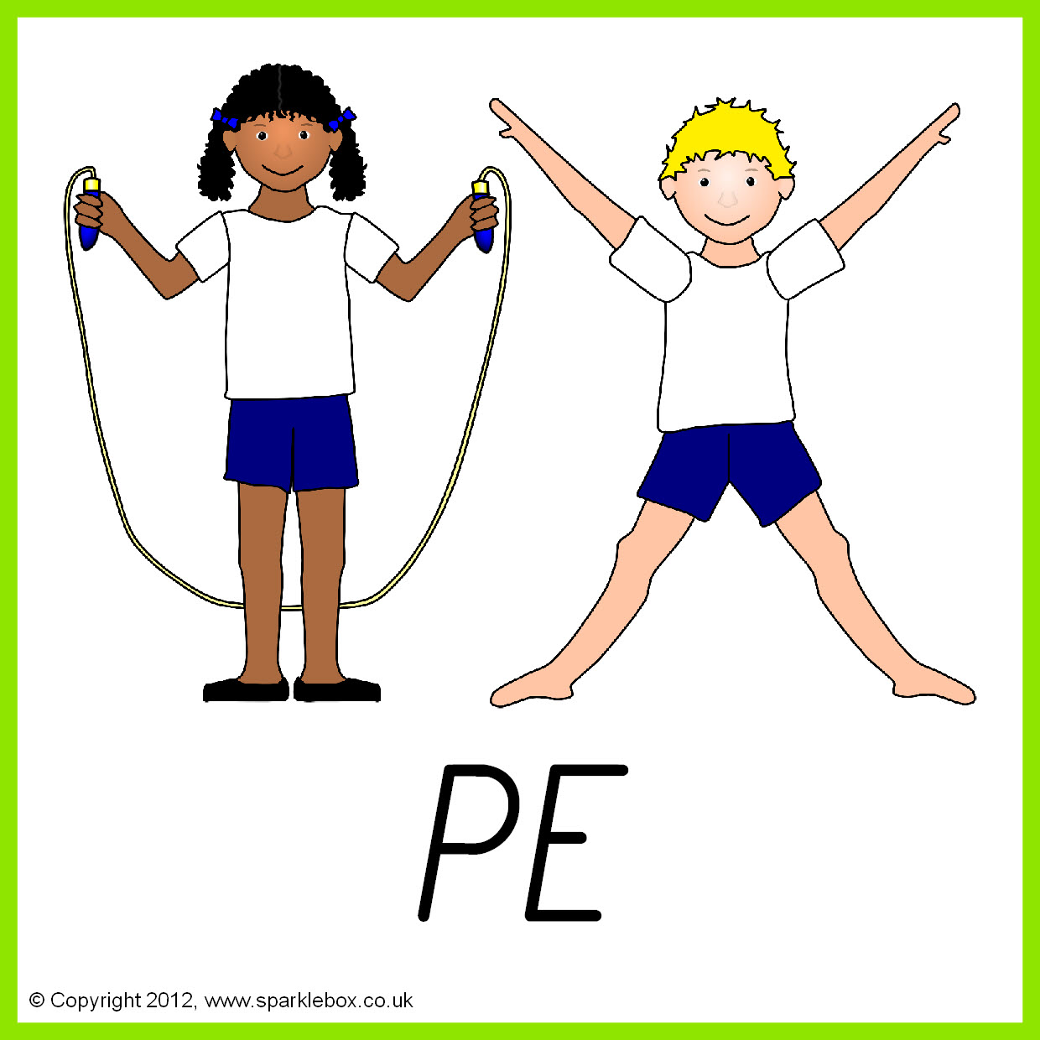

**Topic** My school community

Strengths and achievements

**Topic** –

Pop up books and moving pieces

