Class 5 Autumn 2018

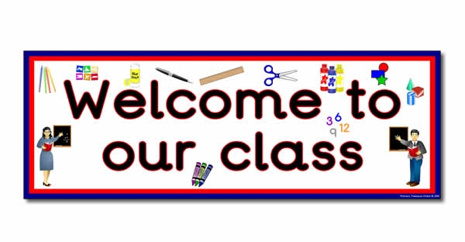

Class 5 staff

Mrs H. Williams

Mrs C. Dumican

Mrs E. Bourque

Topics

**Number -** Number and place value, Comparing numbers. Addition and subtraction. Multiplication, (identify doubles to 20) Division (sharing and grouping)

**Shape -** naming 2D and 3D shapes

**Measures - telling the** time – dates, months, weeks, days. Telling time using analogue to nearest hour/half hour

Measures – length

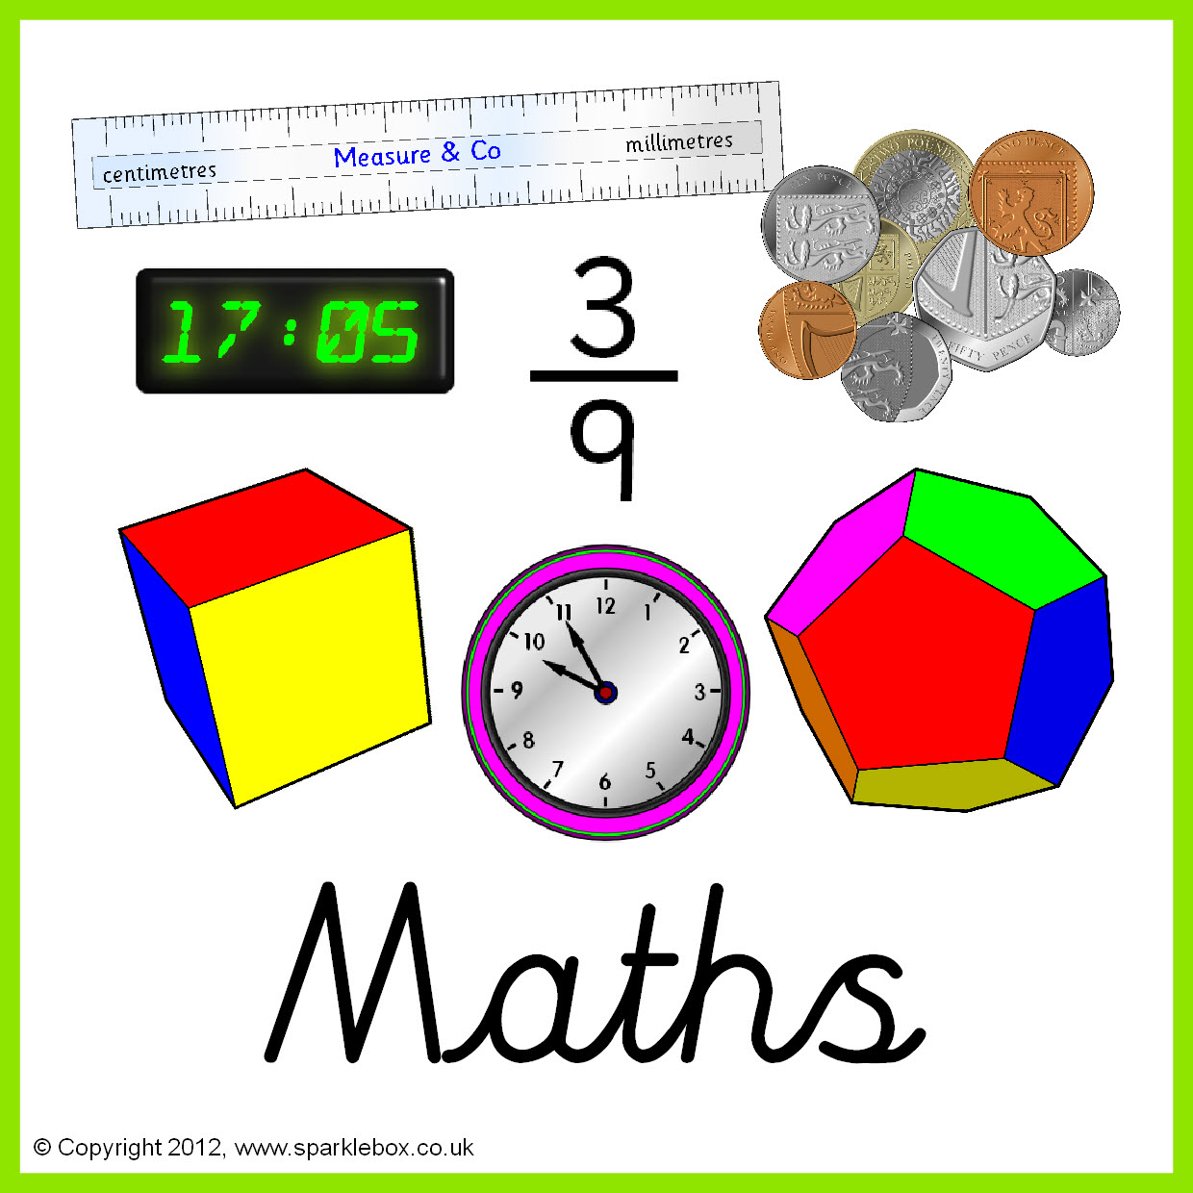

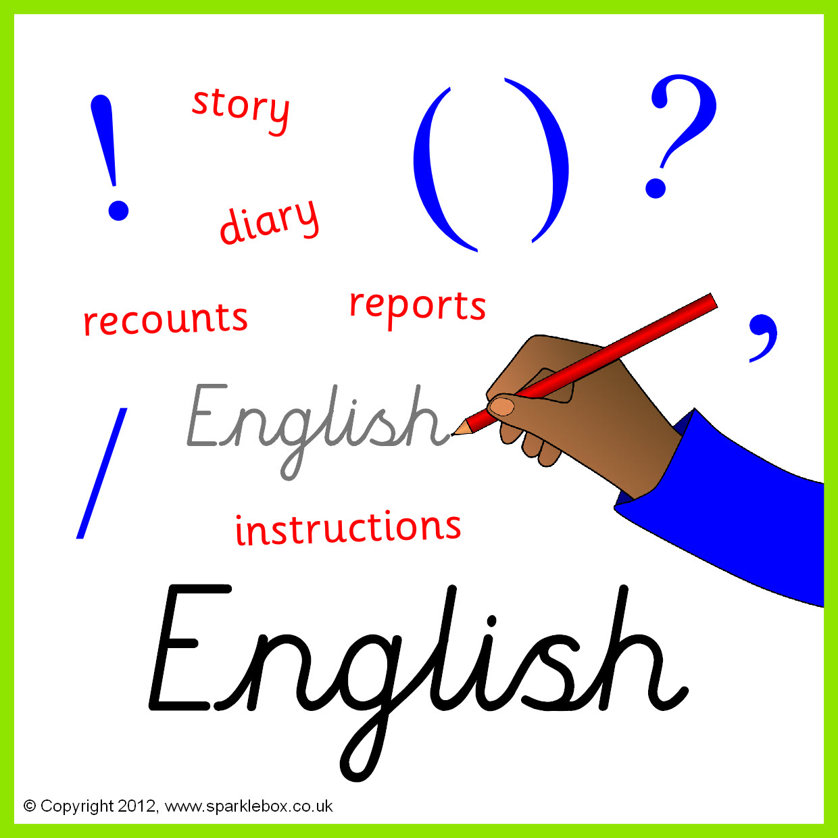

Topics

Stories by the same author

Persuasion and class poetry

Letters and sounds and Popat phonics work, Guided Reading,

Handwriting.

Speech and language work.

Topics

Online safety

Coding

Cross curricular computing.

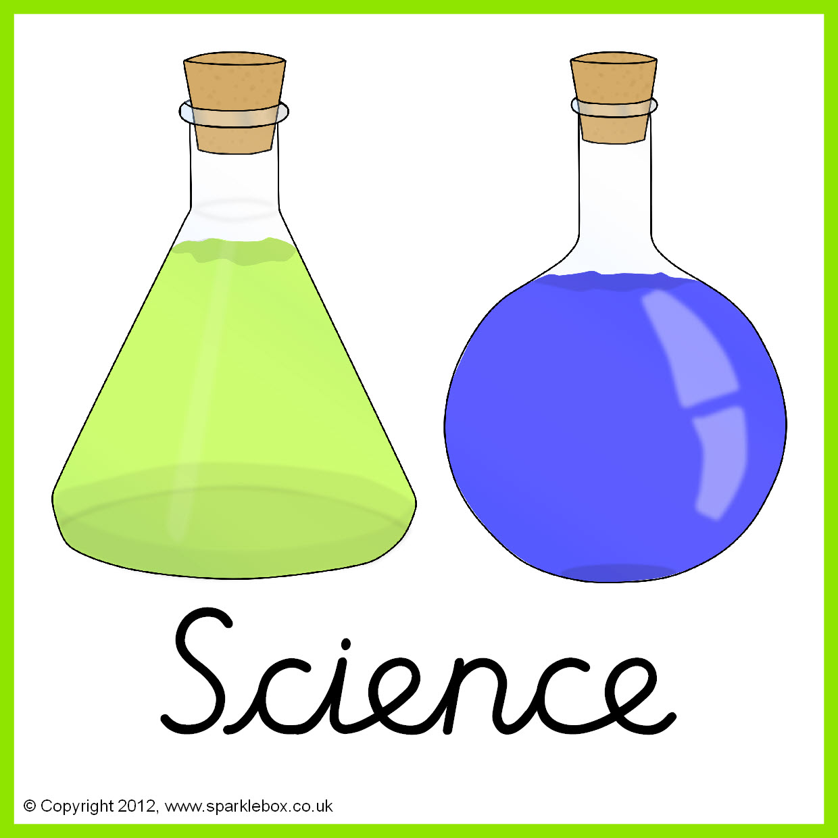



Topic –

Human digestion

Teeth

**Topic**

Scotland and Wales





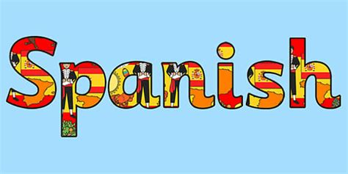

**Topic**  Faces

Key Skills –using different materials to create pattern, precision, using technology to create art

Topic

The gunpowder plot



**Topic**

Greetings – my name / numbers 1-10

**Topics**

Harvest festival

Christmas story

**Topics**

Dance / gymnastics





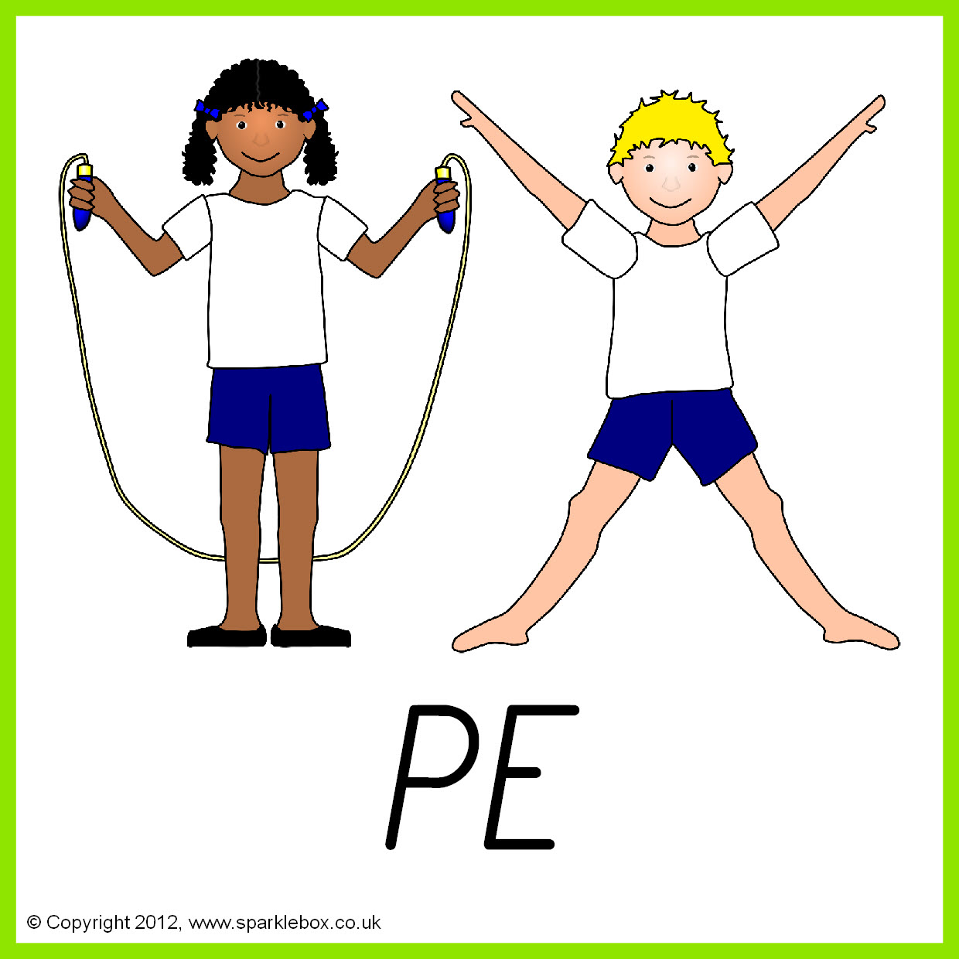

**Topic** – taking part

**Relationships and emotions**

**Topic** –

Balanced diet – cakes and treats

