
Home Learning Activities
Class: P4 Week: 8 Week Beg: 11.5.20

Maths  Complete 1-2 pages of the home learning pack. | Maths  Make your own number line, either from 1-10, 1-20 or 1-30!  You can use your number line to help you with your maths worksheets. | Maths  Count how many shoes you own! | Maths  Complete some simple sums – have an adult make some sums up for you. Use your number line to help!  Remember to jump along your number line! | Maths  Make a paper chain with 10 chains!  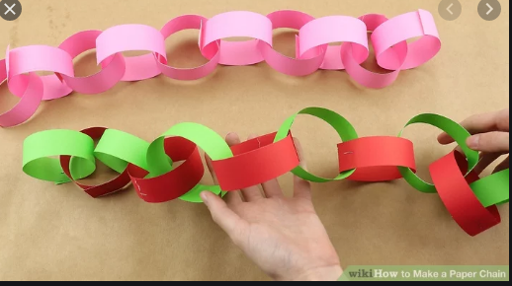
English  Tell an adult or write down what you did at the weekend. You could record it on video and put it on EfL! | English  Read a book or have an adult read a book to you.  Answer questions about the story. | English  Draw a picture and then describe the picture. E.g. draw a house and describe the features, such as a door, windows etc. | Handwriting  Practice writing the letters: a, b, c and d. Write the letters big and small, use different colours to write the letters.  If you have play dough then make the letters out of play dough. | English  Complete 1-2 pages of the home learning pack.
Fine Motor Skills  Use Lego or building blocks to make a house. | Fine Motor Skills  If you have paper clips, then make a chain using them. Can you make the chain 10 paper clips long? | Fine Motor Skills  Draw some squiggly lines on a piece of paper, and then use scissors to cut along those lines. | Fine Motor Skills  Make a drink yourself, with adult supervision and a little support if needed. | Fine Motor Skills  Colour in a picture.
PE/Gross Motor Skills  Watch an episode of Cosmic Kids on Youtube and have a go! | Sensory  Put some paint in a zip lock bag and draw patterns using your finger.  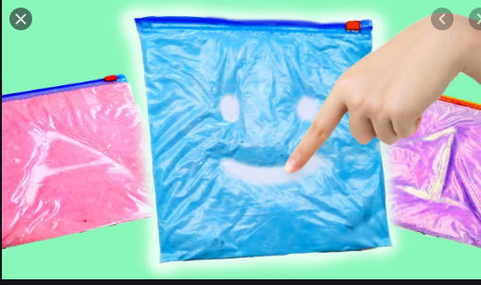 | PE/Gross Motor skills  How many laps of your garden or living room can you do? | PE/Gross Motor skills  Have a go at holding the ‘plank’! If you find this difficult, rest on your knees when you are doing it. | PE/Gross Motor Skills  How many high knees can you do?
Music  Learn the dance to a song, e.g. Steps 5,6,7,8! | Computing  Play some educational games on one of the websites that school have recommended, e.g Purple Mash | PSHE  Help an adult to cook or bake. | Geography  Find some flag colouring on Google or have a go at drawing different flags yourself. | Science  See what sinks and floats in a tub of water.

