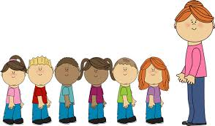



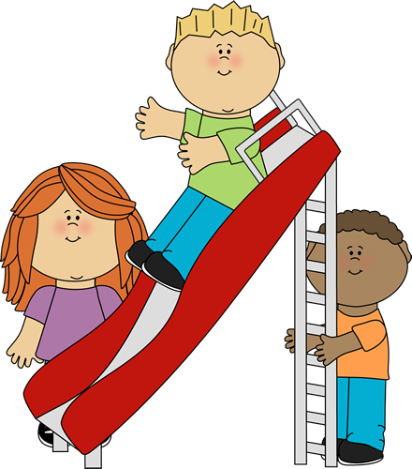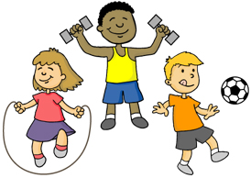

Using PECS/ Makaton

Answering simple questions.

Rhyming words.

Copying familiar words and expressions.

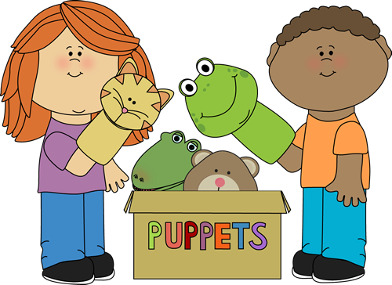

Expressing preferences

Sharing

Understanding emotions

Developing friendships with other children.

Doing things for myself.

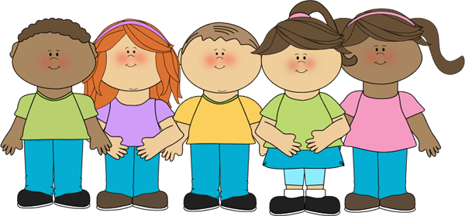

Physical Development

Communication and language.

Class 1 Staff

Mrs C Skermer

Miss H Chadwick

Mrs K Lothrop

Our curriculum is based on the EYFS strategy. We encourage the children to explore and learn through play.

Class 1 Summer 2019

Letters and sounds

Foundation Pop-at

Aaggh Spider

Caterpillar Shoes

Creepy crawly Calypso,

Hungry Caterpillar

Moving in different ways.

Dressing and undressing.

Using the O.T. room.

Minibeast crafts

Patterns in nature

Dance.

Music.

Exploring using all the senses.

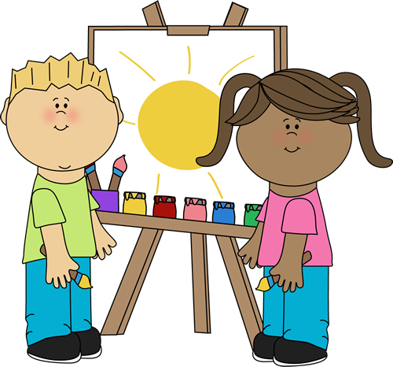

Minibeasts

Healthy eating

Food for thought

Passover

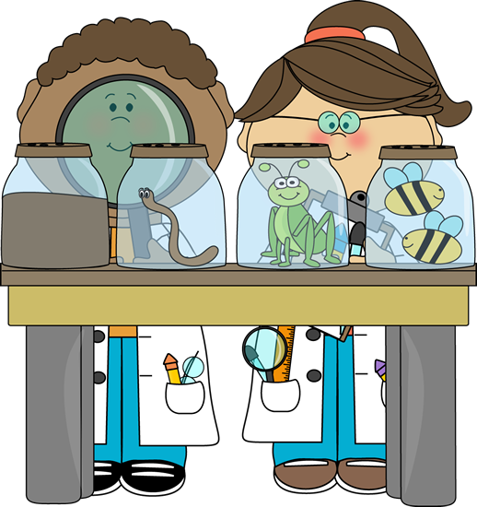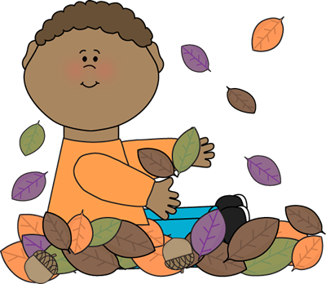

Learning and recognising numbers,

Sorting and patterns,

Shapes and measuring,

Positions

Adding and taking away.

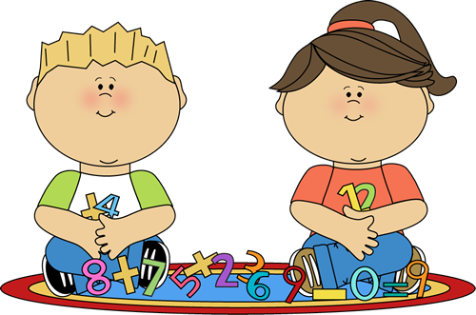

Personal, Social and emotional development.

Expressive Arts

Knowledge and understanding of the world.

Mathematics

Literacy

A Unique + Positive + Enabling = Learning and

child relationships environments development