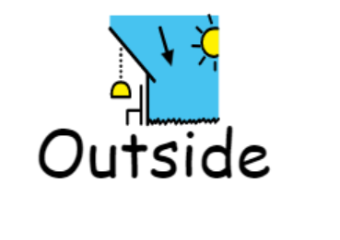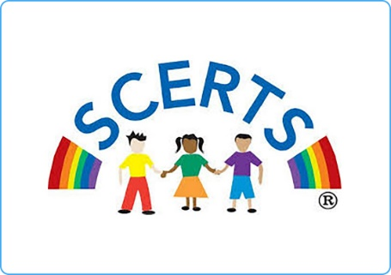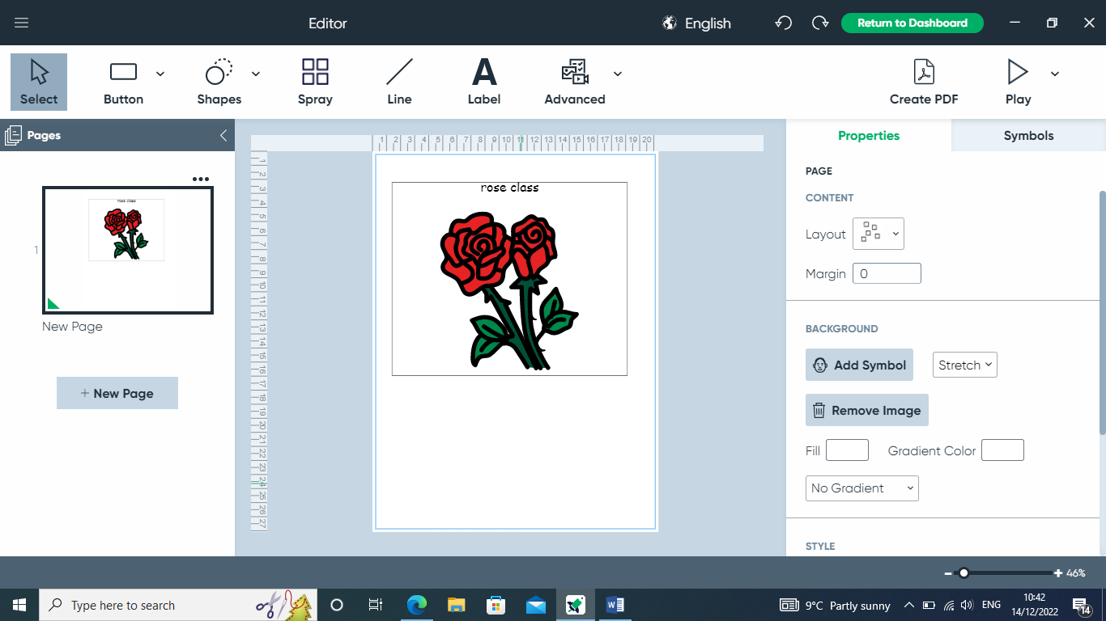

**Topics**

Addition and subtraction

Measuring Mass

Time

2D shapes- Properties of shapes, Making pictures using shapes, Repeating patterns, Positions

**Topics**

Adventure stories

Teddy bears picnic

**Topics**

Sound and music

Programming and algorithms

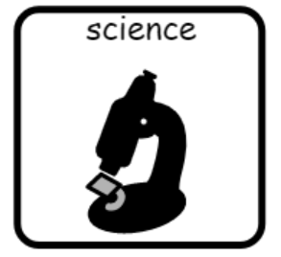

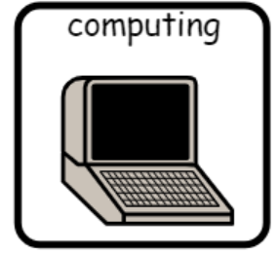

**Topics**

Lets go outside - plants

What does it light up?

Science day – what do we know about the dinosaurs?

**Topic**

Colours and pattern

**Topic**

UK landmarks

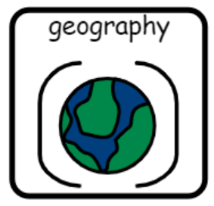

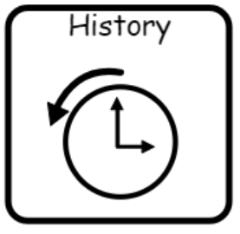

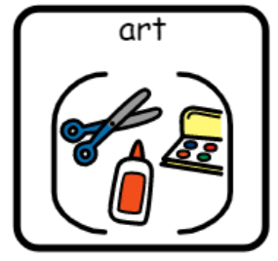

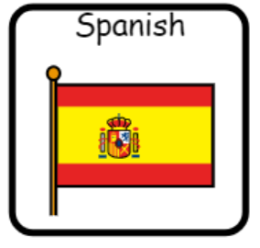

**Topics** –

Numbers to 5

All about Spain

**Topic**

Houses past and present

**Topics**

The Church

The Easter story

**Topics**

Games

Core skills

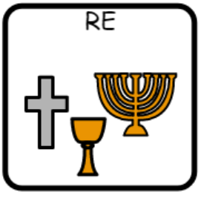

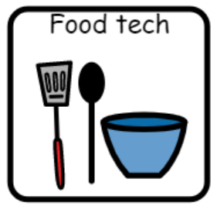

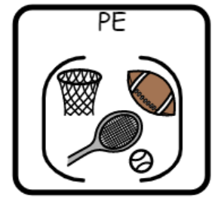

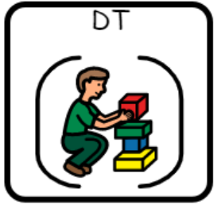

**Topic**

Sandwiches and wraps

**Topic** –

Buildings