
Home Learning Activities
Maths Overview: This week, we will be exploring Addition and Subtraction
Definition and examples - Addition – to understand the process of combining two groups and that the answer is bigger than the two initial numbers.
Subtraction - to understand the process of taking away from a group and that the answer is less than the original number.
Useful websites- https://uk.splashlearn.com/class/mrs-mac-class-6/grades/first-grade/curriculum
https://www.topmarks.co.uk/maths-games/5-7-years/addition-and-subtraction
https://www.bbc.co.uk/bitesize/topics/zwv39j6 (Key Sage 1) (Key Stage 2) https://www.bbc.co.uk/bitesize/topics/zy2mn39
Monday | Tuesday | Wednesday | Thursday | Friday
Maths  Watch the clip…  https://www.bbc.co.uk/bitesize/topics/zwv39j6/articles/z8hyfrd  Have a go at collecting two different groups of objects (Eg. 5 socks and 3 socks). Practice combining the two groups together. Remember to put the largest group first.  Have a go at writing a number sentence (E.g. 5 + 3 = 8). | Maths  Have a go at completeing some addition number sentences using the number lines that you made last week.  Practice jumping up along the numer line to find the answer.  E.g…  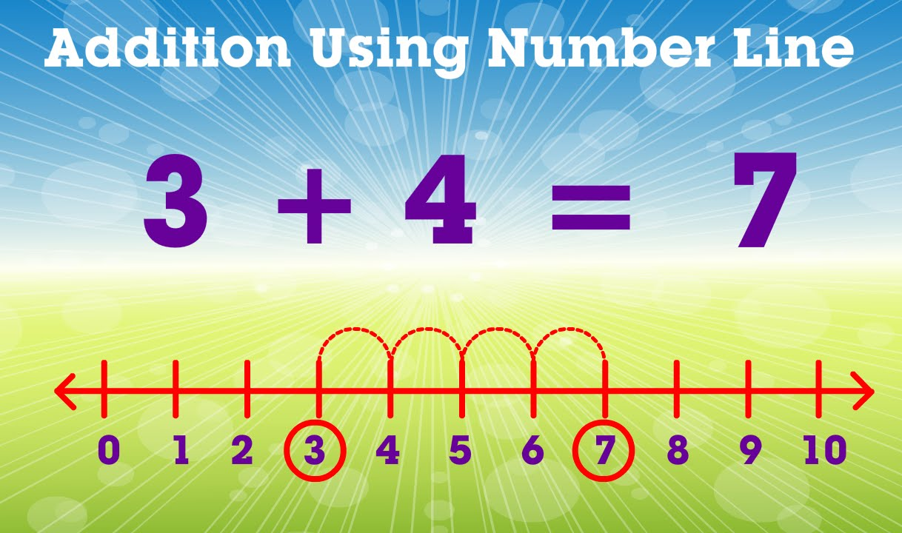 | Maths  Watch the clip…  https://www.bbc.co.uk/bitesize/topics/zwv39j6/articles/ztpmrwx  Have a go at collecting a group of objects from around your house (E.g. teddies, dolls, Lego blocks etc).  Take a smaller group of objects away.  Have a go at writing a number sentence to show what you have done (E.g. 10 – 6 = 4) | Maths  Check out Espresso,  For KS1, all of the videos and activities on handling data are under the title – Addition and Subtraction.  https://central.espresso.co.uk/espresso/primary_uk/subject/module/frontscreen/item736870/grade1/index.html?source=subject-Maths-KS1-Maths-Resource%20types  For KS2, all of the videos and activities are under – Addition and Subtraction  hhttps://central.espresso.co.uk/espresso/primary_uk/subject/module/frontscreen/item414571/grade2/index.html?source=subject-Maths-KS2-Maths-Resource%20types  Username: student7070  Password: green3 | Maths  Have a go at writing a story for a number sentence.  E.g.  I have 5 pieces of Lego, my sister has 3 pieces of Lego. We have 8 pieces of Lego altogether.  Use props to help you.
English Overview: This week, we are starting our topic on Magazines.
Definition and examples – This topic is about media literacy and non-fiction texts and requires pupils to be able to write recounts and non-chronological reports. All of the work we do, will build up to pupils either writing a non-chronological report or a simple recount.
Useful websites - https://central.espresso.co.uk/espresso/modules/e2_medialit/index.html?source=search-all-all-all-all&source-keywords=magazines
Recommended Reading - A selection and range of appropriate magazines. Appropriate magazines for adults are fine too (E.g. Cooking, fishing, TV choice etc), just for pupils to get the idea of what a magazine is.
Monday | Tuesday | Wednesday | Thursday | Friday
English  Reading  Watch the clip on Espresso…  https://central.espresso.co.uk/espresso/modules/e2_medialit/analysing/video_splodges.html?source=search-all-all-all-all&source-keywords=magazine  Look at a selection of adverts on billboards, on the internet (with an adult), on television. Think about what the advert is trying to sell.  Make a list of what the advert is trying to sell and who to.  E.g | English  Writing  Have a go at designing your own advert that would appear in a magazine. | English  Writing  Watch the clip…  https://www.bbc.co.uk/bitesize/topics/z8x6cj6/articles/z3dcmsg  Have a go at writing words or sentences using an explanation mark…  E.g  Win a prize!  Free gift in this magazine!  Wow!  Today is also World Book Day!  What’s your favourite book? Enjoy some books today with an adult. There is a great selection of interactive books on Espresso | English  Handwriting  Check out the videos on Espresso in the handwriting section. Look at letters that you are still struggling with.  Have a practice at these letters to get better. | English  SPG  Do a look, cover and write with the following words…  Pass  kiss  miss  mass  grass  What was your score? Can you think of any more ‘ng’ words?
  Product | Audience
  Sweets | Children
PSHE Overview: The Power of kindness! During these difficult times, one thing is clear: small acts of kindness make a big difference. This is last week of home-learning. Each day, do something that helps someone else and then something that helps you. Being kind to others and also, being kind to yourself is important. Keep a diary of these tasks/activities/acts.
Useful websites - https://www.redcross.org.uk/get-involved/teaching-resources/kindness-activity-pack

Monday | Tuesday | Wednesday | Thursday | Friday
PE  Check out Cosmic Yoga – again!  The last week, lest do some cosmic yoga!  https://www.youtube.com/watch?v=LhYtcadR9nw | PE  Check out Cosmic Yoga – again!  The last week, lest do some cosmic yoga!  https://www.youtube.com/watch?v=xhWDiQRrC1Y | PE  Check out Cosmic Yoga – again!  The last week, lest do some cosmic yoga!  https://www.youtube.com/watch?v=j_3weVPH0-U | PE  Check out Cosmic Yoga – again!  The last week, lest do some cosmic yoga!  https://www.youtube.com/watch?v=KAT5NiWHFIU | PE  Check out Cosmic Yoga – again!  The last week, lest do some cosmic yoga!  https://www.youtube.com/watch?v=kxk78inN-3Y
Spanish  Our topic this term is The Weather  Check out the vocabulary and activities on BBC Bitesize…  https://www.bbc.co.uk/bitesize/topics/zh7wqp3/articles/zr274xs | Geography  Our topic is the Living in a Village or a City  Look at aerial, satellite maps of cities on google maps. Why not look at our closest city – Manchester.  What do you notice in a city? Are there lots of buildings or lots of fields? What types of buildings are in the city? Would we find these types of buildings in our street or in a village? | Design Technology  Our topic this term is Playgrounds.  This time, why not try to make a seesaw?  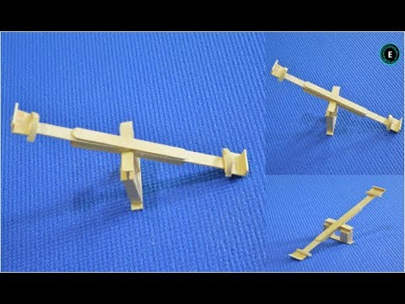  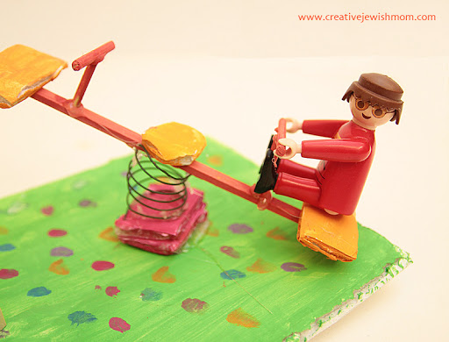  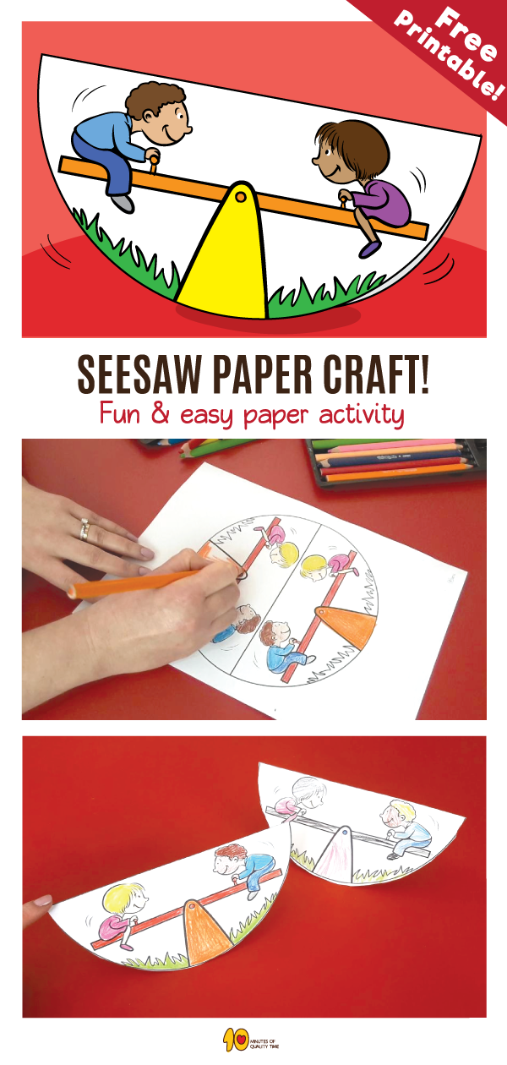 | SCIENCE  Our topic this half-term is Forces  Watch the clip…  https://www.youtube.com/watch?v=ljRlB6TuMOU  Make your paper helicopter at home. Try dropping your helicopter. How can you make it fall faster? How can you make it drop slower? | COMPUTING  This week, we will be looking at Safer Internet Day.  Check out the website for more information…  https://www.saferinternetday.org/  Why not design a poster explaining how to stay safe on the internet?

